Elias Martin:

A Swedish Émigré in London

(1768-1780)

A Thesis submitted for the degree of Master of Philosophy
By
Paul Tear MBE

Faculty of Design, Media & Management
Buckinghamshire New University
Brunel University

January, 2017
This copy of the thesis has been supplied on condition that anyone who consults it is understood to recognise that its copyright rests with its author under the terms of the United Kingdom Copyright Acts. No quotation from the thesis and no information derived from it may be published without proper acknowledgement.

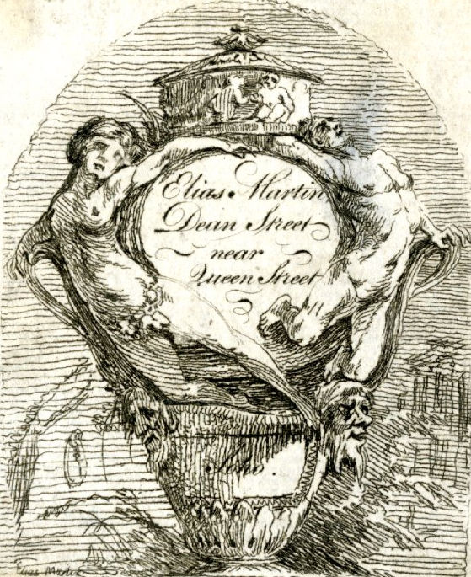

Elias Martin’s Trade Card, Banks Collection, British Museum

Abstract

Elias Martin: A Swedish Émigré in London (1768-1780).
This thesis explores the career of the painter, Elias Martin (1739–1818) during the period 1768 to 1780, when he was working and living in England. It investigates Martin’s relationships with the renowned architect Sir William Chambers (1723-1796) together with the Swedish Circle of Émigrés, an influential circle of artists and designers based in London during this period. The thesis aims to explore, through a number of key institutions and projects, how Martin’s collaboration with members of the Swedish Circle remained an important critical stimulus in the development of his identity as an artist and designer during his stay in London.

By reappraising a range of primary material and analysing the projects that he participated in and visited, it will be shown that there was a far greater level of co-operation between artists and craftsmen of different disciplines in late eighteenth century London than there is today. Much has been written on art in the eighteenth century, little has been written on the subject of relationships between the various professions that made up this sector. It identifies omissions in the literature that required further investigation and hence themes of study were established. Therefore, the main aim of the thesis is to re-appraise and offer greater insights into this period by drawing together connections which have previously been overlooked by historians and scholars.

This research is located where the traditional boundaries of Decorative and Fine Art fields overlap. It contributes to current critical discourse in the field from a practitioner’s perspective with over thirty-seven years of experience as a professional conservator. From this insight, the thesis discusses connections between inter-disciplinary influences, and the process through which works were conceived and developed through examples of Martin’s work across several media. It provides better understanding of the working/personal relationships among a number of artists working in London in the late eighteenth century.

Acknowledgements

In undertaking this thesis, it has at times seemed like a millstone around the neck. You embark on a journey of discovery, on which, once started, there is no turning back. There is no turning back because as you embark on your research, you receive the most wonderful support from everyone you come into contact with, which means that you owe it to them as much as to yourself to complete the research.

It is not possible to thank everyone that I have made contact with over the last eight years, so I apologise in advance to those I have not mentioned. I would like to thank Peter Cornish for his support and for giving me the opportunity to undertake this research; my wife Jenny and my family for their unswerving support; my two supervisors, Professor Juliet Simpson and Professor Jake Kaner, for their unwavering support throughout the process of researching and writing this thesis.

Thanks also to National Museum Stockholm, Dr Mikael Ahlund, Goteborg Museum of Art, Håkan Wettre, Eklund Gunilla, Birgitta Lindholm, Josh Akcil, Diane Clements, Philip Winterbottom, Mark Pomeroy, Anders Boström, , Chris Gravett,
Sir Edward Dashwood, Annelise Hone, Jill Tovey, Wendy Carter, Amina Wright, Gemma Entwistle, Andrew Bulford, Ann Mitchell, Sue Webber, Rhian Wong, Wolfgang Nittnaus, Dr Andreas Onnerfors, Andrea Gilbert and Tonna Danzine. And finally I express special thanks to Susan Millis, Dr Ernest Riall and Rachel Dealey for their perceptive reading and help with the formatting of the thesis.

Author’s Declaration

I declare that, except where explicit reference is made to the contribution of others, this thesis is the result of my own research and has not been submitted for any other degree at Buckinghamshire New University or any other institution. Every effort has been made to ensure the accurate acknowledgment of all literary sources used in this thesis.

Contents Page
Abstract iii
Acknowledgements iv
Author’s Declaration v
Contents vi
List of Illustrations ix

Introduction:
0.1 Overview 2
0.2 Personal Rationale for Research 4
0.3 External Rationale for Research 7
0.4 Literature Review 10
0.4.1 Introduction 10
0.4.2 Review 10
0.4.3 Summary 15
0.5 Aims and Objectives 17
0.6 Thesis Structure 18
0.7 Scope and Limitations 20

Chapter One: The Early Years 1739 - 1763
1.1 Introduction 25
1.2 Stockholm: Elias Martin Formative Years 25
1.3 Sveaborg (1763-1766) The Ship yards of Sweden 28
1.4 Paris (1776-78) Centre of European Taste 30
1.5 Summary 33

Chapter Two: England 1768 - 1780
2.1 Introduction 36
2.2 Martin’s arrival in London and Early Contacts 37
2.3 Martin’s Membership of the Royal Academy 39
2.4 The Swedish Church in London 44
2.5 Family Life, Marriage, Children and New Markets 48
2.6 Summary 51

Chapter Three: Fellowship, Integrity & Good Citizenship
3.1 Introduction 54
3.2 Family Relationships 56
3.3 The Swedish Circle: Working Relationships 58
3.4 Societies; Church & Freemasonry 62
3.5 The Freemasons 70
3.6 Summary 74

Chapter Four: Sir William Chambers & The Swedish Circle –
An Exploration of Four of Martin’s Projects
4.1 Introduction 78
4.2 John Boyd and Danson House 79
4.2.1 Danson House 83
4.2.2 Danson’s Interior 85
4.3 Woburn Abbey 105
4.3.1 Woburn Abbey Refurbishment 106
4.4 Sunbury Villa (Court) 115
4.4.1 Martin’s Paintings at Sunbury Court 118
4.5 Painshill Park 123
4.5.1 The Park 124
4.6 Summary 125
4.6.1 Danson 125
4.6.2 Woburn Abbey 129
4.6.3 Sunbury 130
4.6.4 Painshill 131

Chapter Five: Martin’s Return to Sweden and his Final Years
5.1 Introduction 139
5.2 Caricature 140
5.3 Summary 146

Conclusion:
6.1 Introduction 151
6.2 Further Research 160
6.2.1 The City of London 161
6.2.2 Martin the Entrepreneur 161
6.2.3 Furniture 162
6.2.4 Artists & Architects 168
6.3 Contribution to Knowledge 169

Account of Sources

Bibliography, Primary Sources 171
Manuscripts 173
Secondary Sources 174
Catalogues 178
Newspapers and Journals 179
Letters 180
Record Offices 181

Appendices:
Appendix I
Martin’s Letter to King Gustav III of Sweden (1746-1792) 182
Appendix II
Early Artistic Training in London 184
Appendix III
The Formation of The Masons 186
Appendix IV
The list of paintings, drawing & watercolours exhibited
by the Martin brothers at The Royal Academy Exhibition, 187
(1769-1790)
Appendix V
The list of paintings, drawing & watercolours exhibited
by the Martin brothers at The Society of Artists of Great Britain 190
(1760-1780)
Appendix VI
Elias Martin Studio Addresses 192
Appendix VII
Examples of Elias Martin’s drawings showing the breadth 193
of his skill in other areas

List of Illustrations: Page
Inside page; Elias Martin trade card for Dean Street, Banks collection,
British Museum D, 23220 ii

Introduction:
Figure 0.1 Kingsland Road, with St. Leonard’s Church,
Church Shoreditch in the distance, Elias Martin
1770, NMS 57/1904 1
Figure 0.2 Ebenisterna (Marquetry) Elias Martin, (1768-80),
NMS, NM 1421 5
Figure 0.3 ‘Now to work’, Elias Martin, (1768-80), NMS, D16.696 6
Figure 0.4 Worker at the workbench, Elias Martin, (1768-80),
NMS, D10.840 6
Figure 0.5 Diagram of the Swedish Circle 8

Chapter One:
Figure 1.0 Utsik Frän Lejonbacken över Helgeandsholmen
(View from Lejonbacken over Helgeandsholmen),
Elias Martin, 1760, NMS, 338/1924 24
Figure 1.1 Elias Martin, bas-relief, Johan Tobias Sergel, 1779,
NMS, k 833 25
Figure 1.2 Baroque Altar, drawn by Elias from a copper plate
engraving, 1750, NMS, 308/1860 27
Figure 1.3 Vy over Helgeandsholmen (View Over Helgeandsholmen),
Elias Martin, 1763, Stockholm City Museum 28
Figure 1.4 Fartyg ur skargardsflottan I Gustafsswärdssund
(Ships from the Archipelago Fleet in Gustaf Sward Sound),
Elias Martin, 1764, NMS 147/1931 29
Figure 1.5 G. P. Creutz, Swedish Ambassador in Paris,
his sitting room in the ambassador’s residence
Paris, Elias Martin, 1767, NMS 103/1904 30
Figure 1.6 Mme Hirault, Elias Martin and George Haupt’s
landlady in Paris, Elias Martin, 1767, NMS, 109/1904 31
Figure 1.7 Portrait of George Haupt, Elias Martin, circa 1760,
Nordiska Museum, 98.978 32

Chapter Two:
Figure 2.0 Sjalvportratt (self-portrait) Elias Martin, 1765,
NMS, 87/1884 35
Figure 2.1 Royal Academy Library, The Minutes of the
Royal Academy, RAA/GA/1/1, p. 39,
(Author’s photograph) 42
Figure 2.2 Royal Academy Library, The Minutes of the
Royal Academy, RAA/GA/1/1, 1772, p. 63,
(Author’s photograph) 43
Figure 2.3 The site of the original Swedish Church,
Prince Square (1792-1911), London E1 8BH,
(Author’s photograph) 45
Figure 2.4 The Swedish connection lives on, street name
in the East End of London E1 0BH,
(Author’s photograph) 45
Figure 2.5 The Swedish Church today, 6 Harcourt Street,
London W1H 4AG(Author’s photograph) 46
Figure 2.6 The Swedish Church in London, 6 Harcourt Street
London W1H 4AG The book of communion
1748–1816, (Author’s photograph) 47
Figure 2.7 Copy of Elias Martin’s marriage certificate. LMA.
Microfiche X025/010, page 110, marriage
certificate no 439, LMA 49

Chapter Three:
Figure 3.0 Bror (brother) Carl Gustaf, Elias Martin’s Brother,
Carl Gustaf, Elias Martin, 1772, NMS 89/1904 53
Figure 3.1 Diagram of the Swedish Circle 55
Figure 3.2 Diagram of Haupt family tree, Ulrica Haupt,
Elias’s mother, was from the first marriage.
George, Ulricia half brother was from the second marriage 57
Figure 3.3 Commode by Christopher Fuhrlohg, central marquetry
medallion from design of Angelica Kauffman,
Lady Lever Art Gallery, acc. no, LL 4233 59

Chapter Four:
Figure 4.0 View of the Thames from the foreshore at Sunbury
Elias Martin, NMS 77
Figure 4.1 Map of Danson. Detail from Andrews,
Dury and Herbert, Map of Kent, circa 1760, Bexhill Trust 80
Figure 4.2 The park at Danson in 1768 showing the canal and the
house that John Styleman built rebuilt in the 1740s,
Elias Martin, 1768, NMS, 86/1982 81
Figure 4.3 The view of Mansion House, the pediment was added later,
figures carved by Robert Taylor. (Author’s photograph) 82
Figure 4.4 Landscape with waterfall over fireplace, by
Claude-Joseph Vernet (1714–1789), the
Walter Art Museum, acc. no; 37.2411 83
Figure 4.5 Ground floor plan for Danson, showing the series of
four rooms (Author’s photograph) 84
Figure 4.6 Danson house from the north-east following restoration
in 2009 (Author’s Photograph) 85
Figure 4.7 The saloon at Danson, landscape with waterfall over
fireplace, copy of original by Joseph Vernet
(Author’s photograph) 86

Figure 4.8 The dining room chimney piece designed by Chambers
with over mantle picture, A Sacrifice to Bacchus, with
decorative panels to the left and right, Charles Pavillon,
1766 (Author’s photograph) 90
Figure 4.9 The view of the front of Danson house, painted by
George Barrett, circa 1768 (Author’s photograph) 91
Figure 4.10 Engraving of Danson from the south-east,
published in 1794 from an earlier drawing by 96
Richard Corbould, British Museum, 1862, 0712.838
Figure 4.11 Saloon chimneypiece (Author’s photograph) 98
Figure 4.12 Design for a chimneypiece in the eating room
at Danson, William Chambers, Metropolitan
Museum of Art, acc. no; 49.56.19 99
Figure 4.13 Library fireplace, Danson (Author’s photograph) 100
Figure 4.14 The medal cabinet for the Earl of Charlemont,
1768, Courtauld Art Gallery 104
Figure 4.15 Illustrations of a dropping pendant, from the medal
cabinet for the Earl of Charlemont, Courtauld Art Gallery 105
Figure 4.16 Preparatory drawing of Wooburn Abby (sic)
Elias Martin, circa 1770, NMS, 55/1904 109
Figure 4.17 Commode, chest of drawers by Pierre Langlois,
1764. ‘From Woburn Abbey Collection’ 112
Figure 4.18 Sunbury Court, front view (Author’s photograph) 116
Figure 4.19 View of state room, Elias Martin, 1770, NMS, 44/1904 117
Figure 4.20 Wall fresco showing a landscape with figures in
oriental dress (Author’s photograph) 118
Figure 4.21 First over door, dining room, Sunbury Court
Elias Martin, (Author’s photograph) 120
Figure 4.22 Second over door, dining room, Sunbury Court
Elias Martin, (Author’s photograph) 120
Figure 4.23 Third over door, dining room, Sunbury Court
Elias Martin, (Author’s photograph) 121

Figure 4.24 Fourth over door, dining room, Sunbury Court
Elias Martin (Author’s photograph) 121
Figure 4.25 Two Cherubim Playing, Elias Martin, NMS, 293/1904 122
Figure 4.26 View of the lake at Painshill, with ruin in the background
(Author’s Photograph) 124
Figure 4.27 Sir Francis Dashwood, dressed as the Grand Turk,
West Wycombe Park 130
Figure 4.28 Detail from wall fresco, illustrating figures in oriental dress
(Author’s photograph) 130
Figure 4.29 Inside the Grotto at Painshill (Author’s photograph) 132
Figure 4.30 Oil painting of the build of the iron bridge at Coalbrookdale,
Shropshire. Elias Martin, 1779, Private collection, 133

Chapter Five:
Figure 5.0 Design for a secretaire, with Masonic emblems,
Elias Martin, NMS 142/1895 138
Figure 5.1 Elias Martin preaching on his success in London,
Johan Tobias Sergel 1779, NMS 142
Figure 5.2 Elias Martin the dinner guest from hell.
Johan Tobias Sergel, NMS,550/1875 144
Figure 5.3 Elias Martin in old age, Johan
Tobias Sergel, NMS, 551/1875 145
Figure 5.4 Elias Martin eating sausages, Johan
Tobias Sergel, NMS, 552/1875 146
Figure 5.5 Elias Martin’s tomb stone, www.gravsted.dk/person.php?nav=sliasmartin,
accessed 4th October 2007 148

Conclusion:
Figure 6.0 Elias Martin as an old man, Elias Martin, NMS 150
Figure 6.1 Trade Card, Watson & Martin, BM, H28-229 155
Figure 6.2 Trade card details showing Johan Martin’s signature,
BM, H28-229 156

Figure 6.3 Elias Martin in his Studio in London, 1779,
Johan Tobias Sergel NMS, 625/1875 157
Figure 6.4 Mistley Hall, Manningtree Essex,
Elias Martin, NMS 2265 158
Figure 6.5 The front of Danson House, George Barret, 1767
(Author’s photograph) 159
Figure 6.6 Johan Fredrick Martin, Elias Martin, NMS 6679 160
Figure 6.7 Secretaire, 1770, NMS 72/2006 164
Figure 6.8 Prometheus and Priestess admiring the wonders of fire,
Elias Martin, circa 1772, NMH 339/1904 165
Figure 6.9 Drawing of heads with various face profiles, Elias Martin,
circa 1772, NMS 558/1941 166
Figure 6.10 Detail of marquetry from secretaire, Elias Martin,
NMS 72/2006 167
Figure 6.11 Detail of front of secretaire, 1770, NMS 72/2006 168

Appendix VII:
Figure AVII.1 Design for fire place, with over mantle, Elias Martin,
NMS 187/188 194
Figure AVII.2 Design for a decorative urn, Elias Martin, NMS 12/1922 194
Figure AVII.3 Designs for vases, Elias Martin, NMS 311/1884 195
Figure AVII.4 Design for tea caddies Elias Martin, NMS 298/1884 195
Figure AVII.5 Architectural study, Elias Martin, NMS 569/1890 196
Figure AVII.6 London Bridge and St Paul’s viewed
from Thames side, Elias Martin, 1769, NMS 488/1884 196
Figure AVII.7 Figure studies, Elias Martin, NMS 244/1884 197
Figure AVII.8 Figure study; ‘you don’t say so’, Elias Martin,
(1768-80) NMS 23/1884 197

Abbreviations

London Metropolitan Archive LMA
National Museum, Stockholm NMS
Public Records Office, Kew PRO
The British Library BL
The British Museum BM
The National Archive of Sweden NAS
The National Library of Sweden NLS
National Portrait Gallery, London NPG
National Gallery Scotland NGS
Uppsala University Library, Sweden UUL
The National Library (V&A) NL
Westminster Archive WA

Introduction

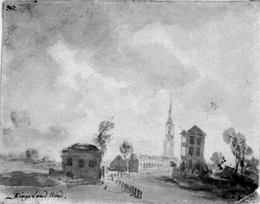

Figure 0.1. Kingsland Road, with St. Leonard’s Church, Shoreditch
in the distance. Elias Martin, (1769), NMS

0.1 Overview

England has at all times been famed as a hospitable country and for being singularly appreciative of foreign intellectuals and artists. In this respect the 18th-Century, one of the most brilliant epochs in the moral and material development of England, denotes the very climax and at least for some decades scarcely any other city in Europe could rival London as a centre of intellectual and artistic effort. The colony of foreign artists played an important part in the British metropolis, which gave as well as it received and far-flung rumour has much to tell about the possibilities, which both as regards training and patronage were available to artists in London.

The above quote by Ragnar Hoppe in the Burlington Magazine in 1943, underlines the status of London as a multinational artistic centre in the latter part of the eighteenth-century. Hoppe was bringing to the attention of the readers of the Burlington Magazine how London had helped to provide new career opportunities for one of the most famous Swedish artists, Elias Martin, during his stay in London from 1768 to 1780. Ten years earlier, Hoppe had completed a synopsis of Martin’s career, which began in Sweden, followed by two years in Paris and twelve years in London before Martin returned to his native Sweden.

This upsurge of interest in Swedish culture throughout the 1930s and 1940s led to a series of exhibitions on ‘Sweden’s Golden Age’ and Martin’s work was always represented (Sweden’s Golden Age, Rijks Museum, 1935). Sweden at that time was very proud of this talented artist who recorded so much of Swedish life during the eighteenth-century.

A major exhibition of his work was organised, between the Arts Council of Great Britain and the Swedish Institute for Cultural Relations, in 1963. One hundred and forty-five paintings and engravings were exhibited; all the paintings were by Martin with some engravings by his brother, who played an important role in turning many of his paintings into prints.

The choice of Martin over one of the many other eighteenth-century Swedish artists was probably due in part to the twelve years that Martin spent in London, but also the imagery that was displayed would have been very familiar to a London audience. This interest in and the exposure to Swedish artists aroused interest in many of the major museums and collections. They started to reassess the works of art in their collections and, in a number of cases, paintings and drawings were reattributed; a case in point is a drawing in the Royal Collection:

The drawing you refer to (night watchman, inventory number RL 13484) is currently ascribed to Hogarth – No 357 refers to the entry in the catalogue by A. P Oppé, English Drawings in The Collection of His Majesty the King at Windsor Castle, 1950. I see now that this drawing has been more recently attributed to Elias Martin.

So we see that this heightened awareness of Swedish artists leads to a greater appreciation of all forms of Swedish art. Yet this period of Martin’s time in London remains relatively unexplored, by both English and Scandinavian researchers; many major English museums and collections have work by Martin. This thesis hopes to establish some degree of chronology for when these works of art were executed and link how they played within the projects he undertook during the twelve-year period that Martin was in London.

This thesis will examine and re-appraise the twelve years from 1768, when Elias Martin came to London and 1780 when he returned to Sweden. It will present this in a chronological way, documenting Martin’s progress, mapping his contacts and events that influenced both his private and professional life. I will illustrate how Martin was influenced by the contemporary fashion, but then, over time, also developed his own particular style of painting, drawing and engraving. He also toward the end of his time in London circumnavigated the more traditional way of selling his work.

London in the 1770s was a much more open environment with the public receptive to new ideas and innovation. The thesis considers how Martin may have seen England as a land of opportunity, where he could not only develop his artistic skills, but also use his entrepreneurial skills to try out new ideas and to earn a comfortable living for himself and his family.

0.2 Personal Rationale for Research
In January 1979, I joined the Wallace Collection as a conservation officer, having been trained as a cabinet-maker in the commercial sector and spending the previous three years at the Museum of London. I had known the Wallace Collection for many years and had visited it on several occasions, admiring its wonderful collection, particularly the marquetry furniture, which has been often referred to today as ‘Painting in Wood’. I always have had an interest in marquetry and now working at one of the world’s greatest collections of French furniture gave me the opportunity to further my research into the subject.

As the conservation department had a world-renowned reputation for the conservation of French furniture, we often dealt with enquiries from conservators, curators, students and journalists. In 1982 we were asked by a freelance writer, Dr Ada Polak (1914–2010) to explain some of the basic techniques used to produce marquetry, for an article she had been asked to write by the Swedish consulate in London. At the end of the interview she enquired whether we were aware of a number of paintings and drawings by the artist Elias Martin (1739–1818) in the National Museum of Stockholm. We were not, so she offered to send us a photograph of one of his paintings and photocopies of some of his drawings that were undertaken during his stay in London between 1768 and 1780.

When the illustrations arrived, they intrigued me, as it was apparent that the subject of painting was composed, as it was unusual to see the two craftsmen so close together, this was not true-to-life. What was also intriguing was that all the tools illustrated were very accurately depicted, indicating that the artist had a good knowledge of cabinet-making tools and techniques (figure 0.2).

The drawings were very freely drawn but capturing the moment, they depicted cabinet-makers about their craft, not as detailed as in the painting, (figure 0.4), but the basic tasks of cabinet-making, basic sawing and planing of a piece of wood, or putting on one’s apron, ready for work (figure 0.3).

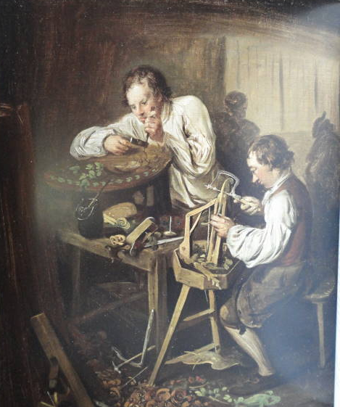
Figure 0.2. Ebenisterna (Marquetry), Elias Martin, (1768-80), NMS

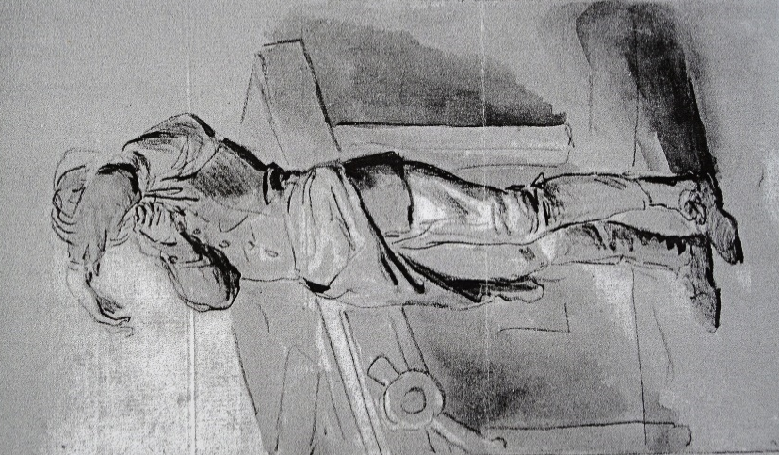
Figure 0.3. Now to Work Figure 0.4. Workers at the workbench
Elias Martin, (1768-80)

As my long term relationship with Elias Martin had begun, research progressed slowly, until 1996 when I attended a course on marquetry at the Carl Malstream School in Stockholm. This allowed me the opportunity to visit the National Museum of Stockholm where I saw many more examples of Martin’s work and was overwhelmed by its diversity. It became clear talking to the Swedish participants on the course that Martin’s work was much admired and the family, despite the ups and downs in their fortunes during the late eighteenth century, were respected members of the Swedish Cabinet-Makers Guild.

While the interest in Scandinavian art and design had passed its zenith, I had always felt that the twelve years that Martin lived in London were worthy of further research. This was brought home to me during a discussion on Martin’s work with an eminent picture curator, who upon looking at some of Martin’s painting declared that this ‘was not art’. She felt that as his work did not follow the normal eighteenth century convention of portrait/landscape painting and was more historical painting, it could not be considered to be ‘true’ art.
This comment spurred me on to investigate Elias Martin’s time in London in more depth than has been covered in current literature, in an attempt to support the valuable contribution he made to the late eighteenth century London art market.

0.3 External Rationale for Research
While all the published material has given me a good insight into the life and work of Martin, they naturally concentrate on his paintings, drawings and his engraved prints. My initial proposal was to look at his career in London with special emphasis on his work relating to the cabinet-making profession. Research indicated that there was a very strong artistic Swedish community in London in the late eighteenth century; from within this community a small group of artists was formed, a circle of friends that became the Swedish Circle.

Existing literature does not always make connections between the work of various artists and craftsmen working in different fields, who are associated through location, nationality and friendship. The assumption is, in many cases, that they would only collaborate with fellow artists/craftsmen within their own profession and would not normally collaborate outside their chosen field. This thesis aims to dispel this assumption and show that there was a far greater level of co-operation across a number of different artistic fields.

The main supporter of this ‘Swedish Circle’ was Sir William Chambers (1723-1796). As this circle of artists had moved to a foreign country, it is not surprising that they would seek out fellow emigrés for help and support. Martin seemed to have received support from Chambers, as from 1772 we see a series of works produced by him which followed projects that Chambers was heavily involved with. In figure 0.5 we can see the ‘Swedish Circle’ preliminary research and literature review confirms that Sir William Chambers (1723–1796) was the central figure, around whom there are a number of prominent artists and institutions from both the fine and decorative arts. On the right we see Chambers and his involvement with the Royal Academy, mapping his association with a number of prominent artists of the day such as Angelica Kaufman (1741–1807).

On the left are members of the decorative arts field, for example John Linnell (1729–96), who had, or were working in, successful workshops in the high-end market for design and decorative art situated in the West End of London, in Oxford Street and Tottenham Court Road areas.

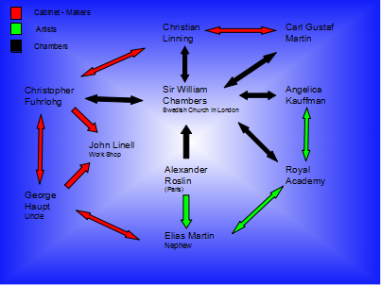
Figure 0.5. Diagram showing ‘The Swedish Circle’

This thesis attempts to illuminate how the cultural contexts and institutions of the developing eighteenth century and the London art world continued to influence and develop Martin during his time in London. It considers in particular the people, crafts, and the different environments which continued to shape his artistic and design vision. I will show how such a short period of time in Martin’s career allowed him to develop from a talented artist into a confident businessman, who would return to his native Sweden with a clear vision on where he wanted to take his career.

Through this investigation of the activities of Elias Martin, Sir William Chambers and the other members of the Swedish Circle, the thesis aims to establish that a considerable level of cooperation existed between architects, artists and craftsmen, which is a new way of understanding the history of European eighteenth century art.

In reappraising this small timeframe through the life of Martin, it is hoped to show that Eighteenth-Century art was undergoing great change and witnessed a significant surge in popularity. Extensive studies have shown that this period saw the birth of the industrial revolution and the emergence of a bourgeois society, and as many scholars have pointed out, these advances were arguably most developed and extensive in later eighteenth century Britain. Indeed, as historians Greig and Riello observe:

There is little argument that during this period, (the late eighteenth century) England was transformed more than any other area of Europe from being a rather underdeveloped nation to the heart of a new late eighteenth century European industrial world with material conditions and cultural vitality unimaginable just a century earlier.

This thesis will demonstrate that Martin’s work was coloured by this context, showing affinities with that of other English artists of the period who responded to the spread and transformation of the Industrial Revolution, in particular Joseph Wright of Derby (1734-1797).

0.4. Literature Review

0.4.1 Introduction
This literature review brings together some of the written texts and some relevant images that have been published on a range of artists and craftsmen working in London in the late eighteenth century. It allows the reader to see the scope of what has already been researched and published in this area, and equally importantly, what has not.

Libraries around the world are awash with research that has been carried out on the history of fine and decorative arts; the period of the late eighteenth century in London is rich in literature. This thesis will not research this area of study extensively, but will summarise it in order to contextualise the members of the ‘Swedish Circle’ working in England at the time of this study. It reappraises secondary research material from this period, together with primary research from archives and collection to draw what in the first instance may seem to be a number of tenuous links between the various artists, into a positive collaboration among a group of craftsmen/artists.

0.4.2 Review
It is essential to reflect on the broader area of Furniture History in England, as this will help develop the understanding of where London was placed within this manufacturing sector. The history of English furniture has been researched widely by groups of researchers including art historians, academics and museum curators. One of the most useful sources in recent years has been The Furniture History Society, formed in 1964 to promote and disseminate research into all aspects of furniture design, manufacture, patronage and history and it has provided through its annual journal a number of key articles on members of the Swedish Circle. Lucy Wood, formerly curator of the Lady Lever Art Gallery, wrote a seminal work on commodes at the Lady Lever Art Gallery; following its publication she continued to research the cabinet-makers John Linnell (1729–96), and Christopher Fuhrlohg (1762–1787). After research for the Lars Ljungström book on George Haupt (1741-1784), she published articles on Haupt and Pierre Langlois (1754-81) .

In these articles Wood not only discussed their output, but also started to investigate the possibility of working on paternal relationships between other cabinet-makers.

Prior to the creation of the Furniture History Society, it was the monthly periodicals such as Apollo and Burlington magazine in which articles could be found on various artists and craftsmen. The seminal text regarding Elias Martin’s life and work remains “Elias Martin” by Ragnar Hoppe, published in 1933; this publication continues to be quoted in subsequent publications and exhibition catalogues as the major source of information. Ragnar Hoppe published a précis of his book (in English) in The Burlington Magazine. In both his book and article, Hoppe wanted to raise awareness of this talented Swedish artist who had worked in London and travelled around England recording such a diverse range of imagery of England in this period.

John Hayward (1916-1983) was the next furniture historian to take up the mantle, publishing a series of articles on Christopher Fuhrlohg (1762–1787). The first appeared in The Burlington Magazine in November 1969, followed by two further
articles in 1972 and 1977; all three greatly improved our knowledge on Fuhrlohg and enhanced our understanding of some of the working practices relating to the high-end cabinet-making industry in the Tottenham Court Road area. In particular, how established cabinet-makers would welcome foreign workers into their workshops, in the hope that they would bring with them the latest designs and techniques in order for them to incorporate them into their own work.

A further article by Pat Kirkham (1967) in the Furniture History Society Journal on the father and son firm of William and John Linnell again provided an insight into the collaboration between father and son, but also with architects such as Sir William Chambers, and Robert Adam (1728–1792), whom they worked for on the refurbishment of many of the great English country houses following their owners’ Grand Tours. This collaboration can be best illustrated by looking at Osterley Park, Middlesex, where, in the middle of the eighteenth century, Robert Child engaged Robert Adam to remodel the house.

A number of different craftsmen were employed to create Adams’ designs; the artists Antonio Zucchi (1726-1795) and G.B. Cipriani (1727-1785) supplied paintings, the cabinet-maker John Linnell (1729–96) supplied the furniture and the architect Sir William Chambers designed a number of fireplaces.

Pat Kirkham also recognised that furniture history is one of the most academically strong areas within the umbrella of design history. Her book ‘The London Furniture Trade’ (1982) was the first real attempt to give an integrated account of the furniture trade in London. This text analysed the role of the furniture-maker as well as the rise of the professional designer, reviewing the various crafts involved in furniture making, training, design, management and innovation.

The most in depth study of the relationship between Elias and his brother Johan’s engraving activities, can be found in ‘Elias och Johan Fredrick Martin’s gravyrer’ (Elias and Johan Fredrick Martin’s engravings) by Hans Frolich, published in 1939. This book outlines the long relationship between the brothers from the time that Elias brought Johan to London in 1770, to returning to Sweden together in 1780. This book becomes a very important resource when used in conjunction with the collections of engravings housed in the Uppsala University Library and the National Library of Sweden; this is due in part to the quantity of material in their collections.
No published catalogue has been undertaken to date, so books on the Martin brothers’ output help the researcher navigate through the mountain of material in their collection.

Newspapers have been a very rich source of information regarding how Elias operated in London, particularly with reference to the way he sold his engravings, and links with the other artists who shared his studios. They are references by painters David Martin (no relation) and Johan Martin (brother) as giving their address as the ‘Studio of Elias Martin, Dean Street’. Most newspapers have to be searched online from many public archives, since the British Library newspaper annex at Colindale has been closed.

Martin’s prolific output means that most major museums throughout Europe have a number of prints, drawings and occasionally paintings of his work. Most of his major works are distributed throughout Sweden’s and Finland’s substantial network of museums; in the major museums (including National Museum of Stockholm) they are catalogued. There have been occasional articles in the museums’ bulletins, including “Art Bulletin of Nationalmuseum, Stockholm”. These articles give up-to-date information regarding a small number of paintings and furniture recently acquired by the museum. In the smaller museums Elias Martin’s work is not catalogued in a published format, but is often available online as part of the ‘24 Hour Museum programme’.

In many cases the prints are duplicates of Martin’s prolific output; they also hold small numbers of drawings, and the occasional oil painting. Martin’s work appears in the museum guides and coffee table books on Swedish Painting, providing good colour illustrations with some historical information. The most useful historical information is to be found on the prints as many of them include information on the original artist, the engraver and the date of production. Therefore it is possible to track the work by Martin and engraved by Martin, work by Martin and engraved by Johan Fredrick Martin, and original work by Johan Fredrick Martin.

There are a small number of letters, diaries and official correspondence written by Martin in Swedish depositories, most of which are from the 1790’s. Whilst this is a little late for the period of this thesis, it is interesting to note that he kept a diary; no diary of his time in London has been found to date. His writing gives us a good insight into the man, particularly in later life, when his health and financial situation were deteriorating. The British Library holds a number of primary sources relating to Martin; the most useful of these are the letters of Sir William Chambers and early sale catalogues relating to Danson House. The London Metropolitan Archive and Westminster Archive house information on Martin’s personal and business activities, as well on the Swedish community in London. The Royal Academy Library holds a full set of records pertaining to its formation in 1768, and Sir William Chambers figures repeatedly in these records, as does Martin as he was one of the founding students.
Travel guides have been a source of information on Martin, although they do mainly relate to his career upon returning to Sweden, the most relevant for this thesis being one by Joseph Acerbi (1802), Travels through Sweden, Finland and Lapland to the North Cape.

A review of Martin’s work would not be complete without referencing some sources on art and artists of the late eighteenth century. The latest publications in this field include works by eminent researchers and authors such as Richard Solkin, Charles Saumarez Smith, Thomas Crow, and Kidson Barker. All these authors have produced seminal works relating to the fine arts field, many of which describe the taste and fashion of the late eighteenth century. They have focused on the better known artists of the period, such as Reynolds and Gainsborough. This thesis sets out to examine the significance of Elias Martin’s work together with his connections to lesser known artists during this period.

While not always appreciated when exhibited in the same exhibitions, today their work is being re-appraised and acknowledged as making a valuable contribution to the development of eighteenth century art. Martin and his contemporaries were pushing the boundaries and exploring different ways of expressing what they saw in their art. Their approach was to show a much broader view of eighteenth century life, still presenting it in the traditional manner, but with an underlying scepticism. Critics of the day believed Martin to be an inferior artist and that his forte was more in drawing and printing, but, as this thesis will show, his paintings are now being reassessed and re-interpreted; his true talent as an observer is being re-evaluated. The thesis will show, through the projects that Martin undertook, that his paintings and in particular his drawings and engravings now play a far more important role in our understanding of English life in the late eighteenth century than was previously thought.

Some of the texts in this review are in Swedish, and I am grateful to all the researchers, curators and librarians who have helped in the translation of a number of key texts and who have supported the project. Mikael Ahlund, curator of painting at the National Museum of Stockholm has been most helpful and supportive; Ahlund has completed his own PhD into the life and work of Elias Martin, which has been published as a book (2012). This explores the development of Martin’s work within a broader context of interests. However, it is also guided by significant issues raised in Ahlund’s study in relation to the connection in Martin’s developing artistic career between his approach to nature, art and questions of national identity.

I do not feel it is in direct competition to my own thesis, as Ahlund is looking at how Martin’s painting interacted with travel writing when he moved back to Sweden in 1780. As part of his overview of Martin’s career, there is a chapter on Martin’s time in London, in which he mentions his key achievements and influences, but not to the same depth as in this thesis.

0.4.3. Summary
This literature review has brought together a number of key texts that relate to Elias Martin’s activities during his twelve years in London. It has also identified a number of primary sources which underpin the research for this thesis. The work of Ragnar Hoppe (1933) is still considered to be the key text, as it gives a broad overview of Martin’s life and work. Mikael Ahlund’s research, by contrast, looks at the relationship of Martin’s images in light of the social and economic conditions in which they came about, and he discusses the attitude to nature that they express. Ahlund’s research has allowed us to recapture the relevance and significance of Martin’s work to his contemporaries, information that may have been lost in more recent attempts to understand his work. Together, these two pieces of research remain the most comprehensive studies of Martins oeuvre.

Ahlund’s book, Studies in the Landscape (2012) (based on his recent PhD thesis), whilst highlighting Martin’s particular concern with landscape genres as consistent determinants of his career, neglects to address how landscape painting would also shape Martin’s decorative and design vision: a vision that, as this thesis argues, was much more diverse, covering both fine and decorative arts.
Ahlund’s thesis proceeds from the idea that not only the artist, but also the individual patrons and the public at large influenced the appearance and the style of the images created. An overarching goal of this study, therefore, has been to try to widen interest from the artist himself to the people and settings around him, for whom and which his paintings were produced. A number of different voices from eighteenth century Sweden will be heard, telling the story of these landscapes.

Building on the approaches of Christopher Gilbert, Lucy Wood and John Hayward, their concerns in this study will be to investigate in greater depth, the relationship between artist, architect and cabinet-maker. As Lucy Wood points out, the growing complexity of these relationships and what they suggest about artistic or craftsman status has been neglected. Indeed, Wood focuses in particular on the circle, which included George Haupt, Carl Gustaf Martin, Christopher Fuhrlohg and Christian Linnings, maintaining that “so far, however, apart from some of Fuhrlohg’s early work – has wholly eluded discovery”. It is the aim of this thesis to shed fresh light on the work of these craftsmen and explore further the nature and operations of these relationships. It will also examine the career of Christopher Fuhrlohg as particularly pivotal to the expanded Swedish Circle, which would provide the context for Martin’s work. While there have been many articles written, on Fuhrlohg’s work (Christopher Gilbert and John Hayward) the relationship between Fuhrlohg, Linnell and Carl Gustaf Martin is still intriguing furniture historians.

The main gap in research undertaken in existing literature into craftsmanship in the late eighteenth century is that each area of research is independent of the other. Very few researchers draw together the links that they themselves have uncovered, as they feel they may be going off at a tangent from the main subject of their research.

It is not coincidence that within the various disciplines we see co-operation across the sectors, brought about by nationality, profession, paternity, location, or being a member of the same academy, society or group. By exploring and analysing the various projects, societies, and groups, and the objects that they produced, it has been possible to identify trends and connections between the various members of the Swedish Circle.
One of the main aims of the thesis is to explore these connections, offer new insights into the nature of these relationships, and to show that there was a greater level of co-operation between them. This thesis will also seek to develop new insights into, and understanding of, the impact and development of Martin’s decorative work within transforming identities and values ascribed to artist-designers, in an increasingly market-driven London art world.

0.5 Aims and Objectives
The thesis has four principal aims and objectives:

- To explore Martin’s relationships with other artists, craftsmen, architects and patrons, with particular reference to the Swedish Circle of Émigrés, who were working in London at that time. I will undertake this by establishing that, following support from fellow artists and craftsmen when he arrived in 1768, Martin welcomed other craftsmen from various disciplines into his studio to work.

- To examine the relationship that Martin developed with Sir William Chambers (1723-1796) who was at the centre of the Swedish Circle of Émigrés, of various disciplines, who came to London in the late eighteenth-century. In investigating this context, through a range of primary and secondary sources it will establish the collaboration between a number of artists/craftsmen, including projects that Sir William Chambers was engaged in, with the work that Martin was producing. I also will explore a tangible link between the patrons who employed both Chambers and Martin illustrating their contexts of operation from 1768 -72 during Martin’s time in London.

- To evaluate Martin’s time in London in relation to significant cultural changes, which shaped his development as an artist and craftsman, stimulated his entrepreneurial spark and motivation, and enabled him to progress very quickly up the social scale. I will examine the various networks Martin created and various societies he joined to broaden his range of contacts and to promote his work.
- Through selected images, I will illustrate how his artistic evolution and perspectives changed as he came into contact with newer influences, notably those of contemporary British artists and craftsmen, who were to have a significant impact on his work. I will also discuss how his subject matter and his approach to it, which has been for many years ignored, are now being reappraised.

0.6 Thesis Structure
This thesis focuses on the twelve years that Martin spent in London and how this most influential period not only allowed him to develop as an artist, but introduced a number of different approaches to producing and selling his work. It takes a chronological approach, with attention drawn to influential events that were to shape his artistic direction in the latter part of his career. Further, the thesis illustrates how this second aspect of his artistic development allowed him to confirm his love of nature, history and human activity that would shape his artistic direction in the latter part of his career.

Chapter One
Why did Elias come to England in the first place? Did he see himself remaining in England, or was it just a means to an end, in so much that he intended to return to Sweden at some time in the future, but he had to prove himself first? This chapter begins by looking at Martin’s early years in Sweden and training before he arrives in England, and examines the factors which motivated his move to England in 1768. It explores the support and encouragement that he received from family and friends, which would ultimately give him the confidence to execute some of the ideas he had to make a good living.

Chapter Two
Chapter two examines how Martin’s establishment within a London art world would be increasingly characterised by its mobility and entrepreneurialism. Martin’s skills as a journeyman enabled him to exploit this environment to advance his career, not only as a craftsman, but as an artist.

It subsequently charts the various projects and exhibitions that he participated in, to show how the Swedish Circle developed, as he undertook various commissions and engaged with the other members along the way, in particular when he joined the Royal Academy, and liaised with the architect Sir William Chambers.

Chapter Three
Chapter three considers the various networks and societies that Martin engages with in order to promote himself and his ideas. It explores this very fertile period of his career; we see him marry, which facilitates a move to the more affluent area of London. This fertile and inspirational environment is examined in relation to Martin on his arrival in London. Martin’s engagement with all of these activities attests to the impact of his contact with an expanded public and artistic sphere on his understanding of his practice as a craftsman, further evidenced by his brother’s arrival in London at Martin’s behest to train as an engraver so as to maximize his artistic potential via the growing popularity of prints. He promotes his work through exhibiting regularly at the various art societies and networking by participating in such societies as the church and freemasons.

Chapter Four
Chapter four investigates how and in what forms his contacts within the Swedish Circle enabled Martin to make distinctive and innovative contributions, through his response to landscape painting in the contexts of his work for his clients, and in their country and city houses. Building on Hoppe’s work, the contexts of patronage, markets and their agencies will be investigated in this thesis. It explores Martin’s work and that of his Swedish Circle contemporaries within a broader exploration of artist-client relations, their spheres of influence and operation. It considers this in relation to a late eighteenth century London art market and clientele characterized by its mobility and fluidity of interaction and cultural exchange. Thus, this chapter is guided in its analysis of the entrepreneurial and market contexts for Martin’s work by key recent scholarship in the field, notably by David Solkin, Mark Hallett, and Charles Saumarez Smith.

Solkin’s ‘Painting for Money; The Visual Arts and the Public Sphere in Eighteenth- Century England’ (1982), is of particular significance for this study, in arguing that the development of art in eighteenth century Britain took place in relation to an expanded concept of the ‘public’ sphere through exhibitions, the founding of the Royal Academy and increased access to markets for art through the spread of the engravings and print trades. The focus is therefore on how Martin’s career developed and blossomed through his interaction with these activities, and in relation to an expanded circle of patrons and fellow artists, including Sir William Chambers and other members of the Swedish Circle.

Chapter Five
Chapter five examines how Martin’s career developed upon his return to Sweden in 1780, and it will be shown that these twelve years in England shaped his future, allowing him to gain status in Sweden. This newfound status not only allowed him to obtain a prestigious position, but also to continue to develop ideas and enterprises that he had developed in London.

0.7 Scope and Limitations
This thesis focuses mainly on Martin’s twelve years in London. To put this into context it will look at his life before leaving Stockholm and his career upon leaving England. It will explore the relationships that he developed with other artists and craftsmen and how they influenced his work and allowed him to establish himself in London; and it also will explore the relationship he had with his brothers, encouraging them to join him in London and assist him in developing sources of income which could be used to expand his portfolio of work.

In looking at a very specific period of Martin’s career, it has been possible see what a generative time it was in the development of his career. Within this thesis it has not been possible to explore fully the extent of his print production and selling model; he developed an individual style of selling himself and his work, which was radically new for the rather traditional art market of the late eighteenth century.

One of these initiatives was to engrave a number of his works, producing a number of sets which he would sell by subscription before producing the prints; he would also sell a range of single prints through his own shop, rather than through one of the many booksellers established throughout London.

He developed a distance learning programme for drawing; Martin identified a market for people who wanted to learn to draw in the comfort of their own home. This approach appealed to women who wanted to learn to draw, but were put off by the male domination of the art profession. Martin’s distance learning pedagogy was as follows; he would send each student one of his drawings for careful observation and copying. Original and facsimile would be returned to Martin for comment; he would then annotate the student facsimile with suggestions for improvement and refinement and send it back with another drawing to be copied. If the students liked the original drawings that Martin sent them, they could purchase them, as every drawing had the price written on the lower right hand corner. This area of research although interesting, is beyond the scope of the thesis, as Martin undertook this innovative programme on his own and did not involve any other member of the Swedish circle.

In the thesis I have avoided those topics related to Martin’s work which have already been covered by Michael Ahlund, in his book; Landskapets roster, Studier Elias Martins bildvärld, (Landscape Votes: Studies in Elias Martin’s Imagery) (2012). In his book Ahlund investigates Martin’s imagery in light of the social and economic conditions in which they were created and discusses the attitudes to nature that they express.

Chapter One:

The Early Years (1739 – 1763)

Figure 1.0. Utsik Frän Lejonbacken över Helgeandsholmen (View from Lejonbacken over Helgeandsholmen), Elias Martin, (1760), NMS

1.1 Introduction

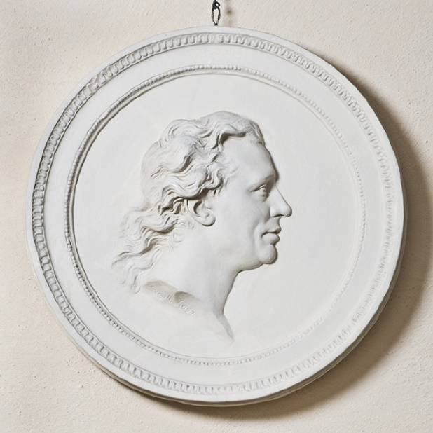
Figure 1.1. Elias Martin, bas-relief, Johan Tobias Sergel, NMS

To understand the development of Elias Martin’s career in London during 1768-1780 it is important to provide insight into his formative years and how these shaped his future as an artist. This chapter looks at his family background in Sweden and their connections with the traditions of cabinet making; his early apprenticeship as an ornamental artist in Sveaborg, and his working with George Haupt in Paris. Throughout this section I will attempt to examine the decisions Martin made, and the people he met, that would be instrumental in influencing his artistic career and his decision to move to London.

1.2 Stockholm: Elias Martin Formative Years
Elias Martin was born on the 8th March 1739, in the parish of Sankt Gertrud in Stockholm, Sweden, to parents Olof and Ulrica Martin (1716-1769). His father was an accomplished cabinet-maker coming from a family with a long tradition of furniture making. Throughout his career, Olof had undertaken a number of commissions for King Adolphus Frederick (1710-1771) at the Royal Palace. His mother came from the Haupt family, another great Swedish cabinet-making family, who had moved from Nuremberg to Sweden in the 1660s. There are very few documents to give an insight into Martin’s family life; the only written record being by Martin himself and is to be found in a description appended to the side of a drawing:

From very early on I have acquainted myself with everything grand, noble and virtuous in society. My father had virtues, ambition and faith to be a good example to me. Our life was defined by simplicity and we were happy, feared God and studied his creations all of the time. In that way I understood religion and God’s mercy and his deeds of mercy that was the basis for my humane understanding.

It would seem that Martin’s father was a moral and fair man who wanted to give his children a sound upbringing based on the fear of God and the understanding of the laws of nature and society: this ‘harmonious’ childhood left him with many happy memories.

Martin was the eldest of four sons and received what would be considered a middle-class education in Bellman, a suburb of Stockholm. As he came from a middle-class background he would have enjoyed home, school and his father’s workshop giving him a secure upbringing. Having the freedom to explore Stockholm to watch the hustle and bustle of everyday life, and then to start recording it on paper, meant that from an early age Olof Martin (1700-1764), his father, would have realised that being apprenticed into the cabinet–making profession was probably not going to be right for his son as his artistic ability began to emerge.

The first known drawing of Elias’s artistic talent dates to 1750, when Elias was eleven. It depicts a Baroque altarpiece probably copied from a copper plate from his father’s workshop (figure 1.2).

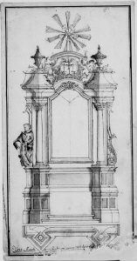
Figure 1.2. Baroque altarpiece, drawn by Elias from a copper plate engraving, 1750, NMS

It was a family friend, Friedrich Carl Schultz who began to teach Martin the rudiments of painting; the grinding of pigments, preparing the canvasses and undertaking the outline under-drawings, eventually allowing him to undertake small commissions for wall and decorative painting. His enthusiasm for the landscape developed when he was between 16 and 17 years of age; he would walk around Stockholm in his spare time drawing and sketching different places and scenes. He also seems to have been drawn to human activity, as many of his drawings and paintings included people at work or play. They included fishermen, sailors, boat-builders, farmers tending their fields and a naval officer playing his violin.

In 1760, at the age of 21, Martin enrolled in the Kongl Malareakadmien (Royal Academy of Arts) at the Royal Palace, Stockholm, where he was taught drawing and painting. He was an unusually gifted artist for his age who worked hard and continued to produce a prolific amount of work, typified by the painting, Vy over Helgeandsholmen (View over Helgeandsholmen), (figure 1.3.), produced in 1763.
This work reflects many of the characteristics of Martin’s art at this stage of his development; his living interest in realities, a refined understanding of colours and intuitive interpretation of the ‘genius loc’i, making his art an important addition to local traditions of topographical and landscape painting in Sweden.

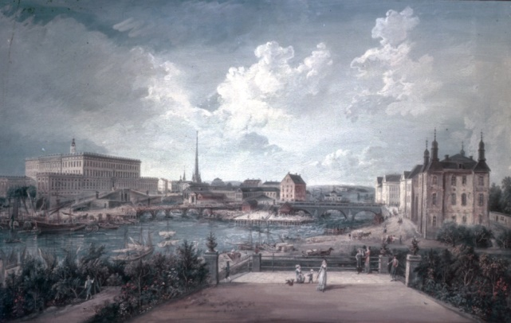
Figure 1.3. Vy over Helgeandsholmen (view over Helgeandsholmen), Elias Martin, 1763, NMS

1.3 Sveaborg (1763–1765): The Ship Yards of Sweden
By late 1763, aged twenty-four, Martin had moved to Sweden’s ship-building centre of Sveaborg, in Finland, where his drawing skills were put to good use as an apprentice ships’ ornamental artist. The fortress commander, Field-Marshal Augustin Ehrensvärd (1710–1772), himself an accomplished artist, continued to encourage Martin by teaching him to paint in the ‘French manner’. The years at Sveaborg moved Elias’s art to the next level; he made copious drawings and paintings of the shipyards. He was commissioned to carry out a pictorial survey of the fortifications along the archipelago and Western seaboard of Finland and he taught the officers at the naval base to draw.

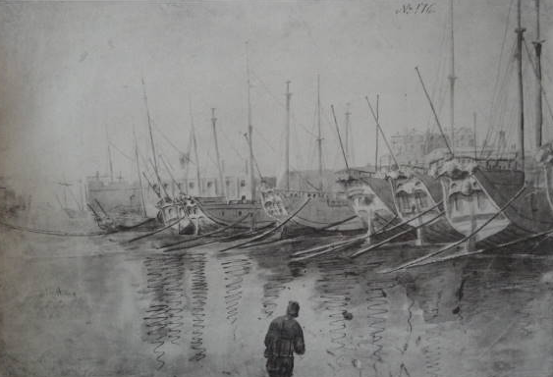
Figure 1.4. Fartyg ur skargardsflottan I Gustafsswärdssund (Ships from the archipelago fleet in Gustaf Sound) Elias Martin, (1764), NMS

Olof Martin, Martin’s father, died in 1764. As the eldest son, Elias returned to Stockholm to administer the family affairs and to contemplate his next move, as he felt that he had learnt all that he could in Sveaborg.

His old friend and mentor Field-Marshal Augustin Ehrensvärd had studied in Paris as previously mentioned and may have encouraged him to consider Paris as a good location to continue his artistic development. It was not surprising that Martin should see France as his next adventure and career move. He had returned from Finland with a number of paintings that he sold and with the proceeds from these, together with his share of his inheritance, he decided to go to Paris. Martin recorded his profound gratitude to Field-Marshal Augustin Ehrensvärd; before leaving for Paris he said; “For everything I know and can do, I thank Ehrensvärd”.

1.4 Paris; (1766-1768): Centre of European Taste
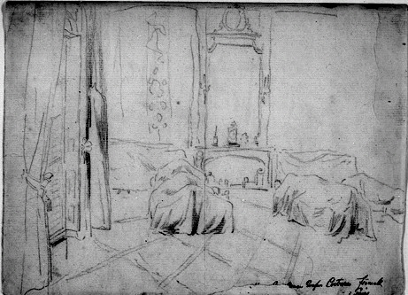
Figure 1.5. The Swedish ambassador’s residence in Paris, G. P. Creutz, circa 1766, NHM

Martin left Sweden via Gothenburg and landed at Le Havre, arriving in Paris in May 1766. Initially, the only point of contact would have been the Swedish Ambassador in Paris, Gustaf Philip Creutz (1733-1785). Creutz would then have advised Martin on other Swedes who were, at the time, working in Paris in the various professions, and as such, it is likely that he may have introduced Elias to the portrait painter Alexander Roslin (1718–1793). Roslin employed Elias and supplied him with a letter of recommendation, which allowed him to enrol in the French Academy of Arts as a student, where one of his drawing-painting tutors was the landscape painter, Joseph Vernet.

In the same year, Martin met the Swedish cabinet-maker George Haupt (1741-1784), to whom he was related on his mother’s side. The pair possibly shared lodgings, staying with Madame Hirault at the Hôtel d’Dauvergne. Martin produced a drawing of Madame Hirault (figure 1.6) and a portrait of his uncle, George Haupt (figure 1.7).

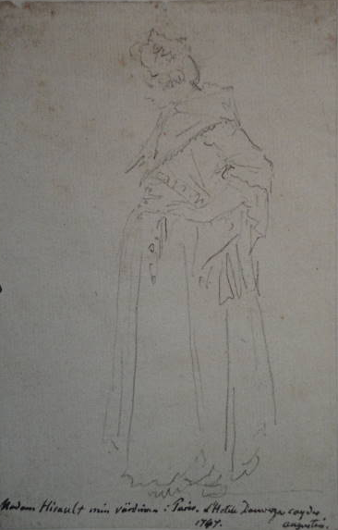
Figure 1.6. Mme Hirault, Elias Martin and George Haupt’s landlady in Paris, Elias Martin, 1767, NMS
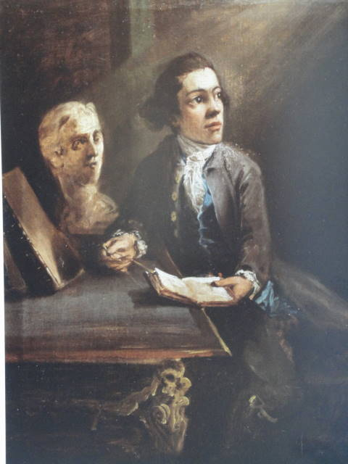
Figure 1.7. Portrait of George Haupt, Elias Martin, circa, Elias Martin, 1760, Goteborg Museum

George Haupt was employed in the workshop of Simon Oben (1725-1786), brother of the famous cabinet-maker Jean-François Oben (ébénist du roi 1756-1763 to Louis XV). Simon took over his brother’s workshop in the Gobelins in 1756, when François moved to the workshops of the Arsenal, after becoming appointed ébénist du roi (cabinet-maker to the king).
The Oben brothers were well aware of the quality of Swedish cabinet-makers’ work, as Karl Peter Dahlström was head of Jean-François Oben’s (1721-1763) workshop between 1750 and 1756. Therefore, there would have been ample opportunities for Swedish journeymen to find employment in the exclusive cabinet workshops of Paris.

In the later part of the eighteenth century, French art was generally divided between portrait and landscape painting. Depending upon which artist’s studio one was apprenticed in, specialism and reputation as an artist tended to be in either one field or the other. This one-sidedness would have been completely alien to Martin, as his training to date was in all aspects of drawing and painting. So, it comes as no surprise that we subsequently see Martin leave the restrictive atmosphere of Paris at the first opportunity for London, where he would find a more open appreciation of all forms of art, suiting his eclectic style.

1.5 Summary
Martin’s journey from leaving his father’s workshop, moving to Finland and then to Paris, was a journey of discovery and enlightenment. Having been born into a dynasty of cabinet-makers, with his father being a master joiner/cabinet–maker and his mother coming from the Haupt family, it was the convention of the day that the son(s) would follow into their father’s profession and as such, Elias was destined to follow in the family tradition of cabinet-making. Martin’s artistic abilities began to show themselves during his adolescent years, and it is possible that he then decided that a career as a cabinet–maker was not for him. It would have taken considerable determination to go against family tradition, but it is this same determination that we see when he came to London that allowed him to succeed and prosper. By moving away from Stockholm, from the traditional confines of cabinet-making, he could focus on his drawing and painting.

Martin also discovered the power of friendship and family; Field-Marshal Augustin Ehrensvärd who took Martin under his wing in Sveaborg, encouraging him to continue to paint and draw, and then in Paris where the French ambassador Gustaf Philip Creutz introduced him to the Swedish artist Roslin. His most important companion would have been with his Uncle, George Haupt.
They lived together for a year, and he no doubt showed Martin how to function in Paris, one of the most enlightening capitals of the late eighteenth century. Having explored a variety of different media and countries, these experiences reaffirmed his ambition to become an artist and, prepared him for his next move, to England.

Chapter Two: Martin Moves to England, (1768-1770)

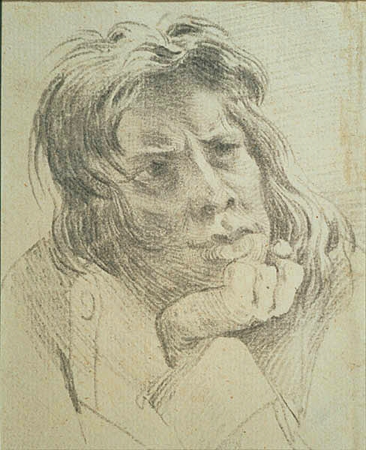
Figure 2.0. Sjalvportratt (self-portrait) Elias Martin, NMS

2.1 Introduction
This chapter will address Martin’s first two years in London, which remain a crucial period of his artistic development. To attain greater understanding of how Martin’s career developed in London it’s been necessary to consider numerous professional and private networks he established, in particular the architect Sir William Chambers. An overview of his early training as an artist in London has been outlined in Appendix II. Prior to the establishment of the Royal Academy, a number of artistic societies were established to promote the work of the English craftsmen, across a number of different disciplines. This chapter also includes how the formation of the Royal Academy changed the artistic landscape in London, allowing it to grow and diverge into a much broader movement. I have detailed the procedure for election, because following the literature review it was apparent that no one to date has explained the procedure fully. Since Martin needed to obtain votes from the Royal Academicians (RA) to be elected Associate of the Royal Academy (ARA), it would have helped his cause to have Chambers as a friend to gather support from his fellow academicians (figure 2.1).

Religion had always played an important role in Martin’s life. The Swedish church in London was formed to support the ever-increasing number of Swedish émigrés coming to London. It is therefore important to discuss why so many of the Swedish Circle did not attend the church on a regular basis; it seems that it was a church to visit while one was in London, but not to make it the church of choice for their regular religious needs. The archives currently held at the church confirmed the some members of the Swedish Circle took communion; the fact that Martin did not is, I feel, as important as if he did. It has been important to examine this because while it would have been a good source of networking to advance his career, there is no evidence that links Martin to the Swedish Church in London. A number of articles and a book have made the assumption that he worshipped there, based purely on the fact that he was Swedish and in London. I feel that it is important to clarify this issue, to establish how important the Swedish Church in London’s role remained, in supporting the Swedish emigrés in the late eighteenth century, bearing in mind the church was in the East End, and people they aimed to support had migrated to central London.
It is important to examine Martin’s family life, as it provides an insight into his early career in London, taken from numerous accounts and sources. This section intends to build up a picture of his life in London through his marriage, religious connections, and social mobility to advance his professional career. His marriage in 1770 and his move to Dean Street, his first studio, offered him a degree of stability, which then allowed him to implement some of the ideas he had for taking his artistic talent and ambitions in new directions.

2.2 Martin’s Arrival in London and Early Contact with Chambers
Martin arrived in London in 1768, having made contact with Sir William Chambers at Danson House. Though he stayed briefly at a lodging house run by Mrs Pinkly, at the bottom end of Duke Street, near Piccadilly, he soon took up new lodgings with a Miss Laveroche, a milliner of Mill Street, Hanover Square, where it is possible he established his first studio. Martin then soon liaised with other Swedish emigrés, in particular George Haupt, whom he had met in Paris, and Christopher Fuhrlohg (1737–1800), both cabinet-makers working in established workshops in London – though Haupt subsequently left England to return to Sweden in 1769, where he was appointed cabinet-maker to the King of Sweden, Adolphus Frederick (1710 -1771).
Martin maintained his contact with the architect William Chambers (1723–1796), who was renowned for his generosity towards young craftsmen and artists, especially if they came from his native Sweden.

Chambers was the son of a Scottish merchant who traded out of Sweden. He was educated in England and then trained as a merchant with the East India Company, which gave him the opportunity to travel to the Far East. The tedium of the journeys was relieved by learning languages and studying fine art and architecture. Leaving the East India Company in 1749, he went to Paris to study architecture at the Ecole des Beaux Arts. In 1750, Chambers moved to Rome and made a number of friendships with artists such as Piranesi and Wilton, English gentry on their Grand Tour. His contacts in, and experience of, Rome would bear fruit in later years when he returned to London in 1775. Just prior to leaving for London, Chambers met Robert Adam (1728–1792), who said of him that he was: “a prodigy for genius, for sense and good taste”.
Adam was aware that Chambers had accumulated a circle of friends and acquaintances in Italy, which would benefit his practice when he returned to London as it would give him an edge over his rivals. Chambers’s talent did not go unnoticed in London, from his lodgings in Covent Garden, close to Tom’s Coffee House:

This was a convivial meeting place of an artistic, literary and noble coterie that included Johnson, Goldsmith, Paine, Lord Clive and others who soon were to become friends, colleagues and patrons.

He was subsequently commissioned by Frederick, Prince of Wales (1707-1751) to design some of the first hot houses at Kew Gardens. The House of Confucius was designed in the style of a Chinese pagoda. Then latterly, he was appointed as architect to the Ministry of Works. Chambers went on to design a number of key public buildings in London, including York House, Pall Mall, Gower House and, as the summit of his architectural career, Somerset House. Yet, possibly of greater significance for Martin was the fact that when the Royal Academy was founded in 1768, Chambers was appointed treasurer.

It was Chambers who gave Martin the opportunity to come to England by arranging with John Boyd for Martin to travel with the painting that he had ordered, from Paris to England, in 1768. The alliance that developed between Chambers and Martin following their meeting at Danson in 1768 is crucial in understanding the influence that Chambers had on Martin's early career in London. Chambers supported Martin via the projects that he (Chambers) undertook, and encouraged his patrons to also commission work from Martin. This relationship with Chambers would continue with Martin working at Woburn Abbey and most importantly at the newly formed Royal Academy.

2.3 Martin’s Membership of the Royal Academy (1769)
In London during latter half of the 18th century there remained numerous hostilities between leading artists and their respective associations that held back the formation of a National School (the training available to artists and craftsmen in London at this time is detailed in appendix II). A number of prominent artists were keen to promote drawing and painting at this time, but each wanted to do it ‘their way’, following their own idiosyncratic method. As historian Rica Jones points out in his book, ‘Manners & Morals, Hogarth and British Painting’ (1987), William Hogarth (1697-1764), although an enlightened artist in many areas, was reluctant to embrace the idea of a central seat of learning for artists.

Hogarth’s academy was successful, and most of the exhibitors at the 1761 Society of Artists exhibition had been subscribers at some time. It seems to have run smoothly for over ten years, but by 1750 Hogarth’s views on academies were seriously out of step with contemporary thinking.

This situation led to a number of disparate groups or schools being formed. Out of the formation of these groups grew a social side of a more convivial nature: dinners at the Society of Virtuosi of St Luke (patron saint of artists); gatherings at inns such as the ‘Rose and Crown’ and ‘Turks Head Tavern’; and from about 1750, an annual dinner held each 5th November at the Foundling Hospital. So, we can see that within all the rivalry there nevertheless existed a ‘Gentleman’s club atmosphere’, where the politics could be forgotten for a few hours and new ideas could be discussed; it was at one of these dinners that Chambers gained support for yet another art school. After the foundation of the Royal Academy, the artists transferred their allegiance from the Foundling Hospital to the Royal Academy and therefore it ceased to function as a meeting place. Meetings, and the dinner to celebrate the Society of Virtuosi of St Luke (patron saint of artists) on 5th November, were then held at the Royal Academy

Still filled with rage over losing the Presidency of the Society of Artists to Paine, and becoming tired of all the in-fighting, Chambers (who had the ear of George III) proposed to approach the king with a view to forming a new society to promote ‘arts and Design’.
A memorandum was drawn up, signed by twenty-two leading artists of the day and presented to the king on 28th November 1768. The king received it graciously and said; ‘I consider the culture of the arts to be of national concern and that they could depend on his patronage and assistance to carry out their plan’. With this encouragement from the king, Chambers drew up the articles of the Society which ran into twenty-six paragraphs; the key points being that training was to be free and that the sovereign would financially underwrite the new society for the first eleven years until it became self-supporting. The government of the day would be responsible for providing a suitable location for the society’s activities, which in the first instance comprised a building located on the south side of Pall Mall⁵⁸.

The new Royal Academy was to contain a maximum of 40 Academicians (RA), to which a new member could be elected only after the death of an existing member. Royal Academy Associates (ARA), no more than twenty at any one time, were elected, and it became the rule that new Academicians were elected from existing Associates of the Royal Academy. The officers of the Academy included a President of the Royal Academy (PRA), a Council of eight members, a Secretary, Librarian, Keeper and others. Professors in painting, architecture, perspective and anatomy were appointed, soon to be joined by Professors in Sculpture and Chemistry, to support the educational activities of the Academy.

The Academy was divided into Schools and these were set up to teach the different elements without charge to students. They included drawing from life, later painting from old masters, and painting from life. Students of the Academy could win travelling scholarships to pursue their studies abroad. The Academy also gave to artists in need and latterly to the widows and children of artists who had subsequently died, leaving the families with no income. Although Sir William Chambers had been the instigator of the new Royal Academy, it was decided that an eminent painter should be the first President of the body, and Reynolds was chosen. His friend and rival, Gainsborough, interested himself much less in the Academy, and only used it as a place to exhibit his pictures. The establishment of a national school was to have a profound effect on the smaller established art schools. Following the establishment of the Royal Academy, the students from St Martin’s Lane School moved into the Royal Academy.
The ‘Incorporated Society of Artists’, were unwilling to merge with the Royal Academy and therefore set themselves up in rivalry to the Royal Academy. This only lasted three years; by 1772, the Royal Academy was the only major academy of art in London. Politics still played an important role in Royal Academy life; it was ‘who’ you knew rather than ‘what’ you knew, that would help an artist progress within the Royal Academy. In order to enrol at the Royal Academy, Martin would have had to produce a number of drawings and paintings for inspection by the Keeper of the Academy and the council members. Whilst an artist of Martin’s abilities would have passed this entry hurdle with relative ease, having a contact such as Sir William Chambers on the Academy council helped. Martin was admitted into the Academy on 3rd November 1769.

As we can see from the Royal Academy list of students (figure 2.1), within one year Martin was elected an Associate of the Royal Academy (ARA 27th August 1770). Elections took place at the Royal Academy once a year; for Associates of the Royal Academy they were held in August and for Royal Academicians in February. For election to Associate of the Royal Academy status, the name of each student would be read out by the Secretary and the Royal Academicians would vote. The students who obtained a number of votes greater than one third of the number of Academicians (thirteen) would be elected to associate.

A similar process was used to elect Royal Academicians, but this procedure was reliant on the fact that there would only be a limited number of places available with the result that in some years two or three students may be elected, on others only one.
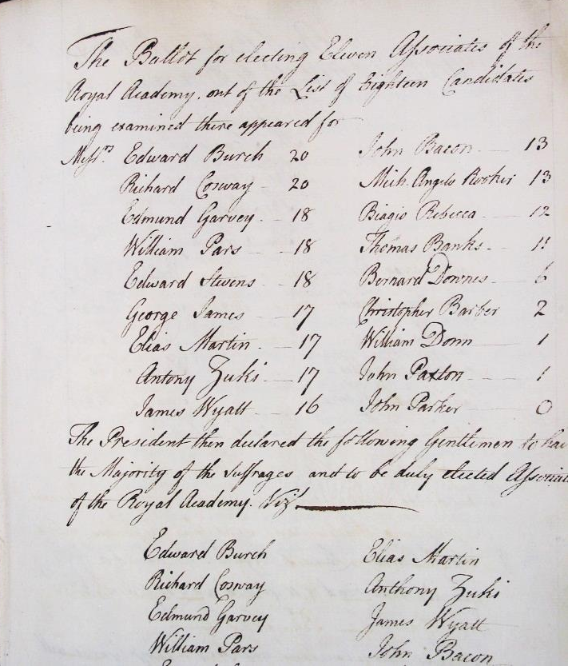
Figure 2.1. The Minutes of General Assembly of the Royal Academy, showing the students who had applied for ARA: 1770

As is evident from the minute’s record, Martin obtained seventeen votes. Those who obtained thirteen votes or more (one third of the forty academicians) were made Associate of the Royal Academy. It is possible that the high number of students progressing to associate of the Royal Academy in the early years was due to the fact that the institution aimed to build the number of Associates to twenty as quickly as possible, or that this early cohort were exceptionally talented students. It could also be suggested that Martin’s acquaintance with Chambers further enhanced his prospects within the academy, with Chambers possibly encouraging his fellow academicians to vote for him.

Martin exhibited at the Royal Academy from 1768 until 1780, and again when he returned briefly to England in 1790 (See Appendix 1). He also continued to exhibit at the Society of Free Artists. In 1772, Martin’s name was put forward for election as a Royal Academician, but he received no votes in the election (figure 2.2).

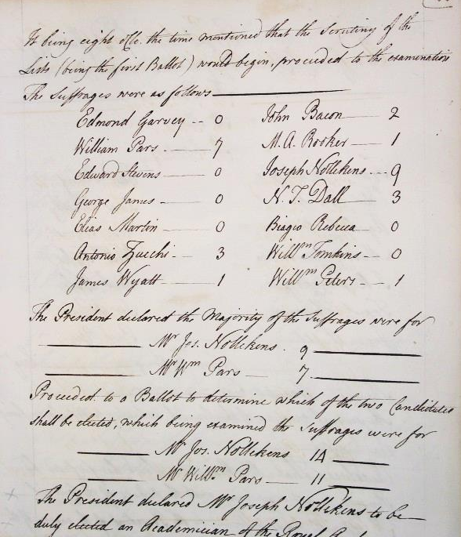
Figure 2.2. The Minutes of the Royal Academy, showing students who applied for election to RA, 1773

This is possibly due to the fact that by 1773 Martin’s and Chambers’ friendship had diminished, so we see, when Martin was put forward for election to become RA in 1773, he received not one vote, not even from his friend Chambers. His name continues to appear in subsequent years, but again he received no votes. He remained an ARA for the remainder of his career, exhibiting every year he was in London (1769-1780 and 1790), and the authorities of the Royal Academy kept him on their books until 1832, unaware that he had died in1818.
The authorities then became the butt of many an art critic’s joke, for not keeping the membership records up to date, such as demonstrated in the following dictionary entry of 1901:

Our Weekly Gossip on Literature and Art
In the way of novelty there is little to be related. A meeting of the Royal Academy is summoned in early February, to elect a member in the room of James Northcote: Newton, Allen, and Briggs are spoken of as the most likely to be put in for nomination. Some members will no doubt vote for Elias Martin: though this veteran has, for many years, it is to believed been in the bosom of St Luke (the patron saint of artists); still he is kept at the head of the list of Associates; and when a person is put up to whom any Academician is averse, he bestows his vote on Martin.

Martin’s acquaintance with Chambers further enhanced his prospects within the academy, and his valuable networks were instrumental in the advancement of his career, certainly up to 1770. This was furthered by Chambers’ involvement in the Swedish Church in London; Chambers and other members of the Swedish Circle did attend the church as it offered a very supportive environment and place of contact for Swedes visiting London.

2.4 The Swedish Church in London
The Swedish community in London grew considerably after the Great Fire of London in 1666; in order to rebuild London they needed to import one of the most important materials, timber. To supply this demand there was a continuous convoy of ships coming from Scandinavia; the timber was shipped from Norway, Denmark and Sweden to Gothenburg, and from Gothenburg to London to their discharging wharves at Tilbury, as the Swedish ships were too large to pass under London Bridge.

The development and scale of the trade was so vast that a seaman’s mission and church was opened in 1710 to offer the Swedish sailors some degree of comfort, spiritual support and a place to remind them of home while staying in the hostile environment of the East End of London. As trade increased, the number of Swedish immigrants also grew; not all were sailors, many tradesmen (carpenters, cobblers, tailors, etc.) decided to ply their trade in London. Many prospered and decided to settle permanently abroad; so, in 1728, in response to this growing community, the church decided to construct a larger building in Prince’s Square, Wapping.

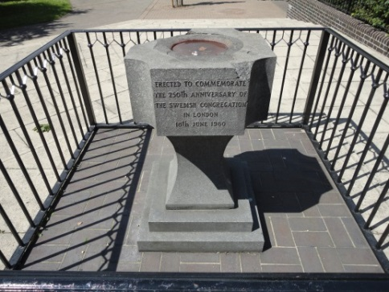 | 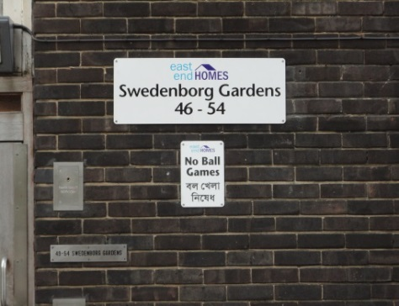
Figure 2.3. The site of the original church In Princess Square, London | Figure 2.4. Streets names are still linked to early Swedish settlers, London E1 8HP

The funds for this project came from a levy that was paid on the tonnage of timber that was being imported into London docks by Swedish ships (6d per tonne of timber landed at the dock side). Despite this regular income, funding was still very tight; donations from the wealthier members of the congregation and from Sweden were still needed to support the work of the church in London.

In 1906 it was again decided to build a new church, upon receiving a number of generous donations from the parishioners and a grant from the Swedish government, which allowed them to purchase their present site in Harcourt Street in Paddington in 1907, and the new Church was consecrated in February 1911.

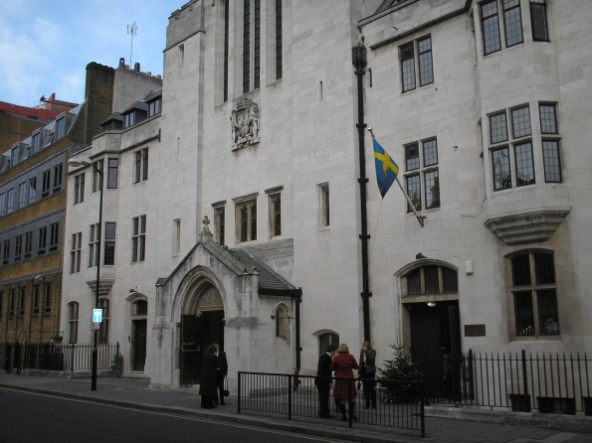
Figure 2.5. The Swedish church in Harcourt Street, London

The Church records reveal surprisingly little reference to the members of the Swedish Circle. The main name, which appears in the council records, is that of Sir William Chambers. This was not in relation to his spiritual needs but as an architect. He was asked to prepare drawings for an extension (Sacristy) to the church in Princess Square. The tendering process for the project was to take the form of an open competition but the vicar, who was overseeing the project, made it perfectly clear to the church council that the contract was to go Chambers, despite his estimate not being necessarily the cheapest. The only other church record that revealed names associated with the ‘Swedish Circle’ was in the book of communion 1748–1816.

The names recorded were:

7th February 1768
Mr Georg [sic] Haupte (Swedish spelling)
7th August1768
Johan Martin (Martin’s brother, possibly on a visit to London to see his brother, as he did not move to London until 1770?)
5th September 1773
Johan Martyn [sic]
3rd April1774
Peter Martin

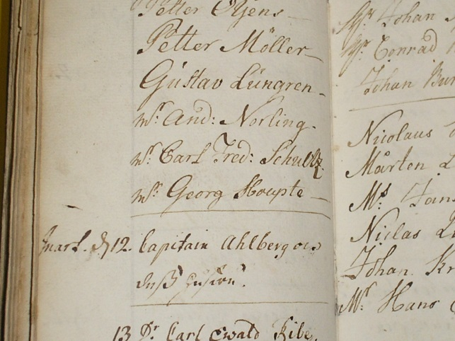
Figure 2.6. The Book of Communion 1748–1816, 7th February 1768, Mr Georg [sic] Haupte

It is interesting to note that Martin’s name does not seem to appear in any of the church records. There is also no record of any examples of his work commissioned for the interior of the church, though the church does possess a number of oil paintings of the various pastors that served there. There are several extant historical illustrations of the original premises in central London and Wapping, but none are by Martin. This is surprising when we consider the lengths to which the council went to associate itself with Sir William Chambers. Thus, it would seem reasonable to suggest that they may have welcomed a promising young Swedish artist such as Martin. However, it is also possible that Martin’s religious views did not meet with the church’s approval; more likely though is the distance of the church from central London, which meant that it was more convenient for Martin to attend a local church there.

The Swedish Church in London is a good example of how members of a specific community come together to support each other. Originally conceived to support Swedish sailors in the London docks, the church grew to supporting a broader spectrum of Swedish emigrés who came to London. While it seems Martin did not attend the church, certainly on a regular basis, other members of the Swedish Circle did, but its location on the outskirts of a growing capital meant that it was becoming marginalised. The church’s move to a more central location in 1907 was, in part, to continue to support the Swedish community that had moved to the more central areas of London.

2.5 Family Life, Marriage, Children and New Markets
By late 1770, Martin’s prominence and status in London society had developed to the extent that he was able to move westward to the more affluent districts, renting premises in Dean Street, Soho, and an area that attracted a number of Swedish and French immigrants of various professions.

He also met and married Augusta Lee (daughter of lead founder Robert Lee) at St Matthew’s Church, Bethnal Green, London. The church records inform us that the marriage took place on the 31st July 1770; Martin was registered in the ‘Parish of Saint Mary Le Bone’. Robert Lee, Augusta’s father, consented to the marriage as Augusta was classed as a minor, being only seventeen years of age at the time of the marriage. The marriage took place under a licence rather than having the banns read in each respective church, which would seem to indicate that the wedding was arranged in a hurry. There is no evidence to indicate that Augusta was pregnant at the time of the wedding, which would have been one of the main reasons for a hasty marriage, as having an illegitimate child would have attracted social stigma in the late eighteenth century.

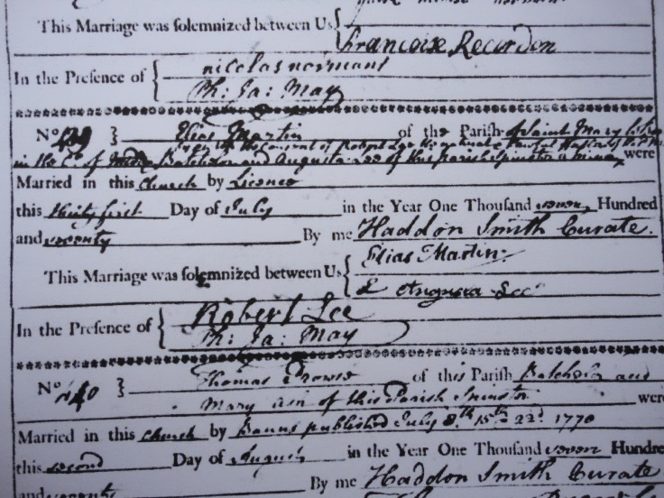
Figure 2.7. Copy of Elias Martin’s marriage certificate

In the years that followed (1771-1777) Elias and Augusta had five children, all of whom were baptised at St Anne’s Church, Dean Street, Soho:

Born | August 1771 | Baptised
Aug 12th | Augusta Elizabeth Martin of Elias & Augusta | 19th August
 | October 1772
Aug 27th | Gustavus Martin of Elias & Augusta | 2nd October
 | March 1775
Feb 19th | Fredrick Erick Martin of Elias & Augusta | 17th March
 | February 1776
Feb 12th | Sophia Mathilda Martin of Elias & Augusta | 13th Feb
 | May 1777
May 5th | Elias Christopher Martin of Elias & Augusta | 8th May

From these records we see Martin’s growing association with a local church, St Anne’s Church Soho, extending to the baptism of his children, which took place there and not at the Church of Sweden in the East End of London.

It is reasonable to deduce from these two events (Elias’s marriage and move to Dean Street) that Elias’s financial situation had improved considerably. He not only moved closer to the artistic quarter (Leicester Fields) but also within the cabinet-making area, as the West End was the centre of the ‘high end’ cabinet-making areas, in Oxford Street and Tottenham Court Road.

The premises were far larger than he required for living and a studio, so he may have planned to sublet some of the space to other artisans/craftsmen. This new-found wealth and the marriage to Augusta may not be coincidental. Augusta’s father, Robert Lee, although not a wealthy man, would have made a comfortable living as a lead founder and as we can see from the marriage certificate he supported the marriage between Elias and his daughter. It is possible that a dowry would have accompanied the marriage, which would have allowed Elias and his young wife to move up in society. It seems that Robert Lee’s fortunes continued to improve, as at his death in 1784 he was recorded as living in St Martin-in-the-Fields. It may also suggest that Martin shared affinities with the religious beliefs of his wife and more importantly her family, which is why we see his preference for marriage and the christening of his children in this denomination rather than in the Swedish Church.

The first person to move into Dean Street was his brother, Johan Fredrick Martin, who was invited to London by Elias Martin to train as an engraver in 1770. The London print market was at its height during this period, not only in the selling of prints but in their engraving and publishing. Martin saw a market for selling art to the middling-classes in the form of prints of current topics of the day and also his own works, which were to be engraved by Elias and Johan, printed in London and then sold directly from his Dean Street studio.

The artist David Martin also shared Martin’s Dean Street studio, as can be seen from the entries from the Royal Academy summer exhibition catalogues; ‘the studio of Elias Martin, Dean Street’. This would seem to indicate that David Martin was sharing or leasing space in Elias Martin’s studio at 62 Dean Street.

2.6 Summary
These early years of Martin’s time in London were the most influential and productive, the support that he received from Chambers at Danson, being part of the first cohort of students to join the Royal Academy, gave him the confidence to instigate some of the new ideas that he had been harbouring. Bringing Johan Fredrick Martin to London, marrying Augusta Lee and then moving into his Dean Street studio were pivotal in developing his career. He also started to expand his circle of friends and acquaintances, through letting space in his studio and exhibiting his work in exhibitions at the Royal Academy, the Society of Artists of Great Britain and the Free Society Artists (see appendices IV & V). Having joined the Royal Academy, he should in theory have ceased exhibiting at the Society of Artists of Great Britain and the Free Society Artists, as he was only permitted to exhibit at the Royal Academy. Martin seemed to have ignored this restriction. This again demonstrates how single minded Martin could be.

Having settled in the Dean Street area, he did not feel the need to travel across London to attend The Swedish Church in London, in the East End. He was content to fulfil his religious obligations in a local church. One possible reason for wanting to move to the Soho area, was that from 1700 there was large-scale migration from France, into this part of London, and having spent two years in France, Martin would have felt comfortable in this environment and there would have been a number of protestant churches in which to worship. His association with Sir William Chambers was also on the wane, and he was now establishing himself in his own right, developing his own ideas and taking his artistic development forward.

Chapter 3:
Fellowship, Integrity and Good Citizenship

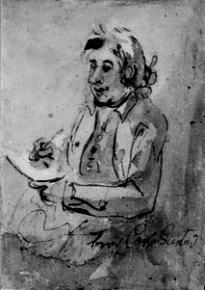
Figure 3.0. Bror Carl Gustaf, Elias Martin’s Brother, Elias Martin, NMS

3.1 Introduction
Family relationships (like uncles and good parents), and the mediation of friends such as business or social associates of one’s father, were an obvious link between master and apprentice.

This chapter will further develop and investigate the network of relations that held the ‘Swedish Circle’ together and Martin’s distinctive contribution to its extending sphere of influence. It argues that it was Martin’s involvement with a Swedish network of craftsmen and artists that would enable him to evolve and promote his identity as an artist. It also examines the activities of the Swedish Circle and unknown insights into the fluid and hybrid interrelations of both patron-client relations and art and craft practices in late eighteenth-century Britain; a model which the Swedish Circle would shape significantly.

Previous chapters have considered the relationships between some of the members of the ‘Swedish Circle’ (figure 1.3). In order to try to draw some of these relationships together it seems crucial to look in depth at how these relationships worked, and to illustrate the ways in which working as part of a group could be mutually beneficial. The first area to be considered in this chapter is family relationships; this has been touched upon briefly, but I will explore this in greater depth.

I will explain the importance of the working relationships that developed across a number of disciplines, which enabled many craftsmen and artists to interact with each other to their mutual benefit. The focus will be on members of the Swedish Circle and some who were outside the close circle of friends, but who were members of other societies that promoted friendship – such as the church. Religion grew in proportion to the expansion of London; the increase in population required places of worship, and this led to the building of many new churches.

While churches gave spiritual support to their parishioners, they also had responsibilities to offer poor relief to those less fortunate who were also living in London. It is through this charity arm of the church that we see patrons of the Swedish Circle donating to good causes, confirming that many of their members were committed Christians. Church communities grew throughout the eighteenth century in London, in particular central London, as a housing boom expanded development across what we now call the west end.

Figure 3.1. Diagram of the Swedish Circle

Another society that grew throughout the eighteenth century was the Brotherhood of Masons. The masonic order is often looked upon with some suspicion as being a secret society, which like many other societies is seen to look after its own members. The use of the phrase ‘Fellowship, Integrity and Good Citizenship’ as the title for this chapter reinforces the idea that in many ways the ideals of freemasonry were very similar to those of the Swedish Circle. This Brotherhood would not have passed unnoticed by Martin, as other members of the Swedish Circle participated at various lodges in London. More importantly his father-in-law to be, Robert Lee, was an active member.
The three elements of family, church and freemasonry offer a supportive environment in which to foster and grow relationships. They are the foundation for any thriving community, and Martin’s participation in, and association with, these groups aided both his family and professional advancement.

3.2 Family Relationships (Elias Martin, his Brothers Johan and Carl)
The Swedish Circle comprised a close-knit group linked by blood ties, business relations and nationality. It has been documented in a number of sources that Elias Martin was the nephew of George Haupt, and there is further evidence to confirm this in the records of the Church of Jesus Christ of the Latter Day Saints.
The maiden name of Elias’s mother, Ulrica Martin, was Haupt and she was the daughter of the cabinet-maker Elias Haupt (1679–1744), who was also the father of George Haupt figure 2.3. George Haupt became brother-in-law to Christopher Fuhrlohg (1737-1800), following Fuhrlohg’s marriage to George’s sister in 1762. Christian Linning (1744-1779) was step-brother to Christopher Fuhrlohg. Christian Linning employed Fuhrlohg after he had left Linnell’s workshop before setting up his own workshop in Tottenham Court Road; he (Fuhrlohg) also employed Carl Gustaf Martin, the younger brother of Elias. From this it can be seen that within the cabinet-making fraternity, and in this coterie of Swedish cabinet-makers, there developed a very close-knit community, where marrying within the profession was not uncommon. This had two main advantages; the first is that through close working relations, individuals within this community were able to share ideas and possibly pass on commissions during productive periods as well as in tougher times.

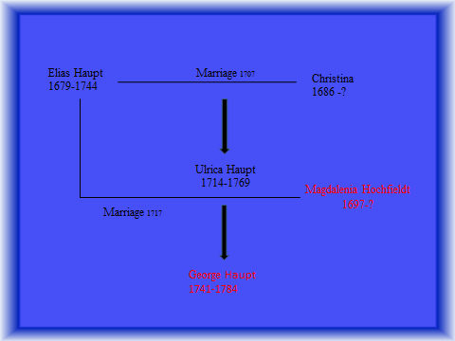
Figure 3.2. Diagram of Haupt family tree, Ulrica Haupt, Elias’s mother, was from the first marriage. George, Ulricia’s half brother, was from the second marriage

The second advantage was that the Swedish circle may have operated in ways similar to a traditional French guild system, where marrying into a cabinet-making family or workshop allowed movement up the social or guild scale. Further, it may have improved an individual’s customer base, while at the same time avoiding some of the restrictive practices that the guilds imposed.

The example below shows the structure and functioning of this more restrictive French model, illustrating the routes through which the French ebeniste Roger Vandercruse, and his family developed into an important Parisian section of the ebeniste (cabinet-making) community:

Roger Vandercruse; R.V.L.C. (1728–99, master, 1749)

Born in 1728, son of an independent artisan-ebeniste in the Faubourg Saint Antoine, Roger Vandercruse belonged to the most important dynasty of ebenistes of the eighteenth century. Of his five sisters, three married ebenistes; Francoise-Marguerite married first Jean Francis Oeben, and then Jean Henri Riesener. Marie-Marguerite married Simon Oeben, and Anne married Simon Guillaume. In 1750, Roger Vandercruse married the daughter of ebeniste Jean Progain; their son Pierre Roger followed in his father’s profession and became a master in 1772, while their daughter married ebeniste Pierre Lavasseur, son of Etienne Lavasseur. Finally, through his wife, Roger Vandercruse was related to the ebenistes Pierre Pioniez and Jean Marchand, both of them being her brothers-in-law. So, we can see from these two examples how important these relationships were, at family level, in helping to facilitate a successful business and create commercial opportunities.

During Martin’s two year stay in Paris, he would have seen how the French Guild system was in some respects restrictive, but in others it supported the family group. Their support for the family business often appeared to outweigh the many restrictions imposed by the guilds. But, while this system was very well established in Europe, by the end of the eighteenth century the Guilds of the City of London were losing their tight control over the crafts in England.

3.3 The Swedish Circle: Working Relationships
The wider operations of the Swedish Circle extended to Angelica Kauffman and to her relationship with the Royal Academy. Angelica Kauffman (1741-1807), was one of the few acclaimed female artists of the eighteenth century. Kauffman arrived in London in 1766 and by 1768 was one of the founding members of the Royal Academy, contemporary with Martin’s training and of significance for this thesis, during the period when Sir William Chambers was Treasurer. Apart from being an accomplished artist, Kauffman also produced designs for marquetry, which were to be commissioned for and reproduced on furniture by Christopher Fuhrlohg.

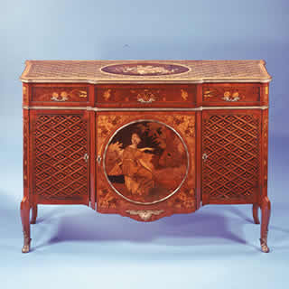
Figure 3.3. Commode by Christopher Fuhrlohg, central marquetry medallion design in the style of Angelica Kauffman, 1772, Lady Lever Art Gallery,

Sir William Chambers remained at the centre of the Swedish Circle, and provides the final link in the chain via his on-going friendship with the French painter Alexander Roslin, whose atelier Martin worked in when he first arrived in Paris in 1766. There were also a number of people who were on the fringes of the circle. They included David Martin (1737–1797), the Scottish artist and pupil of the painter Allan Ramsay, whom he accompanied on his Grand Tour between 1756–57. He was in London by 1759, as a student at the Academy of St Martin’s Lane, winning awards for drawing classes in 1759, 1761 and 1770. On completion of his training, he was again employed in the workshop of Ramsay before moving to his own studio in 1770.

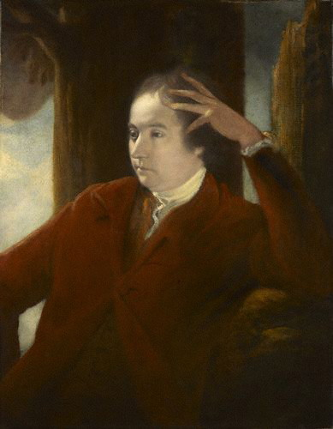
Figure 3.4. Sir William Chambers by Sir Joshue Reynolds, circa 1753, NPG

In 1771, David Martin married Anne Hill; the wedding announcement in ‘Bingley’s Journal’ states his address as Dean Street, Soho. Indeed, the Westminster rate books confirm that the Soho area of London was a popular quarter for artists, but his name does not appear as a ratepayer. If we look at the lists of exhibitors for the Free Society of Artists and the Royal Academy we see that the address he listed is ‘the studio of Elias Martin, Dean Street’.

This would seem to indicate that David Martin was sharing or leasing space in Elias Martin’s studio at 62 Dean Street. David Martin continued to play an active role in the Free Society of Artists, becoming their Treasurer and then Vice-President of the Society between 1772 and 1777; he also exhibited at the Royal Academy in 1779 and 1790.

Further confirmation of his studio in Dean Street is given by an advertisement in the St James Chronicle, on Saturday 6th August 1774, in which it states that the Free Society of Artists wish to let their premises in the Strand: “particulars to be had of David Martin Esq, Dean Street, Soho”. Later that year the Society moved to new premises in John Adam Street. In 1780 David Martin returned to his native Scotland, and was appointed principal painter to the Prince of Wales on the 8th January 1785.

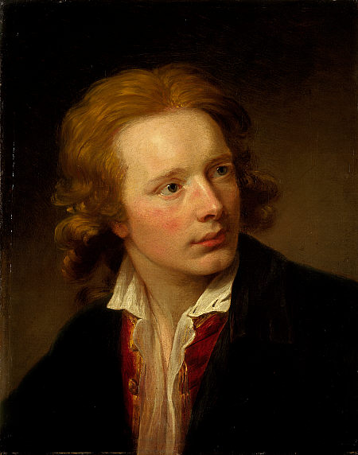
Fig 3.5. David Martin, Self-portrait, circa 1760, National Gallery of Scotland

The other person who contributed to the Swedish Circle was Samuel Martin (1751–1822), the youngest of Elias Martin’s three brothers. It seems plausible that if Martin’s other two brothers, Carl Gustaf (1746–1788) and Johan Fredric (1755–1816), had travelled to London to work, it would not be unreasonable at this stage to presume that Samuel Martin would have been drawn to London.

Recorded in Sir Ambrose Heal, London Furniture Makers, 1660–1840, is mention of a Samuel Martin, upholder, who had workshops, first in Bucklersbury Lane and then in Walbrook; both in the City of London. If Samuel had undertaken a five-year apprenticeship at the age of fourteen, then at nineteen undertaken two years as a journeyman, after which he came to London aged twenty one, he would have arrived in London around 1772. Samuel Martin is recorded in his first workshop in 1774, so he may have worked with Elias, or one of the other members of the Swedish Circle, before setting up his own workshop.

3.4 Societies; Church and Freemasonry
In the latter years of the seventeenth century, London became increasingly prosperous, which resulted in a rapid growth of population. New and elegant suburbs began to cover the open country to the west and east. There was soon a need for the re-adjustment of Parish boundaries and for new places of worship.

 | 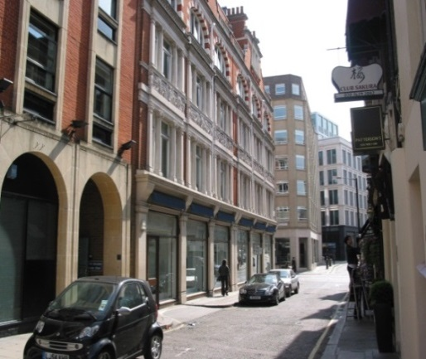
Figure 3.6. Mill Street situated at the bottom of Hanover square, behind St George’s Church. 1799 | Figure 3.7. Mill Street today.

To this end, in May 1711, Parliament passed an Act for the erection of fifty new churches in and about the Cities of London and Westminster, of which St George’s was one.

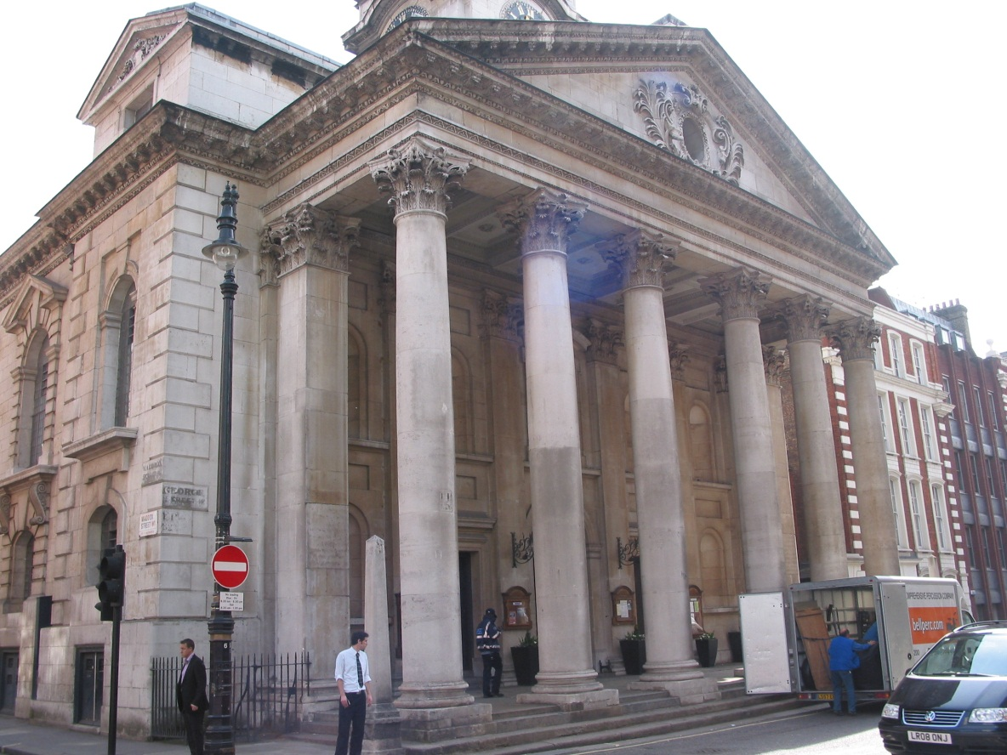
Figure 3.8. St George’s Church with its impressive Palladian frontage. The church was built between 1721-5, by John James, one of Sir Christopher Wren's assistants

Within this development of London, Hanover Square was no exception. An entry from the Weekly Medley of 1717 states that:

A magnificent city seems to have grown out of the ground, it is said to be called Hanover Square. The chief persons that we hear that are to inhabit that place when finished, bought houses, are these following: - The Lord Cadogan, a general, also General Carpender, General Wills, General Evans and General Pepper. It therefore appears that the first tenants comprised of mostly military order.

The popularity of the square as a centre for new fashions and tastes continued and by 1771, a number of leading figures of the day had moved in; ‘The Square’, though so aristocratic, has not appeared to be looked after. John Strype, writing in the ‘Critical Observations on the Building and Improvements of London’, states:

I do not know what to make of it, it is neither open nor closed. Every convenience is railed out and every nuisance is railed in, carriages have an ill-paved street to turn round and in the middle has the air of a cow-yard.

Figure 3.9. Hanover Square, hand-coloured etching (anonymous?), published by Robert Pollard, London, 1787

This observation is confirmed by Martin, who painted a view of Hanover Square in 1769, looking north to south; the viewer seems to be looking down George Street with St George’s Church on the left of the picture. People are seen promenading around the square bemused by the fact that there are animals grazing in the middle. This painting was exhibited at the Royal Academy in 1770.

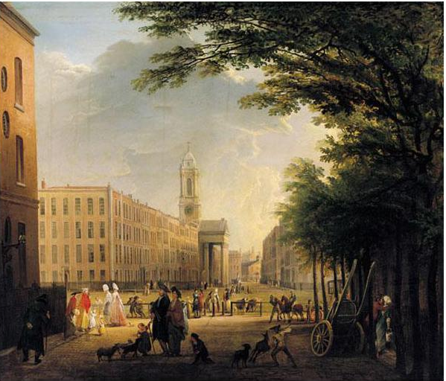
Figure 3.10. View of Hanover Square from the North, looking South, Elias Martin, 1769, private collection

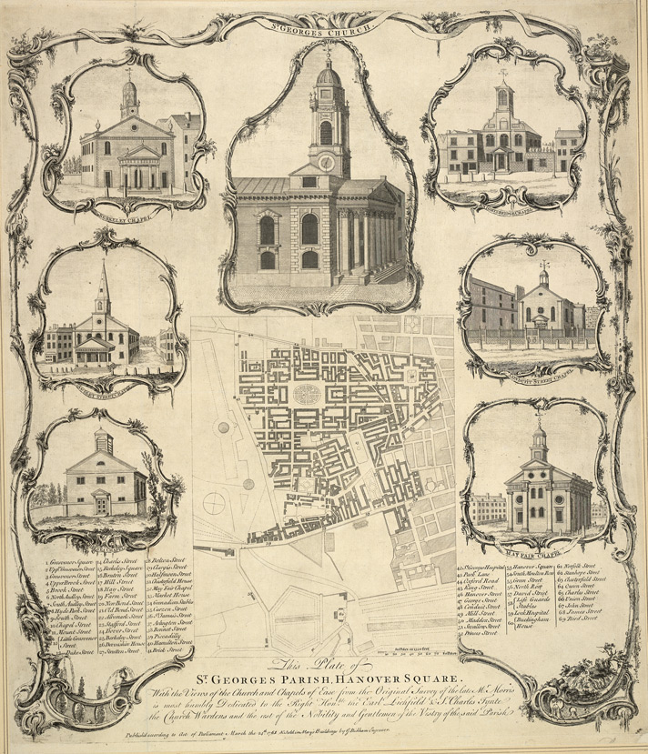

Figure 3.11. Engraving, St George’s Parish, J Bickham 1762

Such was the area, over which the new Select Vestry had powers of administration, that there were a hundred and one Vestrymen. Among them were seven Dukes, fourteen Earls, seven Barons, and twenty-six other persons of title. They were responsible not only for the church's affairs, but also for the civil government of the parish; and the Vestry Minute books are a rich mixture of the ecclesiastical and the secular. Much time was spent on street lighting, highways maintenance, refuse disposal, the appointment of constables and night watchmen, and the levying of rates to pay for these services.
There was also the supervision of the Workhouse in Mount Street, situated on the edge of the Parish Burial Ground. The Vestry assumed almost the status of a municipal corporation, and was presided over by the Rector and Churchwardens.

Although, in the eighteenth century, there were seven proprietary Chapels within half a mile of St. George's, all well attended, there was little social conscience for the small streets and lanes behind the fine houses. Poverty, overcrowding, drunkenness and disease were rife; the infant mortality rate was alarming. Between 1750 and 1755, of 288 children born in or received into the Workhouse, 137 died. It would not be until the beginning of the nineteenth century, under the influence of the Evangelical Movement, that church congregations began to feel greater concern for the condition of the poor.

Having a workhouse within the parish of St George’s indicates a level of compassion for the poor by the church; the church was to mount a number of appeals, which attempted to raise funds for the poor within the parish. The appeals took the form of an advertisement posted in one of the many newspapers that became popular at the end of the eighteenth century. It can be seen from an appeal, published in February 1776 by St George’s church, that there were a number of members from the ‘Swedish Circle’ who were involved with these appeals.

St George’s, Hanover Square, Jan 30, 1776

A subscription is opened for the diftreffed poor in this inciement [sic] feafon, who are refident in the faid parifh, under the infpection of the right honourable and honourable &c. The Governors and Directors of the poor of the faid parifh.

Subfcriptions are received at Meff Chambers, Hircy and Birch, bankers in New Bond Street, where the lift if Governors and Subfcribers may be feen.

To prevent the tumultuous meetings of the poor at the place of relief, it is ordered that all the poor perfons applying for charity do firft leave in writing at the workhouse in Mount Street, their name, numbers in their families and the place of an abode, when proper enquires have been made, if they fhould be found real objects, the relief neceffary for their refpective diftreffes will be delivered to them at their own habitations.

There then follows a list of 180 subscribers, I will only list those relevant to the Swedish Circle:

John Linnell, cabinet-maker, with workshops in Berkeley Square, George Haupt worked in his workshop in 1767-8. Also is connected to Sir William Chambers with the work that he undertook for Osterley Park.
Duchess of Bridgewater, had estates close to Duke and Duchess of Bedford in Hertfordshire. Sir William Chambers used stone from the Bridgewater estate to build a new bridge at Woburn in 1770.
John Langlois, cabinet-maker, with workshops in Tottenham Court Road.

We can see from this example that the church played an important role in bringing members of the community together. The church and its congregation would have been a good source of networking for the members of the ‘Swedish Circle’ as well as affluent members of society, who possessed both town houses and country seats.

A key link is the workshop of John Linnell and the London residence of Sir Francis Dashwood (1708-81); Linnell’s house and workshop was on the north side of Berkeley Square (just to the West of St Georges’s) and Sir Francis Dashwood’s London residence was next door. In 1761 Robert Adam was commissioned by Robert Child to submit designs for the refurbishment of Osterley Park, which seems to have undergone continuous refurbishment since the 1720s.

The recommendation of Adam as a suitable architect probably came from Sir Francis Dashwood, who had also commissioned Adam to refurbish his London residence in Berkeley Square as well as West Wycombe Park. The Dashwoods, like the Childs, were a prominent family of Aldermen and Lord Mayors of the City of London.

Adam’s workload at that point in time was such that he was subcontracting some of the smaller design aspects to others, notably Wilton, Chambers and John Linnell. The relationship between these three possibly needs further exploration, as it is highly unlikely that Adam would have liaised with a rival architect such as Chambers. However, it seems that both Wilton and Linnell undertook work at Osterley, to Chambers’s designs, and Linnell also produced a number of pieces of furniture for Osterley. Wilton had become a good friend of Chambers from the time when they undertook a ‘Grand Tour’ to Rome together. Wilton carved at least two marble fireplaces for Osterley, there is a drawing for one in the collection of the Sir John Soane’s Museum, which despite having Wilton’s signature on, is believed by experts to have been drawn by Chambers. The inference here is that Wilton commissioned Chambers to undertake the design for the fireplaces for Osterley, on the understanding that Adam would think that it was Wilton’s design, knowing that Adam would possibly not have had a rival architect working on the same project.

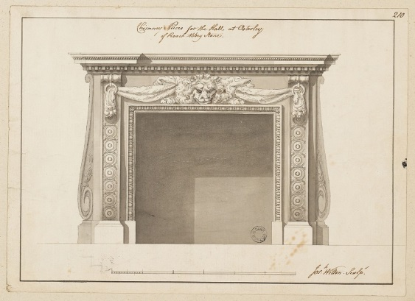
Figure 3.12. Fireplace designed for Osterley Park, signed Wilton, drawn by Chambers.
The issue of signatures on drawings has, at times, perplexed drawing experts; it makes perfect sense to assume that the signature that appears on the drawing has been put there by the architect or draughtsman who undertook the drawing, as many of these drawings would have been commissioned by either a client or manufacturer. However, today, an architect would require the client to ‘sign off’ a drawing to indicate that the drawing has been approved. It has been suggested that this practice was as common in the late eighteenth century, as it is today, so what we might be seeing in (figure 3.12), is Wilton ‘signing off’ the design for the fireplace from Chambers and indicating to his workshop that it is to be installed in the hall at Osterley and made from Roach Abbey stone

3.5 The Freemasons
Freemasonry continued to grow during the eighteenth century; it is not a religion, though many Christian ideas and ideals are incorporated into the Mason’s philosophy. It is what Masons term a fraternal order, whose basic tenets are brotherly love and relief. Brotherly love requires that the Masons be tolerant, respectful, kind and understanding. Relief refers to the active practice of charity and commitment to other forms of philanthropy and truth. The essential qualification all Masons must share is a belief of a single being. Membership, therefore, is open to all people of any race or religion who can fulfil this qualification and are of “good character and repute”. The origins of Freemasonry date back to ancient Egypt and Biblical Israel, but for the purpose of this thesis we will be looking at its development in London during the eighteenth century – and to how Martin and other members of the Swedish circle engaged with this fraternal order. For an overview of the formation of the Masons, see appendix III.

Christopher Fuhrlohg was registered at the ‘Lodge of Fortitude’ Lodge No 6 (now Lodge No 12) London. He was made a member on the 7th April 1773, when his registered address was Tottenham Court Road. The Lodge of Fortitude met in the ‘Roe Buck’ in Oxford Street from 1769 until 1793. To date, no other members of the Swedish Circle have been located at this lodge; the records show a good cross section of society attending this lodge from the baker, Richard Hodgson, to Isaac Richard-Robert, gent (of independent means).
From 1765–1770, there were four upholders (upholsterers), two cabinet-makers and two carvers enrolled in the lodge.

John Linnell is registered at Summerset House Lodge; Lodge No 2 (now Lodge No 4), London. He was made a mason on the 22nd January 1776, when his registered address was in Berkeley Square. The Summerset House Lodge met at the Adelphi Tavern Strand from 1775 until 1778, when it moved to the Freemasons Tavern; subsequently this became the Freemasons Hall, Great Queens Street, in 1865.

An extensive search of the records, which are kept at the United Grand Lodge, was both enlightening and disappointing. The main aim of the search was to try to discover if any other members of the Swedish Circle were masons; to date the only people that have been located were Christopher Fuhrlohg and John Linnell. Elias’s father-in-law Robert Lee was a mason. Lee was first recorded in the Old Horn Lodge, which held meetings at the Turks Head, Gerrard Street, Soho, Lodge No 2 (now Lodge No 4). When this lodge was united with the new Somerset House Lodge in 1774, he continued to meet with them until September 1777, when he then moved to the Lodge of Fortitude, Lodge No 6, (now Lodge No 12). Lee stayed at the Lodge of Fortitude, until at least 1780, though no record of attendance has been found to date after 1780. He died in 1785, aged 63, leaving his residual estate to his daughter, Augusta Martin. It is interesting to note that John Linnell arrived in 1776 and that Robert Lee left in 1777; at this time Martin had his studio in Leicester Fields and was moving from number eight to number one.

Whilst one or two artists are to be found in the Freemasons’ records, compared to other professions their proportion is quite small. The lodge that seems to have attracted the most artists was the Lodge of the Nine Muses, Lodge No 502 (now Lodge No 235). From 1777, they met at the Thatched House Tavern, in St James’s Street, moving to The Free Masons Tavern in Great Queen’s Street in 1821; this then became Freemason’s Hall in 1873. Four members of the lodge were Royal Academicians; G Capriani (joined in 1777), I Bartolozzi (joined in 1777), Agostino Carlini (joined in 1778) and Johan Zoffany (joined in 1780), and all were original members of the Royal Academy in 1768, when Martin was there, but joined the Masons towards the end of Martin’s stay in London.
I Bartolozzi (1728–1815), engraver, born in Florence in 1728, started his training as an engraver with his father (Gaetano) who was a goldsmith. At the age of 15, he entered the Florentine Academy of Art, where he met his lifelong friend Giovanni Battista Cipriani. Following five years of study, he moved to Venice in 1748. His next move was to Rome in 1762, where he worked for the Piranesi. It was in Rome that he was introduced to British engraver Robert Strange, who was in Rome accompanied by Richard Dalton, art dealer and librarian to George III.
Dalton immediately engaged Bartolozzi on an annual salary of £300 per year, and further tempted him to come to London, on the promise that he would be appointed engraver to the king.

Bartolozzi arrived in London in 1764, where he was to remain for the next thirty-five years. He was employed by Dalton and began engraving commissions for the best collectors and artists of the time; the Earl of Bute, George III, his great friend Cipriani, Reynolds, and Kauffman. His connection with the Swedish Circle is that in 1770, Johan Fredrick Martin came to London and became one of Bartolozzi pupils. Bartolozzi taught Johan the art of stipple engraving. The recommendation to send Johan Fredrick Martin to Bartolozzi came from Sir William Chambers, who had used Bartolozzi from 1769; at the Christie’s sale on the 6th June 1811, following Chambers’ death, seven prints by Bartolozzi were sold.

Through correspondence with Dr Andreas Onnerfors, from the University of Leiden, it has been established that Elias Martin joined the Swedish Lodge of St Andrews (Scottish Lodge “Glindrande Stiernan” Shining Star) on 15th December 1779.

Entry in the Swedish General Membership Record.

2373-/466 Martin, Elias. Professor. Obekant GST No 1779
120 15/12

Despite establishing Martin’s connection to the Swedish Masons, I could not locate his connection with the London Freemasons. Yet he joined the Swedish equivalent of the masons as soon as he returned to Sweden, which would seem to indicate that he felt that there were benefits to being a member of this society. Johan Fredrick Martin also joined the Swedish Freemasons upon his return to Sweden.

The Swedish system for lodge membership is different from the English system. The English system is open to any person who is willing to embrace Christian ideas, and it was many of these ideas that were incorporated into the Freemasons’ philosophy.
The Swedish system, which is also used throughout Scandinavia and Europe, is based upon the old mediaeval guild system of four levels:

St John’s degrees
1. Entered apprentice
2. Fellow craft
3. Master masons
St Andrew’s degrees
4. and 5. Apprentice and Companion of St Andrew (one degree)
6. Master of St Andrew
Chapter degrees
7. Very illustrious brother, Knight of the East
8. Most illustrious brother, Knight of the West
9. Enlightened Brother of St John’s Lodge
10. Very Enlightened Brother of St Andrew’s Lodge
Grand council honorary degree
11. Most Enlightened Brother, Knight Commander of the Red
Cross

The entry level into the Swedish lodge system was dependent on the academic status of candidates and their knowledge of, and commitment to, freemasonry. Records show that Elias was adopted as a St Andrew’s Master (degree 6), as a professor, due to his being an Associate of the Royal Academy. Progression to a high level was possible if the Masons’ philosophy was practised, a more responsible role within the lodge was conducted and academic progress was evident.
The most important element of being a mason, under the Swedish system, was that individuals were committed Christians.

3.6 Summary
This chapter has looked in greater depth at the ways in which family, friendships, business relationships and societies such as the Royal Academy, the church and the freemasons, played such an important role in the networking of the Swedish Circle.
The family played the most important role in developing opportunities to better oneself and Martin was quick to develop this by bringing members of his family to England, renting studio space which was larger than he required and subletting it, extending the hand of friendship to other artists. He was, in a small way, emulating Gustaf Philip Creutz, the French ambassador, and Chambers, helping others to get a foothold in London. He was also embracing the ideals of the French guild system which gave distinct advantages to the family run business.

The church and the freemasons were institutions that Martin participated in. We know that he had strong religion convictions and had all his children baptised at his local Church of St Anne’s, Soho. The issue of the Martins’ role in the Freemasons is still unresolved, in that to date no records of him joining a lodge in London have been found. We know that as soon as he returned to Stockholm he joined the Scottish Lodge “Glindrande Stiernan” Shining Star; this would seem to indicate that he had some contact with freemasonry in London. As no records of membership have been found, he could have attended meetings as a guest of his father-in-law, who was a freemason. While Robert Lee may be first choice as he is family, he could have also attended Freemason meetings as a guest of Fuhrlohg, or Linnell. By working together it gave members of the Swedish Circle a much stronger alliance, which would have enabled them to collaborate on projects, sharing their skill sets among the group.

Chapter Four:
Sir William Chambers & The Swedish Circle - An Exploration of Four of Martin’s Projects

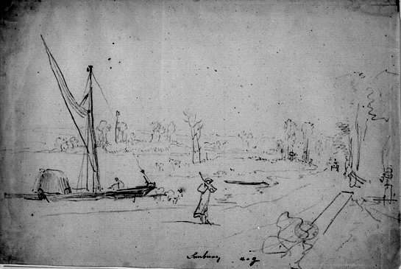
Figure 4.0. Sunbury, View of the Thames from the foreshore at Sunbury,
Elias Martin, (1768-80)

4.1 Introduction
He was, furthermore, an architect first, and an interior designer when necessary.

Earlier chapters have touched upon William Chambers’ relationship with Martin’s developing career within influential London circles of artists and patrons. This chapter explores the developed alliance between Chambers and Martin following their meeting at Danson in 1768. It is crucial to understand the influence that Chambers had on Martin's early career in London, establishing the support he gave to Martin via the projects that he (Chambers) undertook, and encouraging his patrons to also commission work from Martin.

It provides four case studies which offer an insight into the various projects that Martin was directly associated with. The four studies span the period that Martin was in London; the first two reflect on Martin’s relationship with Chambers which was instrumental in allowing Martin to find his feet in London. The other two studies reflect Martin’s growing independence and confidence in his abilities; each study offers a detailed context for, and connection to, the development of his work.

The first and probably most important project was at Danson House in Kent, where John Boyd (1718–1800) commissioned Sir William Chambers to advise on the design of the principal rooms of his new villa. During this refurbishment, Boyd developed a more intimate relationship with his designer and craftsmen, which enabled him to facilitate access to certain artists and craftsmen to complete his set rooms at Danson in the style that he required.

Richard Lea, Christopher Miele and Gordon Higgott, in their excellent book, Danson House, The Anatomy of a Georgian Villa (2011), put forward the hypothesis that it was Martin who introduced Chambers to Boyd in 1786. I will in this chapter put forward a counter argument that Chambers was working for Boyd before 1768 and that it was Chambers who introduced Martin to Boyd.

In tandem with Danson, we see Chambers was also working at Woburn Abbey in Bedfordshire. Following Chambers’ refurbishment of the South Wing, Martin visited Woburn and undertook some preliminary drawing for a subsequent painting which he displayed at the Royal Academy in 1772, but which is now unfortunately lost. He went on to announce publicly his thanks to the Dowager Duchess of Bedford, with a set of six engravings on the theme of the ‘Tender Mother’, which he dedicated to the ‘DutcheSs [sic] of Bedford’.

Having looked at two projects with direct links to Chambers, this chapter will look at two further projects; one situated in the middle of Martin’s time in London, the other towards the end of his stay. At Sunbury Court we see a different technique to Martin’s normal genre. Here we see Martin painting murals directly onto the walls of the dining room. The frescos depict fanciful scenes of the East with figures in oriental dress; these scenes were a backdrop to the lavish dinner parties that the owners, Anne Marie Delegard and George Fermor, held at Sunbury Court.

Painshill Park in Surry was built as a pleasure ground for the guests of Charles Hamilton, Earl of Abercorn, to promenade through, giving them the flavour of a wide range of curious encounters, from Roman Amphitheatre to a hundred-foot water wheel. While many grand houses of the late eighteenth century contained follies to entertain their guests, Painshill was laid out over two hundred and fifty acres, which was then sub-divided into different sections to invoke a unique ambiance. Normally the grounds of these great houses would complement the house; at Painshill, the house complemented the grounds.

4.2 John Boyd and Danson House
The estate of Danson was acquired by John Boyd (1718–1800) as a country seat in 1759, 10½ miles from the city of London. It was ideally placed as a weekend retreat from his town house at 4 Great George Street, London, and his offices in the city, where he had developed an import-export business, Grant, Oswald and Co. Boyd was appointed as a director of the East India Company in 1753, and served as their Deputy Chairman from 1759-66. He became financially stable in 1765, having been left a significant inheritance upon the death of his father, and a regular income from sugar plantations on St Kitts, in the West Indies.
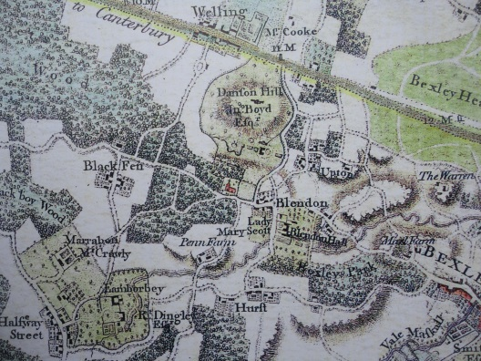
Figure 4.1. Map of Danson. Detail from Andrews, Dury and Herbert, Map of Kent, circa 1760

The Boyd family returned to England in 1735, where John showed little interest in joining the family business. In 1737, aged 19, he enrolled at Christ College Oxford to read Theology. Following graduation, he embarked on his Grand Tour of Europe, returning to England in 1746, where he joined the family firm. In 1749 he married Mary Bumstead, the daughter of a wealthy Warwickshire landowner.
Children soon followed so, in order to accommodate his ever-increasing family, he first purchased the lease for the estate of Danson Hill in 1753, and then subsequently acquired the freehold in 1759.

A manor (realistically a large house) was already on the site, built by John Styleman in the 1740s, but Boyd decided to build a modern house in a more prominent position on the top ridge of Danson Hill. Boyd employed Robert Taylor (1740-88), as the main architect for his new villa and Nathaniel Richmond (1724-1784), who had been an assistant to Capability Brown (1716-1783), as the landscape designer.
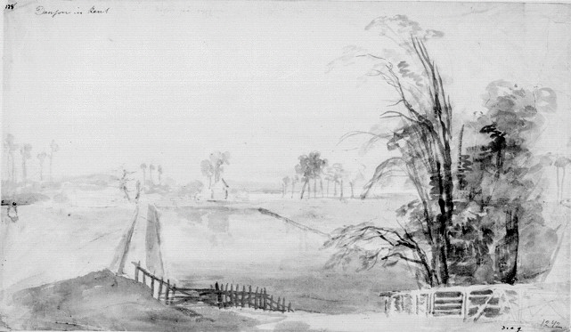
Figure 4.2. View of Danson Park in 1768, watercolour, by Elias Martin. It shows the canal created by John Adye in the late seventeenth century and the house that John Styleman built/rebuilt in the 1740s. Elias Martin, 1768, NMS

He also sought the advice of the Reverend Joseph Spence (1699-1788), with regard to the landscaping scheme. Taylor was a prominent architect of the time. In 1762, when he started to develop designs for Danson, he had already undertaken a number of commissions for villas, which had become very popular from the 1750s onwards. Many of Taylor’s commercial commissions were undertaken in the City of London. His first commission upon returning to England, following his Grand Tour, was the carving of the statuary for the pediment of Mansion House, which was originally designed by George Dance the elder (1695-1768). He gave up his career as a stone carver to concentrate on architecture; his most prestigious architectural project was the designing of two extensions to the Bank of England in 1780-1. He developed a broad clientele from the London livery companies and businesses in the City of London, as Binney observes:

Most of Taylor’s patrons were city men or had strong links with the city of London, and in some cases he built them not only houses and offices but suburban villas or country houses as well.

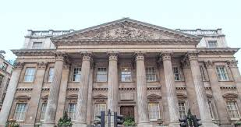
Figure 4.3. The view of Mansion House, the pediment was added later, figures carved by Robert Taylor

When Martin first visited Danson in 1768, the new house, built by Taylor, was nearing completion, but as can be seen from Martin’s watercolour (figure 4.2), the landscaping of the grounds was still in its early stages. The canal and original house were built at the base of the hill whereas the new house was built on the top of the hill to give a better vista across Boyd’s land. The watercolour of Danson was one of the first drawings that Martin made of the English countryside, as Danson House and grounds was the first place he visited having delivered Vernet’s romantic landscape to Boyd (figure 4.4).

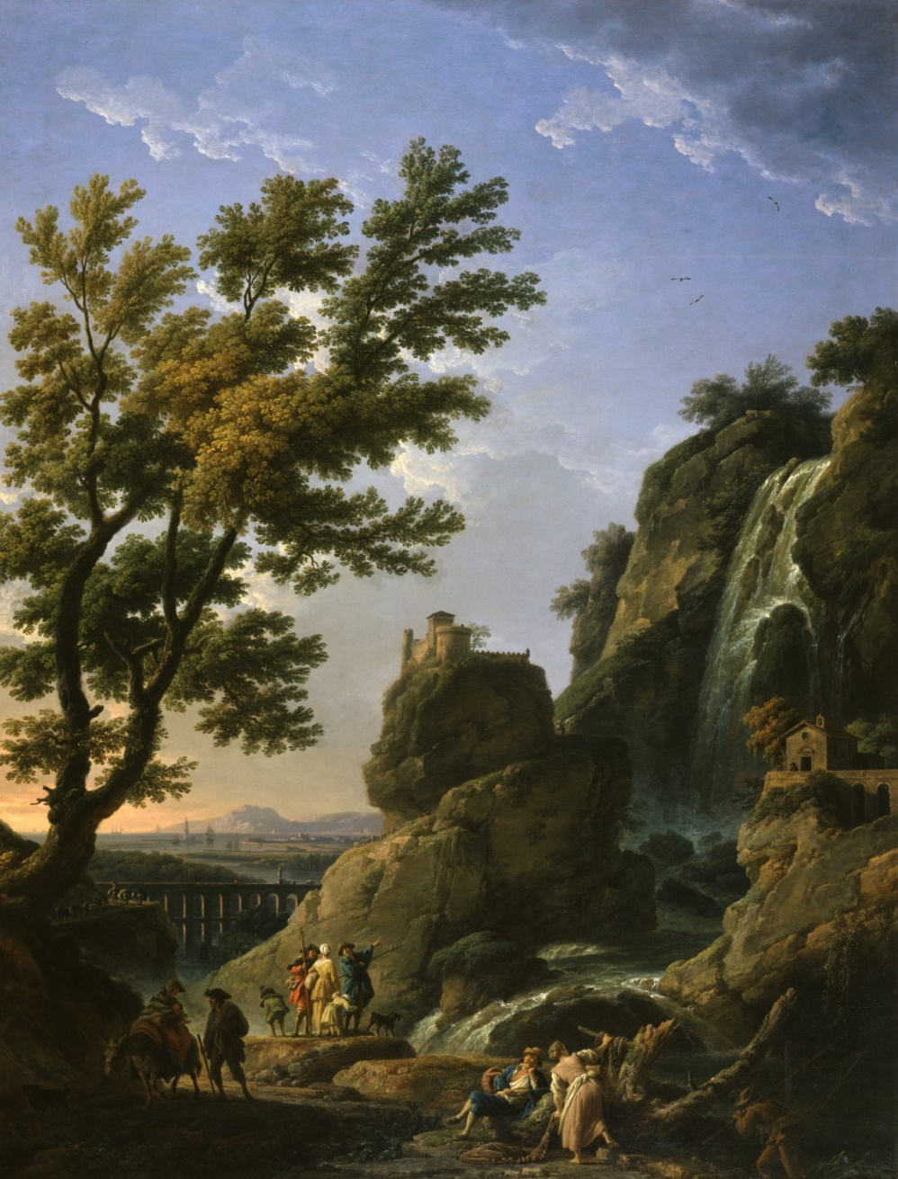
Figure 4.4. Landscape with Waterfall and Figures, Claude-Joseph Vernet, 1768. Walter Art Gallery

4.2.1 Danson House
The design of Danson followed the late eighteenth century trend of using the Palladian vision. The inspiration for many of the features was taken from the writings of Andrea Palladio (1508-1580), with many details taken from his treatise I Quattro Libri dell’Architettura. The villa itself needed to be multifunctional as it was to be a house that could accommodate family living; it also had to have the capacity to entertain Boyd’s business connections. The interiors reflect eighteenth century changes in the pattern of use and new ways of socialising; the trend was for the principal rooms to follow the ‘piano nobile’ format; the piano nobile scheme comprises a circuit of four rooms.

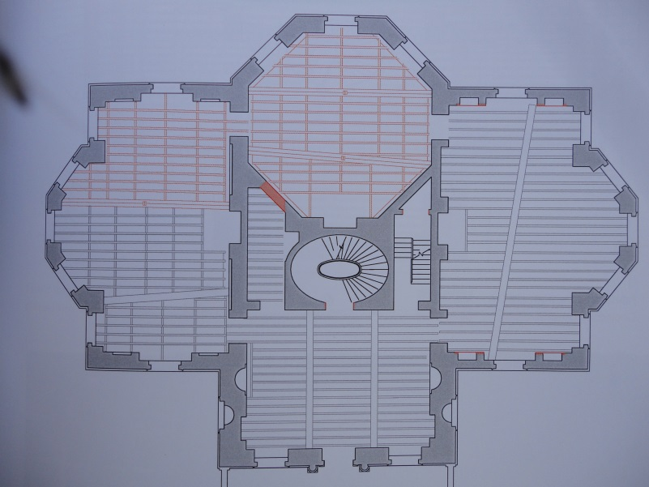
Figure 4.5. Ground floor plan for Danson, showing the series of four rooms, dating from circa 1760

The main entrance to Danson House faces north. On ascending an imposing flight of stone steps, you enter the house into the entrance hall, from which there are three adjoining rooms around a central spiral staircase. To the left of the entrance hall is the dining room or, as it was often referred to, ‘the eating room’. To the right is the library, which also contained an organ and would have been used to give recitals, which was a very popular social activity during this period. Access to the saloon on the south side of the villa was either through the library or the dining room. However, this circular format allowed easy access to all the principal rooms for formal entertaining.

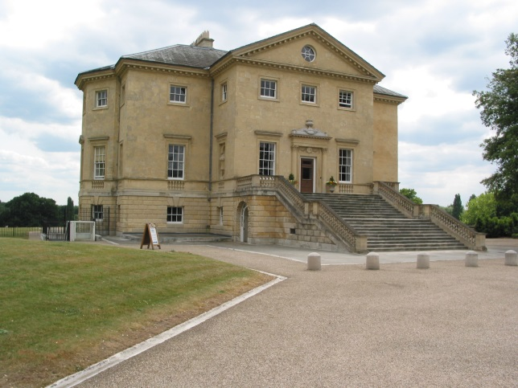
Figure 4.6. Danson house shown from the north-east, in 2009, following restoration

4.2.2 Danson’s Interior
Boyd employed a number of different artists and architects to furnish Danson House, including Sir William Chambers, who played a significant role towards the end of the refurbishment and it is his involvement which is explored here. Visible as you approach the main door to Danson are a pair of Corinthian columns surmounted with a straight entablature designed by Robert Taylor. They were subsequently embellished with a pediment of a vase flanked by scrolls, designed by Chambers. This was the one of many items designed by Chambers who was commissioned to supply drawings for a vase, fireplaces, picture frames, and mirrors for a number of rooms at Danson. Lea, Miele and Higgott (2011) suggest that Chambers’ first involvement with Danson was in 1768. This is due in part to their belief that a painting was ordered by Boyd from the artist Claude-Joseph Vernet (1714-1789). Vernet was working in Paris at the time and tutored Elias Martin at the Ecole des Beaux Arts in Paris, where Martin studied, during his stay from 1766 to 1768.

They suggest that Martin, when he left Paris in 1768 to travel to London, couriered the painting ‘a romantic landscape’, for Vernet. Martin delivered it to Danson, where he subsequently undertook a commission of painting the rear of Danson, and introduced Chambers to Boyd.

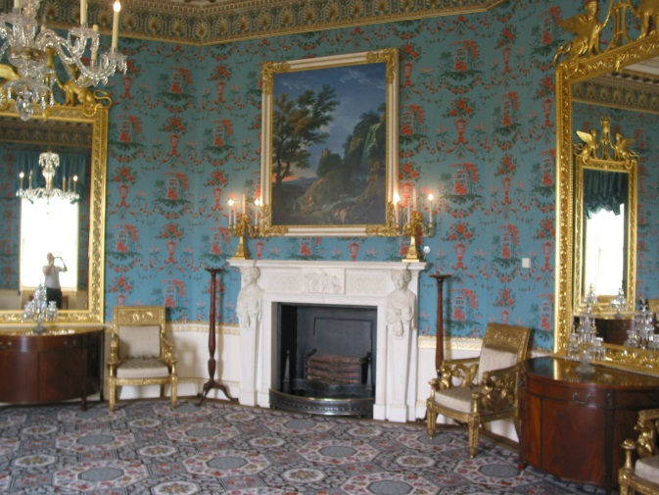
Figure 4.7. The saloon at Danson House, showing a copy of landscape with waterfall by Claude-Joseph Vernet over the fireplace designed by William Chambers

This hypothesis is intriguing and attests to the significance of Chambers’ aesthetic role in the development of the house collections and decorative innovations. There is a link that connects Vernet, Chambers and Martin. When Martin left Sweden via Gothenburg and landed at Le Havre, before arriving in Paris in May 1766, his only point of contact was with the Swedish Ambassador in Paris, Gustaf Philip Creutz (1731-1784), who in turn introduced Martin to the Swedish portrait painter Alexander Roslin (1718-1793). Roslin was also a good friend of Chambers; they met when Chambers revisited Paris in 1752 and continued to keep in contact when Chambers returned to England, corresponding by letter. Chambers also knew Vernet; again they had become acquainted when Chambers was studying in Paris in 1749.

Vernet was a tutor to Martin, but Martin would have been one of many students that Vernet tutored at the Ecole des Beaux Arts, and it is more likely that Martin worked in the studio of Alexander Roslin, rather than in Vernet’s as suggested by Lea, Miele and Higgott (2011).

The saloon at Danson is an octagon room; the central fireplace over which the landscape was to be placed is on the north wall, bordered on each side by a ‘pier glass’. On the east and west access, there are doors leading into the dining room and library. The south side of the saloon comprises three three-quarter length windows looking out onto the park, with pilasters in between each of the windows.
The first reference to the Van Loo painting was in 1776, when Boyd asked Charles Pavillon to contact his friend Louis Michel Van Loo (1707-1771) in Paris to request from Vernet a romantic landscape for the saloon at Danson. The request is reordered in Vernet’s order book:

Order Number 229: Tableau pour M Boyd Anglois à Londres ordonné par M Vanloo par une lettre qu’il a reçû de M Pavillon. Il doit avoir cinq pieds de large, sur six pieds et un pouce de haut mesure d’Angleterre prise sur le pied anglois. Il doit representer une grand chutte d’eau, des lointains et orné de beaucoup de figures; la prix est cent cinquante loüis ou 3600I. Je l’ay promis per le mars de l’année 1768. Il a été ordonné en décembre 1776.

Par une lettre de M Pavillon du 24 février 1767 ecrite a M Vanloo, il a envoyé une nouvelle mesure du tableau cy dessus qui est 5 pieds 10 pounce de haut sur 4 pieds 10 pounces de large mesure de France, il doit y avoir toujours des chutes d’eau mis avec un fond de marine.
Les deux dessus de porte du saloon ou doit érre ce tableau ettant en paysage. Tout le reste a l’egard dudit tableau comme cy dessus [Receipt number] 137.

Translation:
(Order Number 229): A painting for Mr Boyd English in London, ordered by Mr Van Loo, a letter that he received from Mr Pavillon. It must be 5 feet wide by 6' 1" high in English feet. It must include a large waterfall, some distant views and plenty of figures; the price is one hundred and fifty louis or 3600 l (livre). I promise it for the month of March, 1768. It was ordered in December 1766. (Receipt 137): By letter from Mr Pavillon of 24th of February 1767, Britain to Mr Van Loo he has sent me measurements for the painting above, which are 5 feet 10 inches in height by 4 feet 6 inches in English feet, or 5 feet 5 inches, 10 lines in height, by 4 feet 2 inches, 3 lines in French feet, it must have waterfalls with a seascape in the background. The two open doors in the saloon where this painting is to be hung, being landscape. All of the rest with regards said painting as above.

We see from the translation above that Boyd has taken a convoluted route to order his painting from Vernet; Pavillon was a friend of both Boyd and Van Loo, so it seems not unreasonable to ask him to make contact with Vernet. Vernet at this time was a very popular artist, making a good living in Paris painting romantic landscapes in the style of Claude and Salvator Rosa. He would be in a position to pick and choose his commissions and could quite easily have told Boyd that he was too busy. As we can see, the painting was ordered in December 1766 to be delivered by March 1768 at the latest, a lead in time of 15 months. The role of Charles Pavillon was the link to getting access to Vernet. Charles Pavillon was a French artist who had come to England around 1766; he based himself in Scotland, but also had access to a studio in London. When he exhibited at the Royal Academy in 1768 he gave his address as ‘Mr Inge’s in Covent Garden’.

It seems that Danson was Pavillon’s first major commission; he undertook 19 paintings in all, which were divided into two groups. The first were nine large panels depicting near life-size mythological scenes, hung between ten long thin panels painted with foliate and floral designs.

We know he was working on site at Danson by 1766, as he signed and dated the Apollo floral panel, ‘C. Pavillon, 1766’ possibly at the completion of the commission. Boyd might have wanted the dining room completed for his second marriage to Catherine Chapone in 1766.

He (Pavillon) also wrote the letters to Van Loo from Boyd in French, in 1766 and 1767, to order his picture from Vernet, possibly because Pavillon’s French was better than Boyd’s. Furthermore, due to the specific requirements of what Boyd wanted from the painting, both in terms of its content and size, it would seem logical to use someone with French as their first language to ensure that Vernet had understood the requirements for the painting. The second letter dated February 1767, confirms changes to the painting’s dimensions possibly brought about by Boyd confirming the design of the fireplace over which the painting was to be hung. In the first letter Boyd would have been working from the aperture or a fireplace design proposed by Taylor and it may be a valid suggestion that by February 1767 Boyd had approved Chambers’ design for the fireplace and had to reduce the width of the painting in order for it to sit over the fireplace between two of the breakfronts of the marble top. This would have added a pyramid effect to the display and allowed room for a pair of candelabra to be placed on top of the mantelpiece, to illuminate both picture and the room.

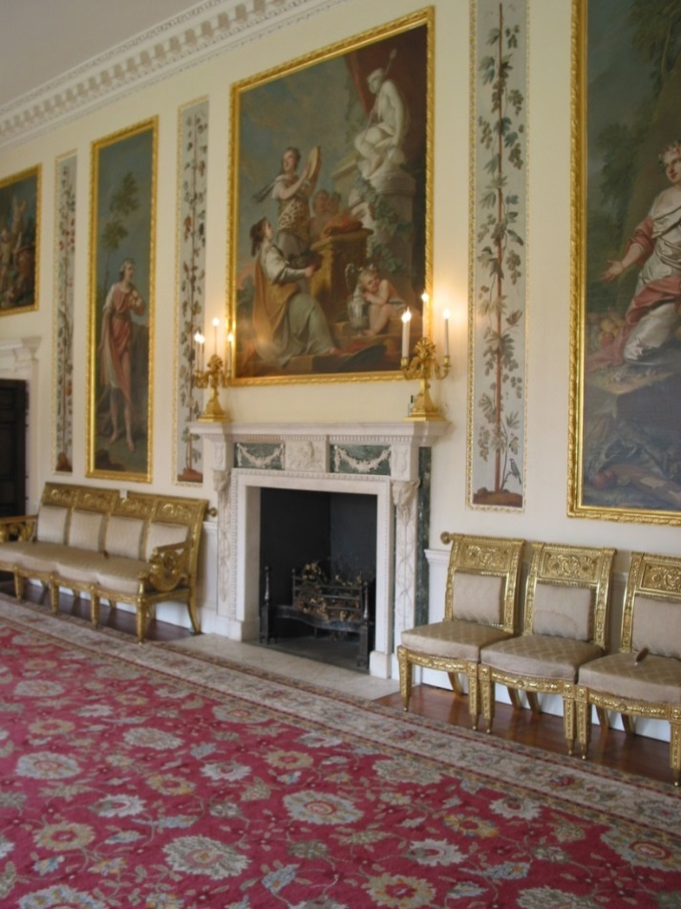
Figure 4.8. The dining room chimney piece by Chambers with over mantle picture, A Sacrifice to Bacchus, 1776, Danson, with decorative panels to the left and right, Charles Pavillon, 1766

It can also be seen from the letter of February 1767, that Boyd had decided to commission two landscapes as over doors for the doors leading into the dining room and library. His chosen artist for these two paintings was George Barrett (1728 or 32-1784). Barrett was born the son of an Irish tailor and was essentially a self-taught artist who in his early years in Ireland specialised in the Italianate views. He moved to London in 1763, and within a year he had secured a number of distinguished patrons including the Duke of Portland and, shortly after, the Duke of Buccleuch. In many respects his subject material was similar to Martin’s.
He was attracted to the natural landscape following a tour of North Wales and the Lake District, which inspired him to produce a number of sublime landscape views that became very popular and commanded high prices. He was, like Martin, an earlier member of the Royal Academy in 1768.

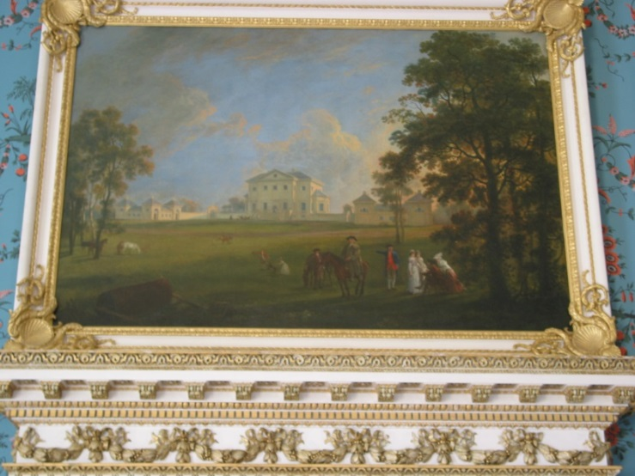
Figure 4.9. The view of the front of Danson House, painted by George Barrett, circa 1768

It was common practice that if a pair of paintings was required, as in over doors or to go on either side of a room, one artist would be commissioned to paint both pictures. Boyd did follow this principle as can be seen from the sale catalogue of his paintings following his death. Due to financial circumstances, his son John Boyd II sold the majority of his picture collection in 1805. Within the sale we can see that Boyd was an active collector of fine art, as well as commissioning works from artists of the day to furnish Danson House.

In his art collection we see pictures by Rembrandt and Cuyp, along with a number of English artists such as Wilson, Van Loo, Romney, Wheatley and Joseph Wright of Derby. Within the sale there were a number of paintings, which could be considered to be pairs, works by Wilson, Joseph Wright of Derby and Barrett had all been purchased, or painted, in pairs for Danson.
However, the over doors in the saloon were painted by two different artists, one by Barrett and the other by Martin, and this would be considered unusual. Barrett had painted three paintings for Boyd, including the one for the saloon; he may have had other commitments to fulfil and was therefore unable to complete the pair for the saloon.

Barrett's picture was the primary view as it illustrates the front of the house.

Lot 45, Barrett, a perspective view of the principal front of Danson in the County of Kent. With lawns, cattle and figures.
Lot 46, Martin, a picturesque view of the back elevation of Danson in the county of Kent. With cattle and figures.

At Danson today only one over door survives in the saloon, the current location of the second painting is not known, the one remaining shows Danson’s front elevation and this is attributed to Barrett.

The question of whether Martin introduced Chambers to Danson in 1768, or whether Chambers had been working for Boyd and introduced Martin to him, can be answered by looking at the correspondence between Boyd and Chambers.

To: Chambers Esq
Architect to the King
In Burnell Street [Berners Street]

Danson, Monday, June 11, 1770
Dear Sir
As the ground is dug out ready for the Bridge I propose making to terminate my water & and that I wish to begin it immediately. I shall be obliged to you if you will send the Drawings of the one you was so kind to promise me to Mess” Wood & Trevanion’s in New Broad Street with directions to forward it here. You’ll please to remember I would have it of one arch 30 feet long. The piers or butments of Brick & the bridge & rail of wood, not to rise too high. The Passage over 9 feet in the clear & to bear a Carriage. I should be glad likewise to have the Drawing of the Temple for the pond head when your leisure will permit & as you give me hope of the pleasure of your company with Mrs Chambers to spend a day here soon, we shall be happy to see you either Saturday or Monday next & beg you would fill your coach with as many of the young Folks as it will hold. We shall expect you to Breakfast in the interim & at all times believe me to be with great regard & esteem.
Dear Sir
Your obliged &
Obed’[ant] humble Serv’[ant] John Boyd

Envelope sealed with red sealing wax impressed with the Boyd’s seal.

Chambers replied to Boyd by Return of post:
Berners Street
Oxford Street
London
12th June 1770
Dear Sir,

Excessive hurry....has prevented me from doing your designs. I am just going to Hertfordshire for a couple of days and on my return will immediately do your temple. In the mean time I have sent you a design for a bridge wh[ich] has scarcely a rise at all it is a thought of Palladios and provided you have it framed by a skilled carpenter will do very well and look very handsome.
Sir
Your obedient servant
William Chambers

Chambers must have subsequently supplied the drawing for the Temple as we see from Boyd’s next letter to Chambers:

To: William Chambers Esq
Berner Street [Berners Street]
Oxford Street

Danson July 12th 1770
Dear Sir
You have paid more attention to my trifling bouyness (sic) than it deserved or I had reason to expect from one so much taken up with more important occupations. I am much obliged to you for the Designs you have sent me of a Bridge and likewise the one you promised me of the Temple which I will talk to you on when I have the pleasure of seeing you here. As my wife is got out of her room, we shall be glad to see you with Mrs Chambers and the young ladies spend a day with this any day after Wednesday next to which time I engaged & as I shall be in New Broad Street next Wednesday beg you would favour me with a line letting me know what day we might hope for the pleasure of your company we will obliged.
Dear Sir
Your most obliged &
Obed’[ant] humble Serv’[ant]
John Boyd

Following the death of his father in 1765, Boyd passed on to his sons-in-law, John Trevanion and William Wood, the management of the family trading business and turned his attention to more congenial pursuits. On 1 August 1766, Boyd married his second wife Catherine Chapone and subsequently had two more children with her, which he brought up with his own children from his first marriage. Danson House was nearing completion and he could now give his full attention to the finer details of furnishing the house and adding final touches to the landscape.
From the research detailed above, it can be seen that Boyd had already started employing artists to furnish many of the rooms.

Significantly, he requested that the landscape from Vernet be delivered by March 1768; one of the 19 paintings by Charles Pavillon was dated 1766, perhaps to signify either the start of the commission or the completion. So it would seem that Boyd was trying to get the internal decoration completed by 1768-9.

Figure 4.10. Engraving of Danson from the south-east, published in 1794, from an earlier drawing by Richard Corbould. Chamber’s bridge can be seen on the far left.

The correspondence between Boyd and Chambers relates to the completion of the landscaping in the park, specifically a bridge to allow coach access to and from the house and a folly in the form of a Roman temple at the head of the lake. This indicates that the furnishing of the house was complete and that Boyd could now turn his attention to the parkland. The style in which the letters are written would seem to indicate a more intimate relationship between Boyd and Chambers. This was not just a client-customer association, but an affiliation that had been built up over many years.

Boyd was never charged for the drawings of the bridge and temple. In a letter from Boyd to Chambers, dated 14th of May 1773, he states: “I am in your debt for the drawings of my Temple which is finished, and when your leisure will permit, should be glad you would come to see it and spend a day at Danson with your ladies.”
Chambers replied, “if the Temple pleases you, it makes me happy.”

Chambers undertook a number of commissions at Danson, mainly in the principal rooms:

Dining or eating room: Marble chimneypiece, with side pilasters ornamented with a Bacchic ‘thyrsus’ surmounted by a leopard’s head.
Library: Marble fireplace, the plainest of the three.
Saloon: Marble fireplace with side pilasters in the form of female terms, central tablet depicting the ‘Marlborough house Gem.’
Door casings.
Two carved and gilt pier mirrors.
Three parcel gilt picture frames.
Main door: A scrolled block pediment with a vase in the centre.

The main body of work centred on the principal entertaining room, the Saloon. Boyd's letter to Vernet in February 1767, changing the size of the painting he required, would seem to indicate that he proposed to make changes to the fireplace below. This involved either replacing the fireplace proposed by Taylor, or installing a new fireplace by another designer. It is reasonable to suggest that the fireplace by Chambers was designed and approved by 1767. Lea, Miele and Higgott (2011) propose that the fireplace was installed in the early 1770s, based on nail marks on the wall indicating that the Chambers fireplace had replaced an original, and a drawing for a fireplace by Chambers for Marlborough house, circa 1771-4.

Their argument is reinforced by the design of the tablet in the centre of the fireplace, which is known as the ‘Marlborough Gem’. The scene is from the popular Renaissance allegory, where Cupid has his head covered to signify his hidden identity as a God, while Psyche, a mortal, is completely shrouded, denoting her ignorance.
Chained together, they approach the marriage couch and an attendant carries a sacramental torch as homage to Hymen, while another carries a tray of fruit symbolising fertility. The possible flaw in their argument is the source for the ‘Marlborough Gem’ which was published and described by Bernard de Montfaucon in 1719.

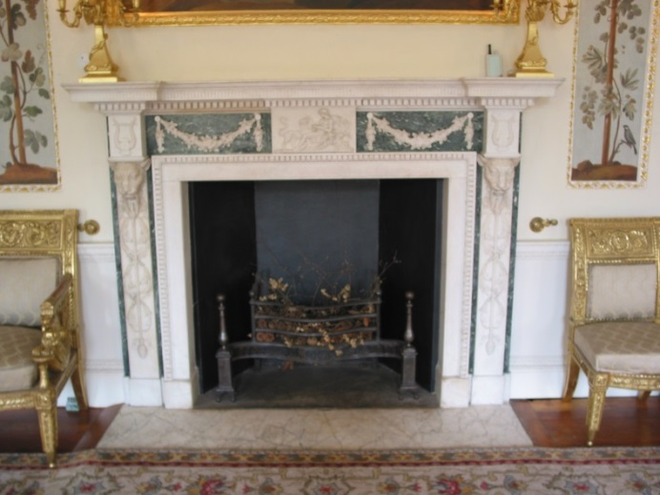
Figure 4.11. Saloon chimney piece. Designed by Sir William Chambers, carved by Joseph Wilton, 1768

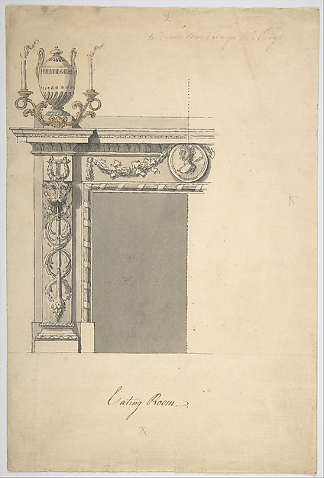
Figure 4.12. William Chambers’ design for a chimneypiece, in the ‘eating room’ at Danson House, 1767, New York: Metropolitan Museum of Art

Chambers’ design for the fireplace at Marlborough House gives the dimension between the inner mouldings of the opening as 4ʹ 8ʺ, the revised width of the landscape by Vernet was 4ʹ 6ʺ, this, therefore, would mean that the width of the canvas would be slightly smaller than the opening of the fireplace. If we then take into account the width of the picture frame (4½ inches), it would sit nicely between the caryatids or female forms situated on either side of the fireplace.
It is feasible that the fireplace at Danson was the first version and that Chambers reused the drawing for Marlborough house; the central tablet and Chambers’ drawing is left blank, in order to allow different designs of tablets to be used according to style and its location.

The fireplace in the library was also designed by Chambers; it follows very closely a fireplace that Chambers designed for General Ralph Burton's house at Haworth Hall in Hull in 1763-8. Boyd may have been aware of the design as it appeared in Chambers’ thesis, ‘Treatise on Civil Architecture’ published in 1759.

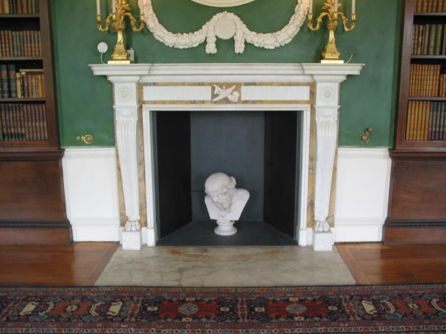
Figure 4.13. The fireplace in library

The fireplace in the dining room (eating room) is slightly richer in design than the library fireplace, again confirmation that it was designed by Chambers using the drawing for the fireplace in the Metropolitan Museum of Art as its basis.

There are slight differences as one might expect; the inner cheeks of the fireplace in the drawing are finished with a reed and ribbon moulding, whereas on the Danson model it has an egg and dart moulding. As was normal, the central tablet differs from the drawing; the drawing shows a medallion with a female silhouette on the fireplace, and Chambers used the marble relief depicting the god Bacchus stroking the head of the leopard. The source for the relief comes from James Stuart and Nicholas Revett, Antiquities of Athens 1762. Chambers has complemented the theme of the central relief by adding, to each side of the fireplace, a leopard's head with a decoration of intertwined laurel swags (a dropping pendant).
Designing and manufacturing of fireplaces seems to have been Chambers’ forte and there are numerous designs for fireplaces by Chambers in archives all around the world. In the case of the Danson fireplaces, most historians agree that the quality of the carving would seem to indicate that they are the work of Joseph Wilton; the cutting and polishing of the marble fireplace’s basic components may well have been undertaken by another workshop. Subcontracting the basic components would have allowed the manufacturing of these objects to be speeded up.

Chambers’ favoured sculptor was Joseph Wilton; they had worked together on a number of projects when they both returned to England in 1755. They first met in Italy, when they were undertaking their Grand Tour in 1754, where at this time they were living in Rome. Chambers was lodging with Giovanni Battista Piranesi and this gave him the opportunity to learn from this revolutionary architect and artist, the radical changes affecting architectural design at that period. As Piranesi’s studio was a centre for such innovative thinking, it attracted a number of artists and milordi, who were also on their Grand Tour.

Wilton was a regular visitor to Piranesi’s studio and it was probably here that Chambers and Wilton’s lifelong friendship began. The quality of the carving on the three fireplaces at Danson would seem to indicate that without doubt they were the work of Joseph Wilton.

It may be suggested that as part of Boyd’s design scheme for the rooms at Danson, Chambers produced drawings for three fireplaces, in particular for the fireplace in the saloon, which is the grandest as befits the main room of the house. It would seem illogical that if the landowner was involved with such a hands-on approach to commissioning paintings, mirrors, door casings and picture frames to furnish the grandest rooms in the house, that fireplace design would feature as a focal point for display of the collection’s most prized paintings.

The next imposing objects in the saloon are the two carved and gilt pier mirrors, which are situated on the walls between the fireplace and the two doors, leading to the library and dining room. During the refurbishment of Danson by English Heritage in 2004, they reproduced the mirrors in the saloon; in September 2013, one of the original mirrors with a nineteenth century copy, came up for auction at Christies in London at their Fine Furniture Sale.

Sale entry, Lot 18
The Danson Hill neo-classical gilt wood pier glasses.
The design attributed to William Chambers, the original cresting and one mirror George III circa 1770-80, the other early 19th century.
Each mirror surmounted by a flower filled urn with swagged tripod support featuring bearded masks and flanked by griffins and wheat sheathes, above a mirrored freeze with oak swags draped over roundels, the rectangular plate with a pierced anthemion and acanthus leaves surround.

The upper border centred by a female mask with drapery swags and with further ribbon and oak swags to the sides, the eighteenth century mirror originally fitted with candle sconces reduced in height and with a 19th-century central plate, re-gilt. Dimensions: 111 inches x 65 inches (2820 mm x1650 mm).

For the purposes of this chapter, it is appropriate to discuss the original eighteenth century pier glass that appeared in the Christie’s sale. Despite the fact that the mirrors have evolved over the last 250 years, it is without doubt one of the original mirrors from the saloon in Danson House. The original mirrors in the saloon were possibly devoid of the top freeze and oak leaf swags trailing down the side, as these were probably added when the mirrors were moved from the saloon to the dining room at Danson. The original mirrors would have had a central urn, flanked by two griffins and a pair of candle sconces on each of the uprights.

The mirror design relates to a number of drawings and objects. A similar rectangular framed mirror, with a central mask, relates to Chambers’ drawing for an over mantel mirror for the saloon at Gower House, Whitehall. A similar rectangular mirror surmounted by a vase in the centre, flanked by two lions with female heads (sphinxes), with garlands descending from the vase under the lions’ bodies and then down the side of the frame, was designed for Adderbury. The ornamentation of the frame, combining anthemion and acanthus leaves, is also closely related to the frieze found in a design by Chambers for the medal cabinet of the Earl of Charlemont.

The use of griffins flanking a sacred urn used on the cresting of the mirrors is reminiscent of Chambers’ designs for the library ceiling at Woburn and for the staircase at Melbourne House, London. A seated pair of griffins can also be found on a pair of gilt brass candlesticks, circa 1767, at Blenheim Palace, Oxford. The earliest evidence relating to the sources for the design of the Danson saloon mirrors is at Gower house, which Chambers began in 1760; he used anthemion and acanthus leaves as decoration around the edge of mirrors in the Saloon. The next related drawing is for the mirrors at Adderbury in 1767-8.

The Adderbury mirrors are very similar to the Danson mirrors, with the exception that they have a small extension to the corners on the vertical plane, which allowed Chambers to put a floral patera in each corner. He used the same egg and dart moulding on the perimeter of the mirror, enclosing anthemion and acanthus leaf decoration, while on the inner edge he has used a reed and ribbon moulding, which is an identical orientation to the Danson mirrors. The Adderbury mirrors are surmounted with a Greek styled urn and sphinxes sitting on a raised frieze, flowers growing from the top of the urban cascade down around the sphinxes then carrying on down the side of the frame.

The medal cabinet for the Earl of Charlemont was completed in 1767-8, for his house (Charlemont House) in Dublin where, again, we see Chambers using anthemion and acanthus leaves along the top frieze of the cabinet. As Goodison also noted:

Particularly striking is the oval medallion in the central panel, carved in relief with a figure of Hercules Musarum and framed with swags of drapery and crossed palm branches. Equally notable are the carved satyrs’ heads on each side of the medallion from each of which hang ribbons holding musical instruments, books, paintbrushes, mathematical instruments - symbols of music, literature, painting and natural philosophy - and laurel wreaths, the symbol of success.

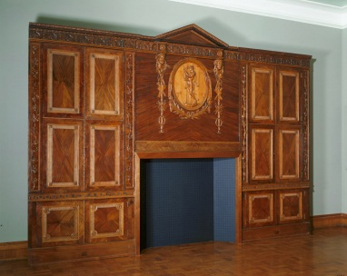
Figure 4.14. The medal cabinet for the Earl of Charlemont, 1768, Courtauld Art Gallery

This form of decoration of a head (Satyr, Goat, Lion, etc.) from which hangs a ribbon either with emblems of the arts and sciences or intertwined laurel swags (a dropping pendant), was used by Chambers on several occasions on bookcases, marble stands (terms) and fireplaces. At Melbourne House (1770-1774), the anthemion and acanthus leaf design was once again used as decoration, on the metalwork forming the spindles on the main staircase.

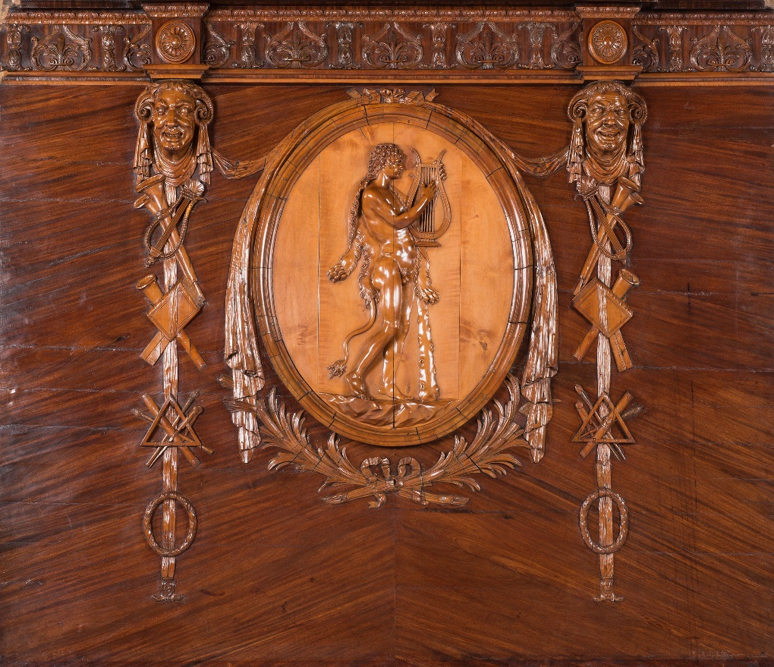
Figure 14.5. Centre section of the medal cabinet for the Earl of Charlemont, illustrating a drop pendant

4.3 Woburn Abbey: Introduction
Woburn Abbey seems to have undergone continuous redevelopment since the Abbey was closed with the dissolution of the monasteries, by Henry VIII, in 1536-38.
Having been seized by the Crown in 1539, the Abbey was initially released to the ‘Stewart King’s Manor’ at nearby Ampthill, the estate of Sir Francis Bryan, and he sequentially sublet the Abbey to Williams Smyth. In 1547, a revision of the lease was granted to John, Baron Russell, of Chenies, who held the title of the ‘Great Steward of England’ under Edward VI. In 1550, he became first Earl of Bedford.
The Abbey was now in the Bedford (Russell) dynasty and underwent a long series of improvements to reach what we now see today, a graceful Palladian house,.

For the purposes of this chapter, the focus will be on the improvements undertaken by John, 4th Duke of Bedford (1710-71). The 4th Duke was a politician and landowner; on succeeding as the 4th Duke of Bedford in 1732, he devoted much of his time to restoring the family fortune, concentrating on restoring the family estates and its London properties.
He developed a number of commercial interests and, in time, became one of the wealthiest men in Britain, with an estimated income of £30,000 per year.

The Bedfords had a number of properties (Stratton Park, Houghton), but their main residences were at Bedford House, London, and at Woburn Abbey, Bedfordshire. They had for a short period rented a house in Bath (1733), in order to take the waters, as the Duchess (Lady Diana Spencer 1710-1735) was becoming quite ill, and they were also in the process of building a new manor house called Stratton Park, Hampshire, a convenient overnight stop between Woburn and Bath. The Duchess did not see the completed house, as she died in 1735, before the house was finished. The Duke remarried in 1737, to Lady Gertrude Leveson Gower (11715-1794), who completed the furnishing of Stratton. Bedford House, in London, was undergoing major improvements, while Woburn was having minor improvements carried out; these were being undertaken by the architect John Sanderson. Between 1740 and 1743, John Sanderson had produced drawings for a new greenhouse on the south side and the library in the south-west corner.

4.3.1 Woburn Abbey: Refurbishment
In 1747, the 4th Duke decided to ‘repair’ Woburn, which still retained some of the original monastic buildings; but the proposed work was to be a major refurbishment, bringing the house up to date stylistically by remodelling the east and west aspects in the Palladian style. The major works were to be undertaken by another architect, Henry Flitcroft (1697-1769). Flitcroft had worked for the family for a number of years at various properties, including the Church of St Giles and the local family church on the Bedford estate. From 1747-1764, Flitcroft submitted designs for the rebuilding/remodelling of the East and West façades; the West front, the principal front, still survives today. In 1765, the 4th Duke embarked on the final phase of his refurbishment, with yet another architect. Stiff Leadbetter (1705-1766), who was undertaking building work at Bedford House (1764-66), was asked to prepare drawings for the rebuilding of the South wing; drawings for the South wing were prepared and approved, but before work could commence, Leadbetter died.

In 1766, Sir William Chambers was employed to continue the work on the South wing. Chambers had previously undertaken a number of projects for the Russell Family. One project that relates to this thesis is the removal of the fixtures and fittings from Stratton Park in 1768; the 4th Duke had intended to give Stratton to his son Francis, Marquis of Tavistock, but the Marquis died in 1767, so he decided to let it instead. The manor was surveyed by Chambers, following which, the major fixtures and fittings were removed and sold on (some of the best being sent to Woburn, for example, two marble fireplaces), there then followed a series of lettings until 1801, when the house and estate were sold off. As Stratton was being asset stripped at the same time as Danson was being furnished, some items from Stratton may have been recycled at Danson by Chambers.

At this time Chambers’ main involvement was completing the South wing that Leadbetter had designed, it seems that the final design did not enhance Flitcroft’s vision of symmetry in the courtyard, since there was a third storey above the principal rooms on the south side. The documentary evidence that survives does not support Chambers’ claims that he built the front and parade apartment, as the bills for the stonemasonry only account for £172.00. This may in part be due to the fact that, on occasions, the 4th Duke had insisted on using his own workforce. This workforce was again supplemented by specialists provided by Chambers; in December 1769, Chambers made reference to a Mr Hillman of Brentford, who was a plumber, and Mr Millar of Queen Street, Westminster, a glazier. The South wing was completed in 1770. In 1771, a Mr Brunis, or Borra, had been instructed to paint the ceilings at Woburn, possibly some remedial work following completion of the project. While working on the South elevation, Chambers also organised minor maintenance/improvements to the house; his penultimate project was to organise Gillian and Taylor, masons of Piccadilly, to mend three water stools and install six chimney pieces executed by Mr Haywood. They also completed the final touches to the principal front, by hoisting and fixing three figures in stone to the central pediment,

The last project that Chambers undertook for the 4th Duke was the building of a bridge across the lake, to the south of the house, to carry a new road to the house; it was started in 1770 and completed in 1773. Again we can obtain an overview of the project from Chambers’ letters, which are preserved in the British Library.

1769; John Rentham is Chambers’ on site supervisor for the Library at Woburn, and it seems he is also supervising work at Houghton at Amphill (a Mr Millard, tradesman), and he subsequently oversees the building of the bridge.

Feburary1770; Bill to the 4th Duke for; Mr Beaumont, a bill for £392.17d for work on bridge at Woburn, at this stage possibly it would be for digging the footing and laying the foundations on either side of the lake.

February 2nd; Letter to Rentham, he has sourced the bricks for the bridge.

March 1770; To Rentham, he refers to the design of the new bridge, which he is working on and hopes to have completed soon.

June 30th 1770; It seems that the design for the bridge has now been completed and approved, as he instructs a T Hill that he has had approval from the Duke of Bridgewater, to extract the facing stone for the bridge from his estates at Ashridge (Ashridge is situated on the edge of the Chiltern Hills, approximately 10 miles from Woburn in Hertfordshire).

August 3rd 1770; Chambers instructs a Mr Wilton, stone mason from Milton, Peterborough, to carve two key stones for the bridge at Woburn.

A drawing for the bridge is preserved in the V&A Museum; the bridge was altered radically, by Henry Repton (1752-1818), under the 6th Duke’s remodelling of the grounds. In 1772, at the Royal Academy exhibition, Elias Martin displayed a view of Woburn:

The Royal Academy exhibition, 1772.
Elias Martin, Dean Street, Soho, London.
Catalogue No Title
148 A view of Wooburn [sic] Abbey and part of the New Bridge.

Martin must have visited Woburn at some stage, between1770 and 71, to undertake preliminary drawings for the painting; a sketch of the principal front is in the collection of the National Museum of Stockholm.

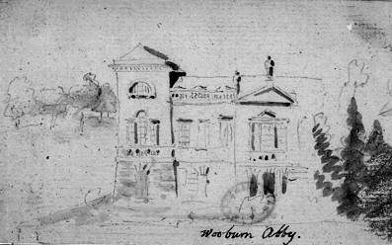
Figure 4.16. Drawing of the principal elevation of Wooburn Abby [sic], Elias Martin, 1770-71, NMS

The drawing is slightly stylised in that it only shows half the front; Martin also only illustrated three windows, between the central pediment and the tower at the corner, rather than the five that exist. We can date the drawing to after 1770, as it shows two of the three figures installed by the stonemason, Gillian and Taylor, in 1770.
This drawing was undertaken as a preparatory drawing for the painting of Woburn, the present location of this picture in currently unknown. It does not appear in the Woburn Abbey inventory of 1771, but may have passed into the collection under Gertrude, Dowager Duchess of Bedford, who ran the estate from 1771, when the 4th Duke died, until 1786, when the 5th Duke became of age. This again underpins the relationship between Chambers and Martin; it is possible that Chambers had asked Martin to paint a record of his work at Woburn. Alternatively, Chambers may have introduced Martin to the Dowager Duchess of Bedford, since, while there is no other record of any of Martin’s work at Woburn, he did dedicate a set of six engravings on the theme of the ‘Tender Mother’, which he dedicated to the ‘DutcheSs [sic] of Bedford’, possibly in recognition of the commissions/support that she had given him. With such a large portfolio of houses, there was also the need to maintain the internal decoration and furnishing of a large number of rooms. The 4th Duke used a wide-ranging circle of craftsmen, many of whom were based in London, but he also used a range of local craftsmen.

While Chambers’ primary role was that of an architect, he was very keen to maintain standards and, quite often, also acted as clerk of works, quantity surveyor and would help patrons furnish the completed rooms with all forms of decorative arts. In 1764, Sefferin Alken (1717-1782), woodcarver, supplied the Marquis of Tavistock with a mahogany bookcase, with drop pendants of music, war, painting and sculpture, to a design by Sir William Chambers, at a cost of £27 9s 6½d. So Chambers can be seen supplying designs for furniture and then using his own craftsmen to undertake the work. Sefferin Alken had undertaken a number of carving commissions for Chambers, and the likelihood is that Chambers had commissioned a cabinet-maker to make the cabinet, which would then have been passed on to Sefferin Alken, to carve the motifs.

Both the 4th Duke and the Marquis of Tavistock, had developed a passion for French furniture; the 4th Duke had visited France between September 1762 and May1763, as Ambassador to the court of Louis XV, where he negotiated a peace treaty between France and England ending the seven-years’ war.

While in Paris, he rented hôtel de Grinberghen, from the duc de Chaulnes in the Place de Vosges area of Paris, in the 4th arrondissement, which he then proceeded to furnish with the luxuries of France, many of which came back to Woburn when he returned. The Marquis of Tavistock accompanied his father to Paris and after a short stay there, he then travelled on to Italy as part of his Grand Tour. This passion for the taste of French decorative arts continued when he returned to England; he patronised the workshops of Pierre Langlois (1727-1780), who came from an émigré cabinet-making family. He was born in England on 10th September 1718, the son of Daniel and Jeanne Langlois. He decided to stay, setting up his workshop at 39 Tottenham Court Road. The first of two pieces of furniture from the Pierre Langlois workshop was recorded in 1760:

A large inlaid commode table supplied to the fourth Duke of Bedford by Pierre Langlois the elder in December 1760 for £78 8s. Marquetry of various woods on a pine carcass, with ormolu mounts.

The second commode ordered from Pierre Langlois by Francis, Marquis of Tavistock, was: A pair of marquetry commodes, the marquetry in various woods inlaid into a rosewood background, with ormolu mounts.

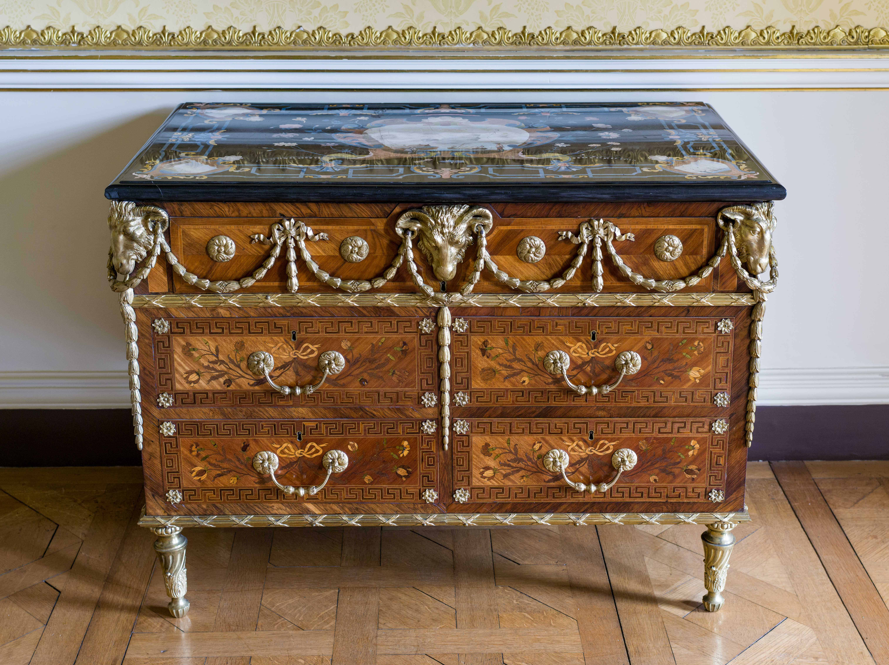
Figure 4.17. Commode, chest of drawers, by Pierre Langlois, 1764, from the Woburn Abbey collection

The commodes were delivered in 1764, at a cost of £70 each, both have scagliola tops dated 1762 and signed by Gori. These were purchased by the Marquis of Tavistock in Florence.

In 1767, following a hunting accident, the Marquis of Tavistock died, followed shortly after by his wife. His furniture passed to his father and can still be seen today at Woburn, apart from the mahogany bookcase designed by Chambers, which is unfortunately lost. Coincidentally, 1767 also saw the death of Pierre Langlois. Beard and Hayward recount an interesting anecdote relating to how this eighteenth century workshop was run:

Pierre Langlois himself also died in 1767, and was buried in the graveyard of old St Pancras church on 19 February of that year. In consequence, payment was duly made to his widow and the sum of one hundred and forty pounds to ‘Veuve Langlois for two commode tables of inlaid wood’ is listed among the debts paid to his creditors by the Marquis Tavistock's executives in 1767. It has hitherto been thought that Pierre Langlois continued to run his workshop at 39 Tottenham Court Road until 1781. We now know, however, that his early death obliged his widow Tracey Langlois, to take over the workshop, and her name appears in the rate books as the occupant of number 39 until 1774. From that year until 1782 a second Pierre Langlois, evidently a son of the first Pierre Langlois, took charge. He, in turn, was replaced by the French bronze founder Dominique Jean, who had married Marie Francis, a daughter of the first Pierre Langlois in 1764, and to whom Daniel Langlois, believed to be another son of the first Pierre, was apprenticed in 1771. Dominique Jean continued at number 39 Tottenham Court Road until 1787 and was probably the maker of the bronze mounts on Lord Tavistock's commodes, which passed at his wife's death to the 4th Duke.

We see here again, the French tradition, in an English workshop, of the widow carrying on the workshop of her husband following his death, until either a son or daughter is old enough to take control, or as in this case, the widow remarries, usually to another craftsman in order that the workshop survives and the family continue to have an income. It is also interesting to note that Tracy Langlois repaid £10.00 from her late husband’s estate to Sir William Chambers, possibly a refund on a project that was not completed due to his death, .

Listed on the following page are the names and professions of some of the other craftsmen (and ladies) that received commissions to work at Woburn and Bedford house:

Name | Profession
Flintcrotf | Architect
Giovanni Battista Borra | Artist
Robert Wood | Dilettanti
John Sanderson | Architect
John Michael Rysbrack | Sculptor
John Devall | Sculptor
William Wilton | Sculptor in plaster
Joseph Wilton | Sculptor in stone
John Linnell | Cabinet-maker
Robert Butcher | Agent 4th Duke
Sir William Chambers | Architect
James Whittle | Cabinet-maker
Thomas Whittle | Cabinet-maker/Carver
William Hallett | Cabinet-maker
Samuel Norman | Cabinet-maker/Carver
Robert Swan & co | Fabric supplier
Pierre Langlois | Cabinet-maker
Crompton & Spinnage | Fabric supplier
Dominique Jean | Brass founder, chaser
William Vile | Cabinet-maker
John Cobb | Cabinet-maker
Charles Smith | Cabinet-maker
Benjamin Goodison | Cabinet-maker
Isaac Gosset | Gilder
Hinchcliffe and co. | Fabric supplier
Safferin Alken | Woodcarver
Mayhew and Ince | Cabinet-maker
Abigail Hutchins | Upholsterer
Hassall Hutchins | Upholsterer
Thomas Shaw | Joiner
Ann Shaw | Joiner
Gillian and Taylor | Stonemasons
Elias Martin | Artist

This list, provided by Francis Watson, illustrates the quantity and diversity of the craftsmen that were needed to create and maintain an English country house in the late Eighteenth-Century. Some like William Vile, John Cobb and John Michael Rysbrack, are famous London-based craftsmen; others like Abigail Hutchins and Thomas Shaw were locally based. This evolution continued and, on the death of the 4th Duke, the 5th Duke employed Henry Holland to completely redesign the interior of many of the rooms at Woburn, destroying much of Chambers’ work. Then the 6th Duke turned his attention to the park, employing John Repton to re-landscape the gardens and in the process remodelling Chambers’ Bridge to what we see today.

4.4 Sunbury Villa (Court)
The Villa at Sunbury was built in 1723, by John Witt, a retired master-builder who lived in the Villa for only 12 years before it was sold in 1735. It changed hands on more than one occasion, before being purchased by Anne Marie Delegard (nee Drayton) (1736-87), in 1755. In 1764, she married George Fermor, the 2nd Earl of Pomfret, Lord of the Bedchamber and Ranger of the little park in Windsor (1722-1785). It was the Earl who commissioned Martin to paint the frescoes, in what has now become Sunbury Court’s main dining room. The Villa was built in the Neo- Classical style, having been extended over the years, both in height and width; these additions have been made in keeping with the original classical style.

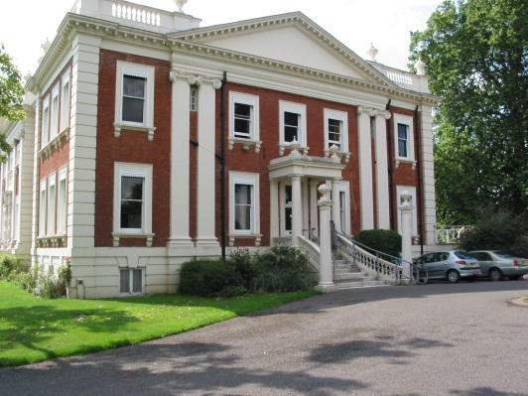
Figure 4.18. Sunbury Court. Author’s photograph.
The walls of the main dining room have been ornamented in a characteristically neo-Palladian style; there is a marble fireplace at one end of the room, balanced at the other end by a large Mahogany credenza. A dado rail divides the wall and on the upper part there are large and small panels; the larger panels take the form of a pseudo picture frame, the outer larger egg and dart moulding is followed by a flat moulding, then a smaller egg and dart moulding, leading the eye into the painted frescoes; the larger frames are also topped with a broken pediment. The larger panels are placed on the major walls of the fireplace, on the credenza, and between the central doors leading out to the garden and the conference room. Between the windows and the corners of the room there are long thin rectangular panels filling the smaller gaps. There are four smaller panels over the four doors, and these panels are depicting an allegorical story.

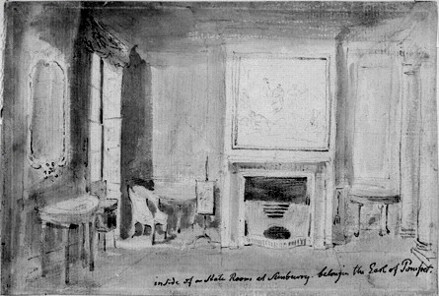
Figure 4.19. View of Stateroom at Sunbury Court, Elias Martin, 1768-80. NMS.

The drawing (figure 4.19) shows the view of the Stateroom at Sunbury Court; it predates the alteration to the staterooms, as doors have now been created either side of the fireplace. These alterations must postdate 1768, when Elias arrived in England, and predate 1780, when Elias left London for Stockholm. Following their marriage in 1764, Anne Marie Delegard and George Fermor, used Sunbury Court as their main London residence until 1799. They could have been made aware of the young aspiring Swedish artist through many of the guests attending their dinners and themed balls held at Sunbury.

It may also have been possible that George Fermor, the 2nd Earl of Pomfret, as Lord of the Bedchamber and Ranger of the little park in Windsor, would have known Sir William Chambers, as they were both in the employment of the king.

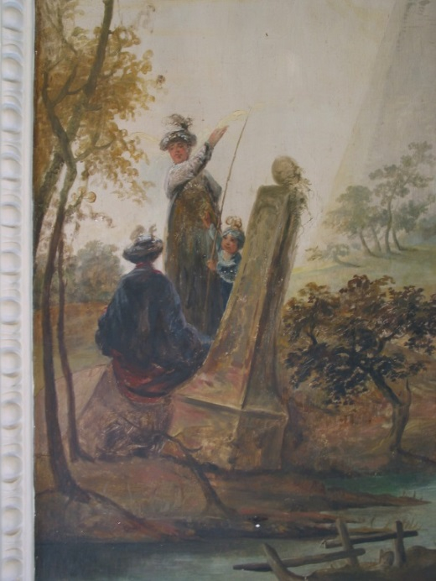
Figure 4.20. Wall Fresco detail, showing a landscape with figures in oriental dress, State Room, Sunbury Court, Elias Martin, circa 1770, Author’s photograph.

4.4.1 Martin’s Paintings at Sunbury Court
Research, to date, has not uncovered any documents that help with the subject matter that Martin painted at Sunbury. It is not established whether Martin was given free rein with what he painted or whether the second Duke specified what he would like the theme to be. The subjects for the six panels, at first glance, appear to be traditional romantic landscapes. When examined more closely, the pictures show classical ruins, houses/buildings with a pyramid-styled roof, Gothic towers, and cottages and farm buildings, the design of which is not what would normally be found in the English countryside.

The figures in the paintings depict fishing and farming, supplemented by families in Oriental dress; in this context these are sometimes referred to as ‘staffage’. In her introduction to the Arts Council exhibition in1963, Gabrielle White refers to this style of painting as capricci. The depiction of farming and fishing in Martin’s landscapes has not been unusual, but the panels at Sunbury are the first time that we see figures in oriental dress. Martin had not undertaken a Grand Tour, so he would not have seen first-hand the traditional clothing of Eastern cultures. It was not unusual for the grandees to have their portraits painted while they were dressed in Eastern costume; they would often hold ‘themed’ balls where the guests would be expected to wear fancy dress.

Anne Marie Delegard, was a well-known socialite before she married George Fermor. Following their marriage in 1764, Sunbury Villa became their main venue for entertaining, as can be seen from the following description:

It was during this period that the estate was thrown open to the higher circles of English society. Guests were treated to sumptuous dinners, and regal balls in the stately mansion, roamed the vast gardens dotted with decorative pools, and gazed across a vista of pastures and orchards separated from the mansion onto the grounds of the house itself without an unsightly fence that would destroy the view.

So, it would seem that the themes for the paintings might have come from Anne-Marie Delegard and George Fermor, to give a fanciful air to their lavish dinner parties. The smaller thin, tall infill panels, containing foliate scenes, are reminiscent of the panel at Danson painted by Charles Pavillon.

The four over doors are quite different in their subject matter and presentation. They seem to be telling a story of the transition from good and evil; the good is represented by a pair of cherubim, evil by goat or satyr. The four paintings have all the attributes of the story of the Roman God Faunus, but Martin has interpreted the story using cherubim.

In the first picture the cherubim may be observed playing as the transitions from good to evil start to unfold - one of the cherubs is shaking the base of the tree fruit from the tree to dislodge the yam hanging from above.

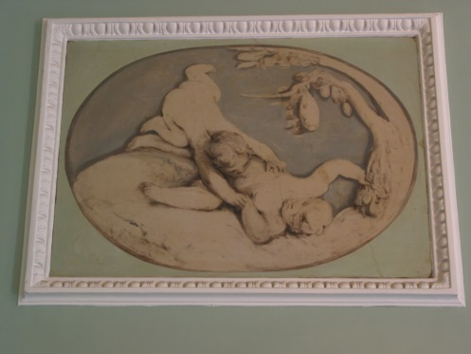
Figure 4.21. First over door, Elias Martin

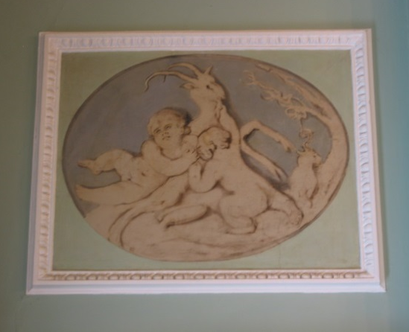
Figure 4.22. Second over door, Elias Martin

In the second picture the two cherubim are evident: one is being encouraged to drink the milk from a satyr, and to the right we see a cat-like creature with crescent horns with the branch from the tree forming a question mark over its head, while in the foreground the yam can be seen, having fallen from the tree in picture one.

In the third picture one of the cherubim has now developed cloven hooves and is being encouraged to drink (wine) from a cornucopia by the other. In the background to the right a pitcher is seen possibly being the source of wine. Here a wreath is being placed (possibly of ivy) on the cherub’s head.

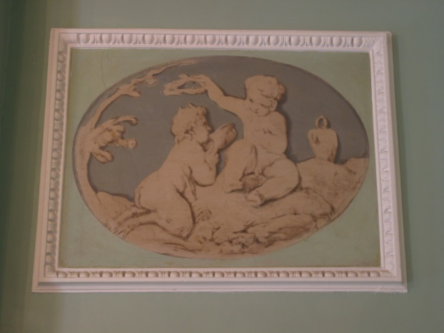
Figure 4.23. Third over door, Elias Martin

In the fourth and final picture the two cherubim are playing, the transition complete. Both have cloven hooves with horns and one is teasing the other by holding aloft a cornucopia containing flowers.

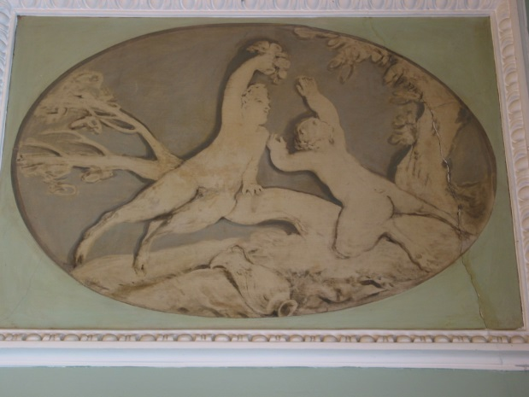
Figure 4.24. Fourth over door, Elias Martin

Martin had a very subtle, but sometimes wicked sense of humour; which he has depicted here, illustrating the relationship between Anne Marie Delegard and George Fermor. Anne Marie Delegard was by all accounts one of the century’s great heiresses, a luminary of English society; George Fermor, while he was very powerful and influential, had a very placid personality. Martin saw that Anne Marie was the dominant partner in the relationship and has depicted this in these four paintings. We see her turning her husband from a studious hard working diplomat into a fun loving, party giving socialite.

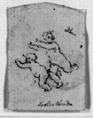
Figure 4.25. A drawing of two cherubim playing, Elias Martin. NMS
In picture one (figure 4.21), Martin has depicted Anne Marie Delegard and George Fermor as two cherubim. Anne Marie presents herself in the form of a normal cherub, and we see the two cherubim are playing; the one on the ground (Anne Marie) seems to be shaking the tree in order to get the yam to fall. In the second picture (figure 4.22), the cherub (Anne Marie) is seen encouraging George to drink the milk of the goat (Satyr), and a yam can be seen in the foreground. From the previous picture, a devilish character on the right is questioning the wisdom of taking the milk. In picture three (figure 4.23), we see the transition almost complete; the cherub (George) has developed cloven feet, horns and a wisp of a tail, and is now being offered wine, from a cornucopia, supplied from the pitcher, while the other cherub (Anne Marie) is placing a wreath on his head. In the final picture (figure 4.24) the conversion of George is complete. Anne Marie reveals herself as a disciple of Bacchus by revealing her own cloven hooves and horns and proceeds to tease George with a cornucopia of fruit, while in the foreground we see a jug, depicting wine, meaning that he is now a disciple of Bacchus with a love of good food, drink and the bacchanalia, or in their case, dinner parties, balls and entertaining in a lavish manner.

4.5 Painshill Park
At Sunbury Court the capricci style was represented in two-dimensional forms as paintings on the walls of the dining room. At Painshill Park we see capricci interpreted in three dimensions. Painshill Park was created between 1738 and 1773, by the Honourable Charles Hamilton, 9th son and 14th child of the 6th Earl of Abercorn. A painter, plantsman and brilliantly gifted and imaginative designer, he dedicated his creative genius to the composition of a landscaped park, which was unique in Europe. Hamilton was born in 1704, and educated at Westminster and Oxford University; he embarked on his first Grand Tour in 1725, his second in 1732, and it was on this second tour that he cultivated his great interest in the arts. Like many other English gentlemen, he acquired a collection of marbles and paintings to import into England, and his collection of busts of Roman emperors was probably unique among English collections.

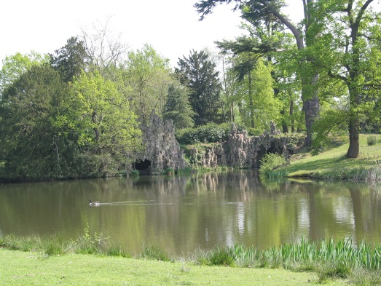
Figure 4.26. View of the lake, with ruin in the background, Author’s Photograph

4.5.1 The Park
In 1738, Hamilton began to acquire land at Painshill; the original purchase contained five farms. He then began buying fields adjacent to his farms to form the basis for his park, and by the end of 1738 had acquired over two hundred and fifty acres. His idea for his park was to move away from the more formalised geometric layout, to one of a more naturalistic style. With his plan to create a romantic landscape to stimulate the senses and the emotions of visitors, Hamilton was at the vanguard of this picturesque movement. The park was divided into two parts; the ornamental pleasure grounds to the south with the lake as the central feature, and the adjoining crescent of open parkland to the north laid out in a free natural style.

The pleasure grounds were composed of a series of scenes that were continually changing, surprising and mystifying. Hamilton used contrasts in architectural style, landfall and planting, to create the effects, together with the lake and river vista. Painshill was very much the garden of ‘moods’, which change from one part of the grounds to the other. The mood is reinforced in an eclectic mix of buildings, each giving a different experience for the visitor. As one promenaded through the park one would stumble across an amphitheatre, a Gothic tower, a Chinese bridge, a temple dedicated to the God Bacchus, a Turkish tent, cascade and water wheel, and a grotto island.
Having completed the park, Hamilton ran out of money and sold the estate in 1773. It passed through a series of owners who cherished and maintained the park until it fell into decline after the Second World War and in 1948, following the sale of the park from the Combe family to Baroness de Veauce, Baroness de Veauce proceeded to divide the park into sellable lots and sold them off. Due to the quality of the materials that Hamilton had used to build these follies, many of them remained intact during this turbulent period, although some had collapsed and had become overgrown with neglected vegetation. In 1981, the trust was formed, which with the help of the local authority, purchased the greater part of the original park. A period of restoration followed, stabilising and re-establishing the original features and in 1998, the project was awarded the Europa Nostra Medal for “the exemplary restoration from a state of extreme neglect of a most important eighteenth century landscape park and its extraordinary buildings”.

It is clear that because of Hamilton's radical and innovative approach to landscaping, by 1770 Painshill had become the ‘must see’ attraction. As early as 1748, Horace Walpole had already visited Painshill; “I have been to see Mr Hamilton's near Cobham, where he has really made a fine place out of the most cursed hill”. There are many other anecdotal references regarding Painshill, but good reference material is decidedly lacking, bearing in mind that they had become the most renowned and influential gardens of the eighteenth century.

4.6 Summary
4.6.1 Danson
In this observation of the work, carried out by various architects, artists and craftsmen at Danson, the relationship between John Boyd, William Chambers, and Elias Martin has been reassessed. I have challenged some of the ideas put forward by Lee, Miele and Higgott (2011) in relation to the dates when some of the work was conducted.

When discussing the interior design for the principal floor of Danson, and in particular William Chamber’s role in designing and supplying a number of objects for the dining room, library, and saloon, the correspondence between Boyd and Chambers is decisive. Many historians have taken the date 1770 as the year that Chambers undertook the majority of the work at Danson; some believe that 1768 is a more realistic date, as this is when Martin came from Paris to London, bringing with him the landscape painting by Vernet for Boyd and subsequently introducing Chambers to Boyd.

The ability to communicate by letter was on the whole very fast, possibly better than travelling by carriage, where to travel any distance in person may have taken days. When discussing projects undertaken by Chambers, it is very easy to forget that he would be working on a number of projects at the same time. He undertook quite a heavy workload, not only in terms of designing, but also on the smaller projects he was architect, clerk of works and quantity surveyor, and paid the tradesmen/ craftsmen himself, claiming the fees back from the client. On a larger project he would get the tradesmen/craftsmen to settle their accounts directly with the client. Add to this the fact that he was a prolific letter writer, keeping his clients updated with progress, as well as discussing with them what was required; to achieve this he would build up a good rapport with his clients. Supplying them with good quality drawings for them to approve, whilst he was not averse to them making minor adjustments or suggestions to the designs, once the design had been approved he would then take full control of its manufacture.

He wanted to give his clients the best possible result, by using good quality materials and the best craftsmen that he could find, and to this end he amassed a broad range of talented craftsmen whom he could rely on to reproduce his designs to the highest quality. It is worth mentioning some of Chambers’ craftsmen who may have worked on the Danson objects: Joseph Wilton, stone carver; Sefferin Alken and Robert Ansell, wood carvers; and Samuel Norman, gilder.

It is also worth noting that when discussing famous craftsmen, authors frequently talk in the plural, that is to say, when referring to an object by the sculptor Joseph Wilton, a cabinet by Thomas Chippendale, carving by Grinling Gibbons, or even the design by William Chambers. Behind all these famous craftsmen and architects there would be a workshop/studio, and within these workshops/studios, there would be a number of skilled craftsmen and apprentices who would be supporting the head of the workshop. Their role would be to source the materials, prepare the materials ready to make the objects and in many cases undertaking the initial making of the objects, so that it was only necessary for the master to add the finishing touches. Examining the output of any famous artists of the time, it would be unlikely for them to have carried out all the work on their own.

In terms of design most architects, artists and craftsmen did, to a certain extent, recycle designs; it makes sense, after taking the time and trouble to develop a design, to reuse it as often as possible. This does not mean that designs do not evolve, because they will over time, but within certain periods where particular motifs are ‘fashionable’ they will get re-used and adapted. In many cases the recycling of designs for marquetry, carving and gilt brass, provides us with clues to the attribution of the object, particularly in the absence of a signature. As mentioned earlier, there had been a number of obvious relationships, which when looked at individually seem not to be connected. With the research undertaken here, it has become apparent that individual paths have crossed, friendships have been made and these have led to associations in later life.

Chambers in particular had a reputation for seizing opportunities in life; on his Grand Tour he recognised, quite early in his stay in Rome, that the associations and friendships he made with the milordi, artists and craftsmen, may well pay dividends later in his career. By the same token, he was also very supportive to artists and craftsmen who may have wanted to visit England, or wanted to find employment in England, particularly if he had met them whilst abroad or they came from his native Sweden. Chambers understood the value of networking which is the basis of entrepreneurship.

Reassessing the circumstances which led to Chambers and Martin working at Danson, a different, more integrated set of commissioning and design relationships is revealed than the current hypothesis put forward by Lea, Miele and Higgott (2011).
When Martin was in Paris around 1767, possibly contemplating his move to London, it would have made sense for him to contact friends or fellow artists before embarking on such a journey. As discussed earlier, Martin was probably working for, or at least in contact with, Roslin. Chambers met Roslin in Paris in 1752, and kept in contact by letter. It would be reasonable to suggest that Martin or Roslin contacted Chambers to say that Martin was proposing to come to England in 1768, and Chambers would very likely have been aware that Boyd had ordered a painting from Vernet, which was due for delivery by March 1768.

If this hypothesis is correct, then Chambers would need to have been working for Boyd before 1768. The design for the fireplace in the dining room is dated circa 1768, but this could be a little earlier, possibly even 1766. The saloon fireplace, which is the same as in the one in Marlborough House, is dated circa 1770s.
On the assumption that the Marlborough House version was the first version and the Danson one was designed subsequently, it is logical to propose that the Danson saloon fireplace was the first version and Chambers then used it in Marlborough House. There is good evidence to suggest that the design and motifs used on the two pier mirrors were being used by Chambers from 1760 onwards, and that the mirrors could have been produced circa 1766-8. The commission to design the picture frames could predate the completion of the canvases, as the design of the frame would need to harmonise with the decor of the room, rather than with the paintings, and the precise sizes of the canvases were known. Following some preliminary designs by Chambers, this commission seems to have been passed to his assistant John Yen (draughtsman) to execute.

After arriving in England in 1755, Chambers slowly started to build up his client base and the friendships and associations developed in Rome started to pay off. Fredrick, Prince of Wales, who was in Rome in 1749, commissioned Chambers to prepare drawings for the House of Confucius, an unusual structure in the form of a two storey hexagon with lattice work windows, a pointed roof, surmounted with a winged dragon.
This Chinese styled building was inspired by Chambers’ voyages to China with the Swedish East India Company. It initially may have looked out of place but was soon joined by the great Pagoda in Kew Gardens in 1763.

He also was appointed drawing master to George, Prince of Wales, in 1756. Following the death of Fredrick, Prince of Wales, Dowager Princess Augusta asked Chambers to lay out Kew Gardens. He was asked to submit drawings for Harewood House Yorkshire, by its owner Edwin Lascelles, but these were rejected as being too ‘avant-garde’, England was still very conservative and the Palladian tradition still prevailed. Success followed, with projects for the Earl of Pembroke at Wilton (1757-9), and the Duke of Richmond at Richmond House, London, (1759-60) and Gower House in 1760. When in 1760, George, Prince of Wales, succeeded to the throne as George III, he appointed Chambers, with Robert Adam, as joint architects to the Office of Works. This final appointment would have confirmed Chambers as one of the up and coming architects of the period, and for someone in Boyd’s position, he would not have gone unnoticed in the circle of the company he kept. A more secure link to their association is the East India Company; the family name of Chambers was associated with the East India Company for many years in Sweden, until Chambers resigned in 1749 and John Boyd became its chairman in 1753.

4.6.2 Woburn Abbey
Looking at the number of architects and craftsman, one possible explanation for the large number of craftsmen employed, is that the 4th Duke was difficult to work for. This conclusion is supported by The Oxford Dictionary of National Biography, which gives us an insight into his personality:

The 4th Duke of Bedford was not tall; Lord Chesterfield referred to him as “bright little grace”. Lord Charlemont commented: “the Duke, a man of excellent parts, though deficient in common sense, was in the highest degree passionate, but perfectly good-natured”. Bedford has a keen sense of his own importance, and his pride and arrogance frequently caused offence. He was certainly strong-willed, but he also had an unwavering sense of duty, though this did not always transform itself into the more mundane tasks connected with his ministerial offices that he held.

When the 4th Duke died in 1771, the Dowager Duchess of Bedford continued to run the estate. Current projects were completed, but no more major projects were undertaken until the 5th Duke took over the running of the estate in 1796.

4.6.3 Sunbury Court
Sunbury offered us a different insight into Martin’s work, and we see him using the capricci style of landscape painting, painted directly onto plasterwork rather than paper or canvas. This style of painting allowed Martin to use his imagination to incorporate scenes from the Grand Tour (though he never undertook a Grand Tour himself), so that guests of Marie Delegard and George Fermor, no doubt in fancy dress, would feel themselves to be in another country as they sat down to dinner.

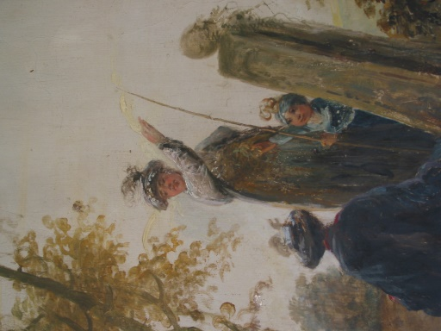
Figure 4.27. Sir Francis Dashwood, Figure 4.28. Detail from wall painting, illustrating
dressed as the Grand Turk figures in oriental dress

The fashion for fancy dress balls was very popular during the late eighteenth century, as can be seen from (figure 4.27) where we see Sir Francis Dashwood, 2nd Bt (1708-81), who has had himself painted wearing a costume of the Grand Turk. Sir Francis Dashwood became infamous for holding lavish parties in the caves at West Wycombe Park, which had a reputation for Bacchic excess, with Dashwood acting as ringleader and master of ceremonies.

The four over doors in the dining room, illustrating the transition from good to evil, support the notion that sometimes the numerous society dinners and celebrations that were prevalent in the eighteenth century ended in drunken debauchery. Martin had been given much more latitude in the conception of the paintings at Sunbury and embraced the opportunity, exploring a style of landscape that would be considered to be unconventional at that time. Martin had explored this concept of capricci before in a number of preliminary sketches, possibly for the commission at Sunbury.

4.6.4. Painshill Park
It is not surprising that we see that, in 1770, Martin had visited Painshill Park, as his love of nature and the natural environment would have drawn him there. Whether he was pleased or disappointed in what he saw we do not know; for Martin, the landscape should have evolved and been shaped by time, not by the hand of a landscape designer. The images we are left with from his visit revolve around the grotto and a view of the Temple of Bacchus. The earliest grottoes were shrines, both built and natural caves at the sites of sacred springs in ancient Greece, to honour the resident water spirits. In ancient Rome, the sea caves around the Bay of Naples, associated with the goddess Venus, were used for dining and entertaining, and inspired marine-styled grottoes. Grottoes to honour Venus were built with a half-dome over an apse to symbolise the birth of Venus from a scallop shell. Architects in Renaissance Italy revived the grottoes of ancient Rome to add an air of historical authenticity to their neoclassical villas and gardens. Renaissance grottoes were decorated with chips of lava rock, coloured marble shells, coral, pebbles and sponge.

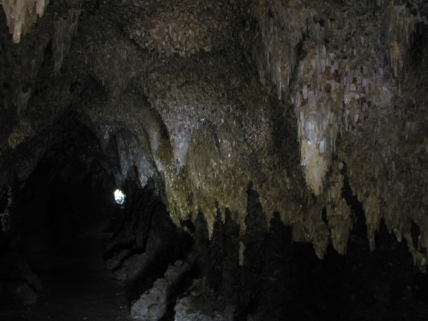
Figure 4.29. Inside the Grotto at Painshill, Author’s Photograph

The English grandees would have seen various types of grottoes whilst undertaking their Grand Tours, so it is not surprising to find them incorporated into their houses and gardens. Martin would have seen the grotto at Woburn Abbey and possibly at Pope's Villa in Twickenham, where he visited and undertook some watercolour paintings. Martin visited a number of other houses throughout his stay, for which a number of drawings and paintings exist; these would seem to have been undertaken for his own interest or as a commission from the owner. The Earl of Upper Ossory, Ampthill Park, Bedfordshire, commissioned two paintings in 1773. In 1774, he exhibited two views of Ampthill Park and a number of portraits, as well as landscapes with colts and horses. The Earl of Waldegrave, at Navestock, commissioned two views of Navestock and three portraits of young ladies.

Martin did not contribute to the design of Painshill, though it gave an important insight into the different ways the English gentry, upon returning to England, following their Grand Tour, interpreted what they saw. At the other great houses that Martin visited, he would have seen fine and decorative art collected and housed within grand buildings. What Hamilton had undertaken at Painshill was to turn this concept on its head, by rebuilding what he saw into a series of follies, built in the open that changed with the seasons and time.

As discussed above, most of Martin’s published works relate to what would now be referred to as the scenery of the Home Counties, based around London. Towards the end of the decade, Martin began to explore the north of England. He travelled further afield, possibly wanting to re-engage with the countryside, and, realising that this was still his first love, he visited Coalbrookdale in Shropshire, in 1779, possibly one of his last excursions before returning to Sweden. While there he undertook a small watercolour sketch of the bridge at Coalbrookdale, being constructed from the new material of cast iron. This unremarkable little water colour painting was to come into its own, when in 2002, ‘Timewatch’ programme attempted to reconstruct a replica of the bridge. Their first attempts failed, until they saw Martin’s image, which clearly showed in his painting, that each of the castings was moulded individually and then assembled on site, like a Meccano kit.

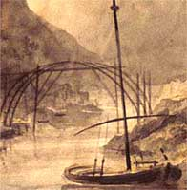
Figure 4.30. Water colour painting of the build of the iron bridge at Coalbrookdale, Shropshire. Elias Martin, 1779, Private Collection

Chapter Five:
Martin’s Return to Sweden and his Final Years

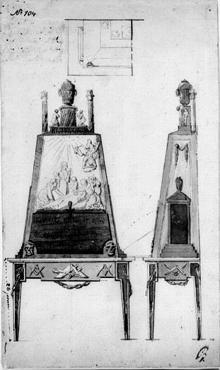
Figure 5.0. Design for a Secretaire, with Masonic emblems, Elias Martin NMS

5.1 Introduction
This chapter gives an overview of Martin’s career upon returning to Sweden in 1780. It examines how Martin extended a number of the ideas that he had developed in London and re-introduced them into his work in Sweden. In order to facilitate his return, Martin composed a letter to King Gustav III of Sweden (1746-1792). In his letter he put forward a number of schemes to be undertaken with the assistance of his brother Johan, for which he was looking to the King for support. It was Sweden’s Foreign Minister, Baron Gustav von Nolcken (1733-1813), who was asked to act as a mediator and a presenter (between Martin and the King), and it was his letter that accompanied Martin’s letter when it was sent to King Gustav III (Appendix 1).

It would seem that Martin’s love of landscape, which he developed from a young age, had become stronger because of living in a busy metropolis. Having spent twelve years in England, Martin, despite having made a good living, decided to return to Sweden to focus on recording the traditions and landscape of his native country. What led up to Martin making this decision to return to Sweden? One possible reason was that he was aware that the incumbent at the time, Carl Gustaf Pilo (1711–1793), was out of favour with King Gustav III. Pilo, at this time, was having difficulties completing a major picture of the King’s coronation. Martin felt this would be a good time to put his name forward to replace him; the Martin brothers had to wait a few months for a reply from the King.

However, as a result of Nolcken’s letter of recommendation, they were eventually called home by the King, according to an article in Stockholmsposten newspaper, Elias Martin had returned to Stockholm at the end of July 1780; we know that he was still in London on 4th June 1780. Johan Fredrik came home in the autumn of 1780.

After working for the King for ten years, Martin briefly returned to England in 1790-2, to re-establish his career, following the decision of Gustav III to go to war with Russia over the ownership of Finland. Gustav III moved parliament to Finland to prepare for war, and this made it inevitable that all work on the decoration of the various Royal Palaces would come to a halt, as all funds were to be channeled into the war effort.

Unfortunately, despite following the trend of the day to move out of London to Brighton and Bath, Martin did not regain the popularity that he had experienced in 1768-80, and he returned to Stockholm in 1792, a demoralised man. His work and health had started to deteriorate, and he relied more and more on his friends to supply him with work. His eyesight began to fail, which prevented him from undertaking small paintings and engravings. One of his last projects was a version of the Ten Commandments, which seems to indicate that he had come to terms with his eventual death. In his final months he became a pauper and had to rely on charity up until his death in 1818.

Martin drew warm and sympathetic sketches of everyday life and his portraits and caricatures are often very expressively rendered. Though this form of art (caricatures) was practiced by many artists particularly in England and Scandinavia, Martin unfortunately became the subject of a number of caricatures himself, particularly in later life.

5.2 Caricature
Throughout the eighteenth century, English artists and cartoonists had used satire to highlight the wayward ways of royalty, politicians, landed gentry, the working classes and, finally, the lower classes. Satirists, like Hogarth, Gillray, Rowlandson and Cruikshank shone a light on what they saw as corrupt and unfair, though there was an unwritten rule in the early eighteenth century that, in satire, one was never to name names (such as in Hogarth’s engravings which ridiculed a type of person).

Martin would have been very familiar with the satirising and moralising prints that would have been circulating in London. While similar prints were being produced in Sweden, there was also a tradition among Swedish artists both to illustrate the letters that they sent to each other, and to ‘satirise’ each other in prints and drawings. Martin’s close friends, Johan Tobias Sergel (1740-1814) and Carl August Ehrensvärd (1745-1800), would illustrate and produce drawings of their fellow artists. A quote from ‘Grove Art online’ illustrates this relationship perfectly:

He (Sergel) documented his relations with artist-friends, such as painters Elias Martin and Louis Masreliez (1748-1810) and the architect Louis–Jean Desprez (1743-1804) with a series of letters. He supplemented his work on portrait busts and medallions with a series of caricatures, among them a number of Gustav III and Carl August Ehrensvärd; Sergel and Ehrensvärd were close friends and maintained a lively correspondence. They inspired each other to produce a stream of drawings, which swing from the solemnly idealistic and the coarsely humorous.

Sergel spent his early career training in Stockholm; he entered the studio of Pierre Hubert Larchevéque (1721-1778) and soon became his assistant. In 1758, he accompanied Larchevéque to Paris where he stayed for seven months, before returning to Stockholm. In 1767, he embarked on his Grand Tour to Italy, eventually staying there for 11 years, before being summoned back by King Gustav III, to take up the position of sculptor to the king.

It was during his return journey in 1778 when he made a visit to London, and on this occasion he produced two watercolours, one of Martin’s studio in Leicester Street (figure 6.3), the other showing that Martin had reached the pinnacle of his success in London (figure 5.1).

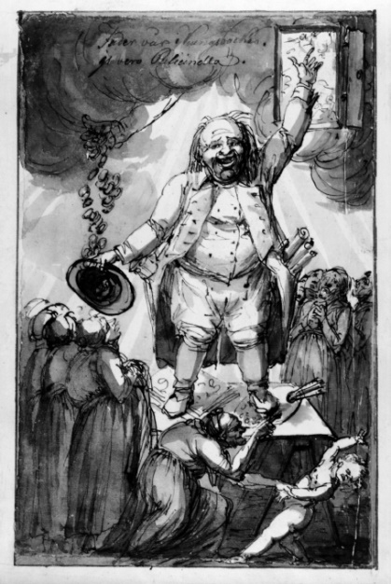
Figure 5.1. Martin preaching in his studio in London at the height of his career, Johan Tobias Sergel, 1779, NMS

In (figure 5.1), we see Martin standing on a trestle table surrounded by an audience of women, transfixed by his posture, waiting for the pearls of wisdom to fall from his lips. In the top left Sergel has written a text, which translates to: ‘trust in your father and the Lord and you will prosper’. This is possibly a comment on one of the few statements that Martin made that have survived, and it was appended to the verso of a drawing:

From very early on I have acquainted myself with everything grand, noble and virtuous in society. My father had virtues, ambition and faith to be a good example to me. Our life was defined by simplicity and we were happy, feared God and studied his creations all of the time. In that way I understood religion and God’s mercy and his deeds of mercy that was the basis for my humane understanding.

His prosperity has come from his paintings, which is illustrated by the artist’s palette under the right foot (as viewed from the front); his drawings, which we see under the left foot, and finally his engravings, which have been rolled up and are protruding from his pocket. The arm on the right hand side of the drawing points skywards to the heavens, confirming his faith in the Lord Almighty, rewarded by the Lord showering Martin with money falling from heaven into his hat, held in the hand on the left hand side of the drawing. Sergel has reiterated what Martin is saying by showing in the foreground a mischievous child pulling away from his mother, not wanting to listen to the sermon from Martin, while his mother no doubt is saying; “listen to what is being said or you will end up destitute”. We can see that Martin’s time in London was successful and productive; had he stayed, he would have certainty continued to prosper, but in returning to Sweden he took the successful ideas that he had established in London and transferred them to his native Sweden. In 1780 from his new home at Regeringsgatan 74, he planned a series of prints for general circulation, Sweden's first voyage pittoresque (picturesque views); they were etched by his brother Johan Fredric Martin, their first collaborative project upon their returning to Sweden.

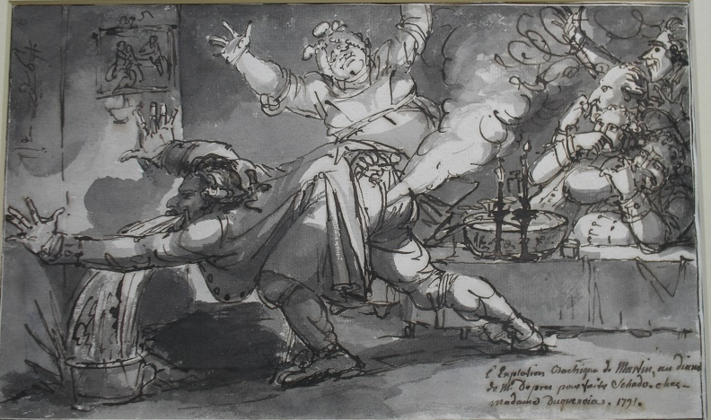
Figure 5.2. Elias Martin being the dinner guest from hell! Johan Tobias Sergel 1791, NMS

As we can see from figure 5.2, Martin was a popular dinner guest. The generosity of his friends was paid back by overindulgence and sickness, and while we can be certain that Sergel is exaggerating, Martin’s circle of friends did diminish as he progressed into old age.

As mentioned earlier, Martin wrote to King Gustav III indicating that he wanted to return to Sweden and asking if he could be considered for the post of ‘Painter to the King’. He was successful in his request and returned to Sweden in December 1780, to take up the post. Possibly more importantly, though, he felt that the taste in landscape painting had changed sufficiently to allow him to bring his own style to prominence. Martin was paid an annual fee by the King, which required him to produce four paintings a year. His career prospered as he took many of the ideas that he had developed in London, around landscape painting, and transferred them to Sweden. He and his brother, Johan Fredrick, travelled around Sweden recording the landscape, taught at the Konstakademien (Royal Academy of Art) and opened a studio in Regeringsgatan 74, where they also held exhibitions.

As their work grew in popularity, they began to attract a number of patrons, many from the iron production industries, which in turn enabled them to subsidise their work with private exhibitions and pupils. However, the King did not take to Martin’s approach to landscape painting, and his main commissions for the King were large figurative paintings documenting court events. A new trend developed in landscape painting in the Gustavian period, where the main focus was on the relationship with Swedish literature, in particular reference to travel writing.

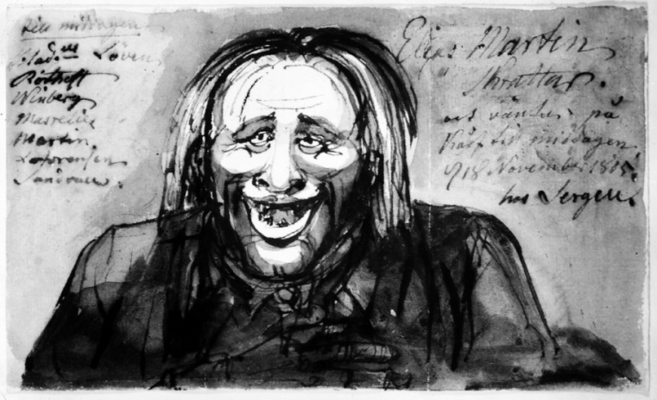
Figure 5.3. Elias Martin skrattar och väntar på korv till middagen (Elias Martin laughing and waiting for sausages for dinner), Johan Tobias Sergel, 1805, NMS

Figure 5.3, shows Martin thirteen years before he died, reliant on family and friends for food. To the left, Sergel has listed his family and friends who were supporting him. The print is entitled, ‘Elias Martin laughing and waiting for sausages for dinner’, Martin’s passion for sausages is a reoccurring theme of Sergel’s work on Martin, as we see in (figure 5.4), a drawing of Martin as a younger man, consuming a large sausage in the form of a cigar.

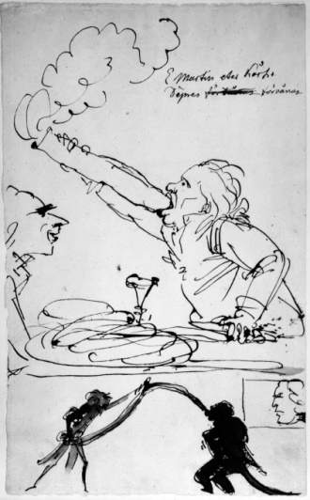
Figure 5.4. Elias Martin äter korv. Desprez förvånad (Elias Martin eats sausage. Desprez surprised), Johan Tobias Sergel, NMS

5.3 Summary
When you study one person so intently, you start to get a feel for their character, personality and persona. I have come to the conclusion that Martin in many respects was a ‘sycophant’ in that he would use people in order to further his own career. My thesis has explored a number of positive aspects of friendship, helping your fellow craftsmen, giving them an opportunity to ‘get on’, but there is a fine line between helping someone and being taken advantage of. When reflecting on the relationships, circumstances and projects that Martin was involved in during his stay in London, they could be interpreted either as a gesture of mutual benefit to both parties, or, as one party gaining an advantage over the other.

Martin’s relationship with Chambers was very strong from 1768-72, when he instigated his own ideas, bringing members of his family from Sweden to help in his enterprises in London. This could either be construed as giving his brothers a similar helping hand that Chambers offered him or, conversely, as using his close family to further his own ambitions.

As Martin’s health began to fail it seems that he started to take advantage of the strong relationships that he had developed with his brothers, in particular Johan Fredrick. Few letters from Martin survive, but three (two are quoted here) in the National Library of Sweden give us an insight into the deteriorating relationship between Elias and Johan Fredrick. The letter, dated 1794, was in reply to one that Fredrick had sent to Elias; it seems that a third person had informed Johan Fredrick that Elias had been selling his (Johan Fredrick’s) work as his own. He started by asking the reason for them to fall out, this third person was wrong in the rumours he was spreading about Elias. They had had a good working relationship over the previous twenty two years, “such a good example that when they die they should put up a monument to the success of the relationship” and concludes by saying “as God is my witness, I would not cheat on you”. He then goes into the arguments that favour the virtues of trust.

A father gives his son away to learn about life. A mother will follow her son or daughter into their first job to make sure that the employer is giving good reports and putting food in their mouths. A poet who gives his work to a printer and a poor old lady who has to ask for work.

We may never know who was right, but as Martin became poorer, he may well have had to resort to selling his brother’s work as his own to make a few Riksdealers.
We can gauge the state of Martin’s health and ability to work from the second letter, dated 1796, to the Royal Secretary and old friend and former pupil, Carl Jonas Linnerhielm (1758-1829). On the 23rd July 1796, he was an administrator and had ordered topographical and religious engravings from Martin.

Martin started his letter by apologising for not replying earlier, but he had been ill, he said, and had left Stockholm for the countryside (Uppeland) to recuperate at the house of a good friend. Martin said he admired him for gaining such a good position and was not jealous of Linnerhielm. Martin was tired of Stockholm and felt it was full of liars and cheats. Linnerhielm had asked for some engraving from Martin, but he stated that “his eye sight was poor and he could no longer do small engraving, his hands shook and he needed a walking stick to get around”.
Martin had undertaken some sketches, “which he would bring around to show him, the engravings would cost 8 Riksdealer each and there were six in the set”. This letter reiterates Martin’s position with regard to his ability to work and to his friends, in this case an old student supplying him with work. Eight Riksdealer each does seem a little expensive, and Linnerhielm, I am sure, realised that he was paying above the going rate in order to help Martin financially.

Martin died in 1818 aged 79 and is buried in the churchyard in the centre of Stockholm, Sweden. The design of the stone follows a design by Sergel, which he had developed for King Gustav III.

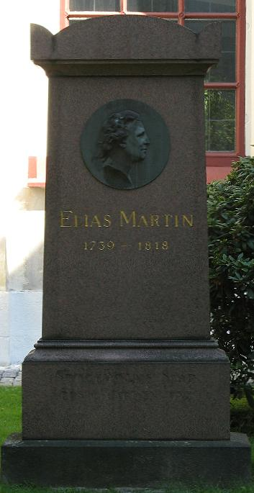
Figure 5.5. Elias Martin’s grave, in Adolf Fredrik´s church and churchyard, in the centre of Stockholm, Sweden

Conclusion

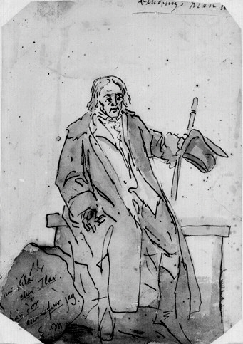
Figure 6.0. Self-Portrait, Martin as an Old Man, Elias Martin, NMS

6.1 Introduction
The main aim of this thesis has been to study the painter Elias Martin’s career, by focusing primarily on the period 1768 – 80, while he was working and living in England.

Chapter one explores Martin’s early career in Stockholm and Finland, and outlines various influences that led to his decision to move and work in London. This may have been due to his realisation that his family’s reputation was on the wane. Martin, aged fourteen, was originally apprenticed to his father as a cabinet-maker, he subsequently left his father’s workshop to study drawing and painting. During his career as a cabinet-maker, his father, Olof, had undertaken a number of commissions for King Gustav III and was an active member of the cabinet-makers’ Guild. His younger brother Carl Gustaf Martin (1746-1788) was also apprenticed to his father (1759-1762), but upon approaching the end of his apprenticeship, his training was considered not to be up to the Guild’s required standard and he had to undertake another apprenticeship between 1762-66.

Sweden, like England, was a monarchy state, and as such was hierarchical; to obtain a position in the government, you had to have connections within government circles. By leaving Sweden and making a name for himself elsewhere, Martin was able to return to Sweden with status, which allowed him to obtain a good position (artist to the king), teach in the national art school and open his own studio.

The added advantage of travelling through Europe was that Paris and London were still considered to be the centres of fashion in the late eighteenth century. The King and the aristocrats of the Scandinavian countries wanted to be seen to have the latest styles, and by encouraging their artists and craftsmen to return home, after having worked abroad, in Europe in particular, they knew that they would bring back with them their knowledge and understanding of the latest styles and trends.

While Martin would have found London an exciting place, he was at heart an opportunist; throughout his career he was not afraid to seize the moment, always looking for opportunities to better himself.
His decision to move from Sweden to Paris, in 1766, following a period in the Swedish Shipyards in Finland, enabled him to take his artistic training to the next level. Attending the Ecole des Beaux Arts, the French Academy of Arts, and working in the studio of Alexander Roslin, allowed him to develop as an artist in one of the most enlightened capitals of the world. The fact that Martin was primarily a landscape artist, which was considered the lesser of the two artistic professions (landscape and history painting) in Paris, could have persuaded him to accept the offer of couriering the painting from Vernet to Boyd in London in 1768.

Chapter two explores Martin’s early period in London, and his relationship with Sir William Chambers and the Swedish Circle of Émigrés in London. Chambers planned to create a Royal Art School, which was inaugurated in November 1768 by a memorandum presented to George III, and he must have had the seed of this idea some months beforehand, which he may have discussed with Roslin by letter, who may in turn have mentioned it to Martin. The opportunity for Martin to be part of this new venture, where he would be part of a new art school, which would have an extensive range of taught subjects, was sufficient for him to make the decision to move to London in March 1768.

Martin joined The Royal Academy in 1769 and was made ARA in 1770, when at this time Chambers was treasurer of The Royal Academy, and supported his election. As Martin’s and Chambers’ relationship grew colder, Chambers’ support for him dwindled and he did not receive any support from Chambers when applying for Royal Academy status in 1772 (figure 2.2).

By 1770, Martin had found his feet; he had married and moved into a new studio in Dean Street, which had allowed him to expand his circle of friends and acquaintances and welcome other Swedish émigré craftsmen from various disciplines into his studio to work. We now see less collaboration with Chambers, but possibly more importantly he had gauged the mood of the London art market, and he started to look for opportunities to broaden his operation. He began by bringing his brother, Johan Fredrick, from Sweden and training him to be an engraver, sending him to the workshop of Bartolozzi.
There, Johan Fredrick started to engrave his brother’s work and they also produced sets of prints of their own design. As was the practice of the day, Martin advertised that he was about to produce these sets of prints and would receive subscriptions before he produced them. The topics of the prints that he produced were in a similar vein to Hogarth’s, in that their subjects highlighted the virtues of family life. From 1774 when he moved to his last house in Leicester Street, Leicester Fields, he sold these prints directly to the public through his studio which he opened to the public on three day per week (figure 6.3).

Chapter three examined how a network of social, religious, business and family
relations extended Martin and the Swedish Circle’s sphere of influence. By 1771, Martin’s second brother Carl Gustaf, who had trained as a cabinet-maker in Sweden, was also in London working from Dean Street. He changed his name to Carolus Martin, exhibiting work at the Society of Free Artists in 1771-2. There is no record of him exhibiting after that date; this may be due to him leaving Dean Street to either set up his own workshop or going into partnership with another cabinet-maker. In the Banks collection of trade cards, held at the British Museum, there is a card for Watson & Marten, at 12 Bartholomew Close, West Smithfield; the trade card had been designed and engraved by Fredrick Martin, Elias Martin’s brother, but also Carolus Martin’s brother, (Carl Gustaf).

I would propose that if Carolus left Dean Street around 1773, to go into partnership with Watson, it would be logical to ask your brother to design and engrave your new trade card. It would seem that the partnership prospered, as according to Sir Ambrose Heal’s Dictionary of London Furniture makers, by 1790 they had become Watson, Peters & Marten. This hypothesis is contra to Lucy Wood, who suggests that Carolus Martin subsequently anglicised his name to Charles and had a workshop at 79 St Johns Street, West Smithfield.

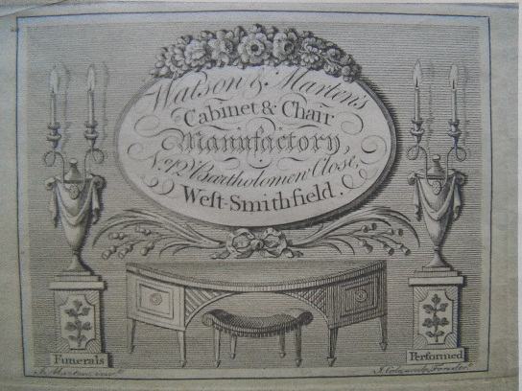
Figure 6.1. Trade card for Watson & Marten, BM

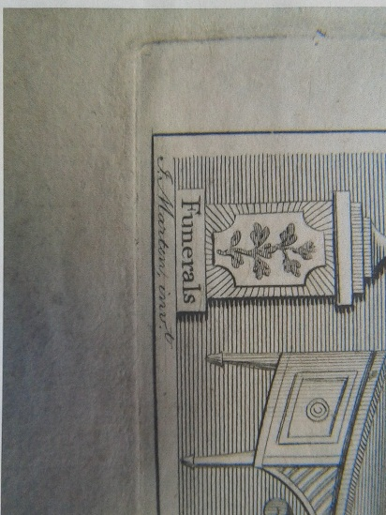
Figure 6.2. Detail of Johan Martin’s signature, BM

Martin’s client base continued to grow, with him taking on a number of commissions in the form of landscape painting, portraiture, and recording London life in his travels. He also continued to draw a wide range of material across the decorative arts field with designs for furniture, ceramics and metal work (See appendix VII). By 1774, he moved to his final studio/house in Leicester Street, Leicester Fields, where he stayed until he left London in 1780.

Leicester Street, Leicester Fields, was a very up market address with many writers, poets and artists frequenting the area. Martin’s studio was open three days a week for members of the public to see and purchase his work, mainly prints and drawings displayed in a revolving unit, and to buy materials (figure 6.3); he was also operating a distance learning drawing course (see 6.2 further research). The shop and studio again demonstrate Martin’s entrepreneurial skills in selling his own work from his own shop, rather than selling his prints through a print seller and selling a range of artist materials direct to the public.

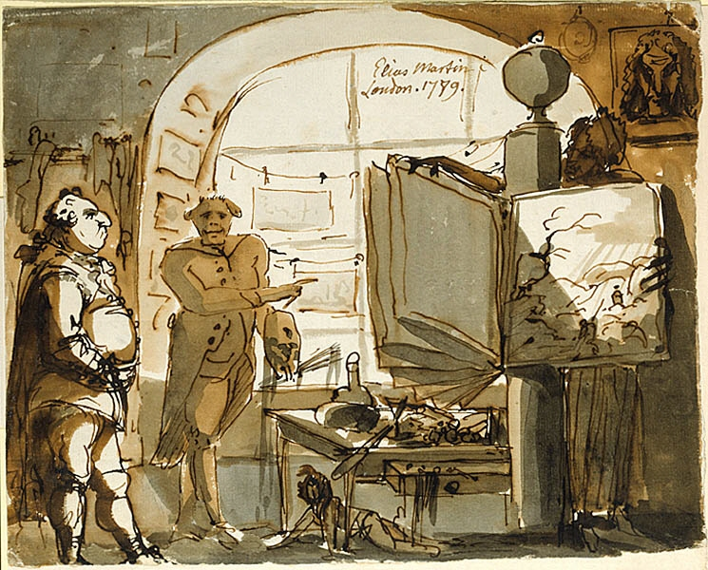
Figure 6.3. Elias Martin in London, Johan Tobias Sergel, 1789, NMS

This chapter has also considered the ways in which the church and the freemasons played an important role in extending professional networks. The church and its congregation would have been a good source of networking for the members of the ‘Swedish Circle’ as well as affluent members of society, who possessed both town houses and country seats. Martin’s role in the Freemasons is still unresolved, in that to date no records of him joining a lodge in London have been found. Yet evidence seems to suggest that when he returned to Stockholm he joined the Scottish Lodge “Glindrande Stiernan” Shining Star, indicating that some contact with freemasonry in London was made.

Throughout this chapter I have explored how these various networks gave members of the Swedish Circle a much stronger alliance, which would have enabled them to collaborate on projects, sharing their skill sets among the group.
Chapter four offers insights into Martin’s time in London through numerous projects, and his support from William Chambers. Martin’s relationship with Chambers from their first meeting at Danson went from strength to strength; Martin undertook painting and drawing at Danson and went on to work with Chambers at Woburn in 1770. It is unfortunate that while the drawings survive (Figure 4.2 and Figure 4.16), the paintings for both these houses are currently lost.
Martin’s journey through his growing independence in London allowed him to develop his portfolio of work and instigate a number of ideas for expanding business. Through the series of projects at Danson, Woburn Abbey, Sunbury, and Painshill, and through his paintings which he exhibited at the Royal Academy and the Society of Artists, this research offers an overview of the working relationships between a number of patrons, artists and craftsmen working in London in the latter part of the eighteenth century. Boyd’s employment of Pavillon assisted him in ordering the principal picture for Danson from Vernet, so even outside the Swedish circle we can find examples of co-operation between patron and artist. This co-operation allowed these building/refurbishment projects to proceed as smoothly as possible by everyone working together and helping one another.
The final chapter examines how Martin extended a number of the ideas that he had developed in London and re-introduced them into his work in Sweden. In his final year in England he embarked on a grand tour to reaffirm his love of the English Countryside. This tour confirmed his growing awareness that he wanted to return to his native Sweden to focus on this aspect of his art.

While London was a vibrant place for Martin, with ample opportunities to make money, I feel he yearned for the countryside. While other artists were making a good living producing portraits and landscapes for the English aristocracy - Reynolds for example would charge eighty Guineas for a full length portrait - Martin was happiest capturing everyday working life in the towns and countryside. He did undertake a number of portraits and landscapes pictures: his painting of Mistley Hall in Essex, which is part of the collection at the National Museum Stockholm, is a typical example of his work (Figure 6.4).

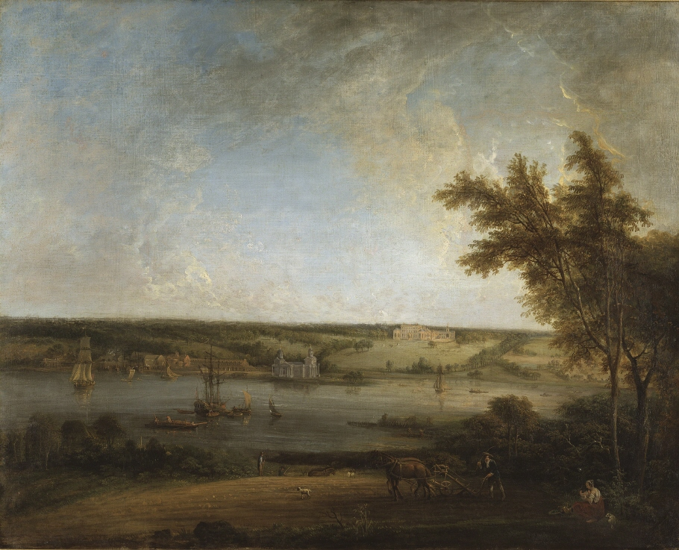
Figure 6.4. Mistley Hall, Essex, Elias Martin, circa 1772, NMS

When we look at the landscape we can see that the house itself plays a minor part in the composition, as it is set back on the horizon; it seems that Elias wanted to draw our attention to the idyllic English countryside (romantic landscape). In the foreground we see a farmer ploughing a field, in the lower right corner we see a lady sitting, possibly his wife, and there is no doubt that she has brought refreshments to the workers in the fields, and then as we look a little further we see another ploughman.
Behind this scene is the river Stour with ships on the move and at anchor, delivering goods to the village of Mainningtree, then in the distance we see Mistley Hall. The Hall is Palladian in style; a grand flight of stairs leads up to a three window break fronted central section, flanked on either side with a two window façade, a grand house, to which the painting does not do justice.

Martin’s style of painting landscapes had become a fusion of two styles; the first goes back to the artist Claude Lorraine and the ideal of the paintings of the late seventeenth century. The composition uses warm evening light, examples of which he would have seen in English country houses and exhibitions at the Royal Academy and the Society of Artists, during the early months of his stay in London. The second influence comes from his association with Joseph Vernet, who was his tutor when he was in Paris (1765–68); the bright horizon and the play of light on the darker trees is an example of this. The painting also shows a common trait of Martin, when dealing with figures, in which the humans are completely out of proportion to the surrounding landscape.

If we compare this with the landscape of Danson House by George Barret (figure 6.5), we see the house is centre stage, the owner, Richard Rigby, is shown on horseback with members of his family promenading in the bottom right-hand side. So here we see the painting conveying wealth and status, which was the fashion of the day.

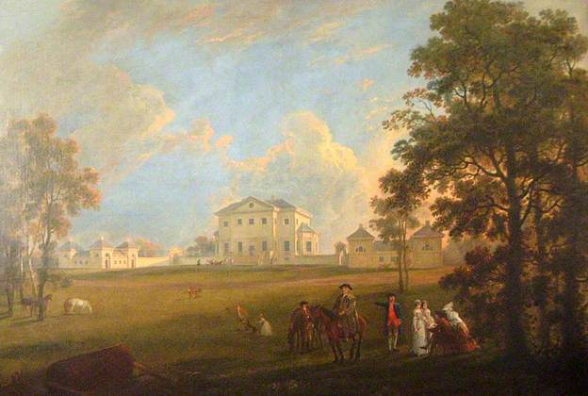
Figure 6.5. The front of Danson House, George Barret, circa 1768, Bexley Trust
Martin was not a prolific portrait painter, at least not from a commercial point of view, as many of the surviving portraits tend to illustrate family and friends; they also tended to be quite small in size, more cabinet pictures then grand house pictures.
His portrait of his brother (figure 5.6), Johan Fredrick Martin, an oval of 30 inches (760mm) x 24 inches (620mm), is probably one of his larger portraits; his more traditional portraits (i.e square) average at 20 inches (500mm) x 20 inches (500mm).

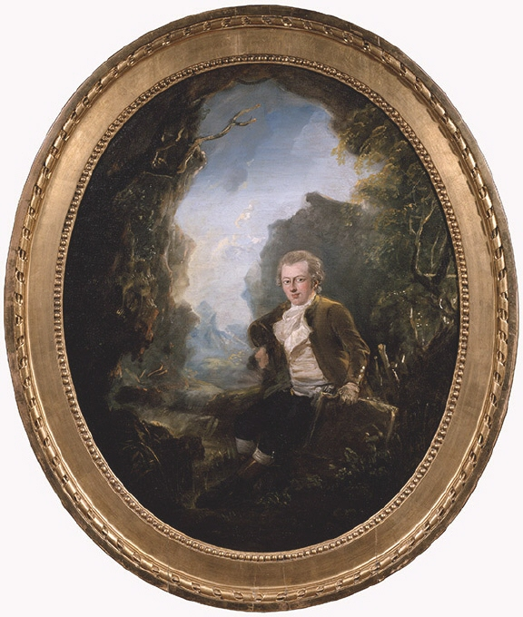
Figure 6.6. Johan Fredrick Martin, Elias Martin, circa 1780 NMS

We see Martin more at ease as a landscape painter and illustrator, recording everyday activity; with reference to his portraits, it seems that he was unable to reproduce a true likeness of his subjects. He appears to have let the satirical side of his personality influence his work; a number of his portraits seem to very subtly extenuate the sitter’s character, so each picture has a slight hint of ‘caricature’ – a strategy that preoccupied much of his later artistic career until his death in 1818.
His technique for producing ‘caricatures’ in his drawings and paintings, was sometimes enhanced by the use of strong dark lines or shadow, to give shape and form to his subjects, which tended to exaggerate their proportions. An example of this can be seen in (figure 6.0.), ‘Self-Portrait, Martin as an Old Man’, where we see the head and face out of proportion to the body.

6.2 Further Research
Research into Elias Martin’s time in London has thrown up many areas of research, which were beyond the initial scope of this thesis. Areas that warrant further research include the following:

6.2.1 The City of London
There is still more work to be done in looking into the relationship between the various patrons of the artists and craftsmen, particularly the Martin family, within the Swedish Circle. The City of London, politics, government appointments, sugar plantation owners, and slavery are all areas that connected the wealthy elite mentioned in this thesis. The relationship between patrons who worked in the City, such as Boyd at Danson, and the Rigbys at Mistley Hall in Essex, whose income came from similar sources warrants further explortion. Rigby’s father and immediate ancestors made a fortune as merchant drapers in the City of London, as merchants and colonial officers in the West Indies, and as speculators in the South Sea Bubble. Richard Rigby’s father also had the same name, and was significant in the history of Jamaica, serving as its Secretary, the Provost Marshal, and a member of the Royal Assembly in the late seventeenth and early eighteenth centuries.

6.2.2 Martin the Entrepreneur
Following his association with Sir William Chambers, in 1768, by 1770 Martin had increased his portfolio of patrons and had developed a number of new initiatives, which demonstrate his entrepreneurial proficiency:

- He also developed an individual style of selling himself and his work, which was radically new for the rather traditional art market of the late eighteenth century.

- One of his initiatives was to engrave a number of his works, producing a number of sets of engravings, which he would sell by subscription before producing the prints.

- In addition, he developed a distance learning programme for drawing; Martin identified a market for those who wanted to learn in the comfort of their own home, which appealed particularly to women who wanted to learn to draw, but were put off by the male domination of the art profession.

- Martin would send the recipient one of his drawings and they would copy it, and return it to Martin for comment, he would then annotate it with suggestions of how it could be improved and send it back with another drawing to be copied. If the recipient liked the drawings that Martin sent them, they could purchase them, as every drawing had the price written on the lower right hand corner.

- By 1778, he had moved to a new shop/studio in Leicester Fields, which was open to the public three days a week. He mainly sold prints, drawings and artists’ materials and invented a machine which held a number of prints on each arm, which the public could use to view each set of prints.

- His ability to cross borders to a certain degree is unrecognised, in so much that when one studies English print-making of the eighteenth-century his name does not appear, as, of course, he is of Swedish origin. However, his contribution to the London print market was quite large and again attracted a discernible audience who liked his work, style and choice of subject.

The direct selling of prints to the public and the distance learning concept to drawing were both a stroke of genius that remain worthy of further investigation.

6.2.3 Furniture
An object that has perplexed curators and conservators is a secretaire belonging to the National Museum of Stockholm (figure 5.12). The design is pure Scandinavian, but the wood that it is made of and its construction would seem to indicate that it was made in England, most likely London. Lucy Wood argues that the three most likely cabinet-makers are Carl Gustaf Martin (Carolus, then Charles), Christian Linnings and Christopher Fuhrlohg; Wood discards Fuhrlohg, although it could have been made by Carl Gustaf Martin, or Linnings in Fuhrlohg’s workshop. I would agree with Wood’s assessment, that out of Carl Gustaf Martin or Linnings I believe the balance of probability puts the cabinet-maker to be Carl Gustaf Martin.

At the 1771 Free Society of Arts exhibition he exhibited an example of cabinet work in the form of the “top of a box, a new invention of cabinet work”.

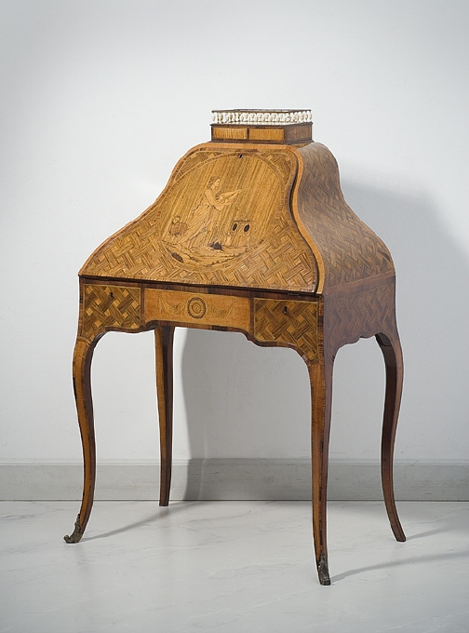
Figure 6.7. Secretaire with marquetry decoration, maker unknown, circa 1772 NMS
This was followed in 1772 with “a drawing for an escritoire, for a lady, in modern taste”, the modern taste refers to the move away from the more rectilinear style to a serpentine shape.
The central panel contains a circular marquetry panel based on an episode in Ovid’s Metamorphoses; this picture represents the theme of "sacrifice". Prometheus, having stolen fire from the gods, had the task of creating the first sacrifice between the gods and men in order to restore a good relationship between them.
The link between the secretaire and Carl Gustaf Martin is two drawings by Elias Martin. (Figure 6.8.) shows a drawing of a sacrifice scene with a young priestess, a young person (possibly the person to be sacrificed) and Prometheus; in the background is a statue of a God.
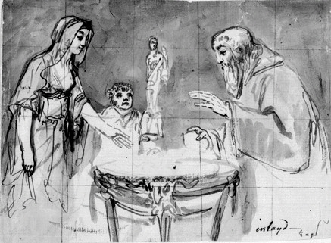
Figure 6.8. Prometheus and Priestess admiring the wonders of fire, Elias Martin, circa 1772, NMS
The drawing is out of character with Martin’s normal drawing style as he has included a grid; he has also titled the drawing ‘inlay’ and half scale, indicating that it is a design for a piece of marquetry and it is to be inlayed into a piece of furniture. This drawing, I would suggest, is the first version of the design for the front of the secretaire, as it differs from the final version. In (figure 6.9) we see a head and shoulders of a young lady, who I would suggest is the possible source for the priestess in the final marquetry.

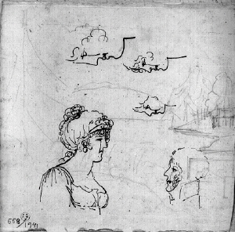
Figure 6.9. Drawing of heads with various face profiles, Elias Martin, circa 1772, NMS
Martin has also drawn a number of additional profiles, paying attention to the nose, mouth and cheeks. The hair, with the Alice band across the forehead and the bun at the back, indicates stylistically that this drawing could have contributed to the design of the marquetry.

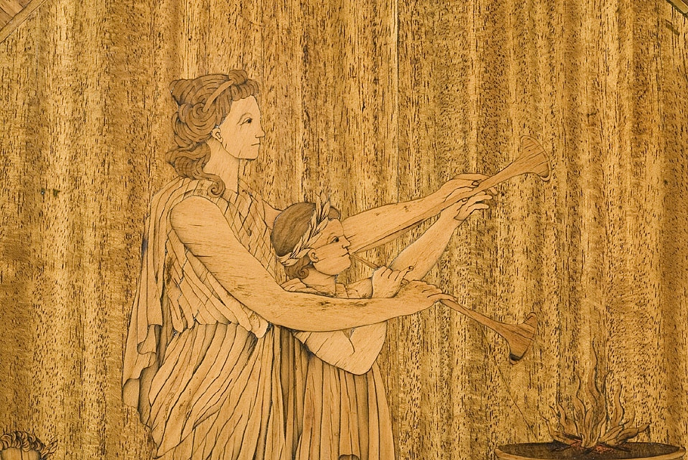
Figure 6.10. Detail of marquetry on front of secretaire, maker unknown, circa 1772, NMS
So again, we see collaboration between Elias and Carl Gustaf Martin, with Elias contributing on this occasion towards the design of the marquetry. The final design may well be Carl’s own work, but the initial design idea probably came from Elias, who would be well aware of the various themes of Ovid’s Metamorphoses, as they have been depicted in art for many centuries. This link between the two brothers with regard to the marquetry tips the balance in Carl Gustaf Martin’s favour over Christian Linnings as the maker of the secretaire. It is possible that Elias Martin also collaborated with Linnings, but as Linnings was an accomplished draughtsman in his own right, we know that he would have been capable of producing his own marquetry design.

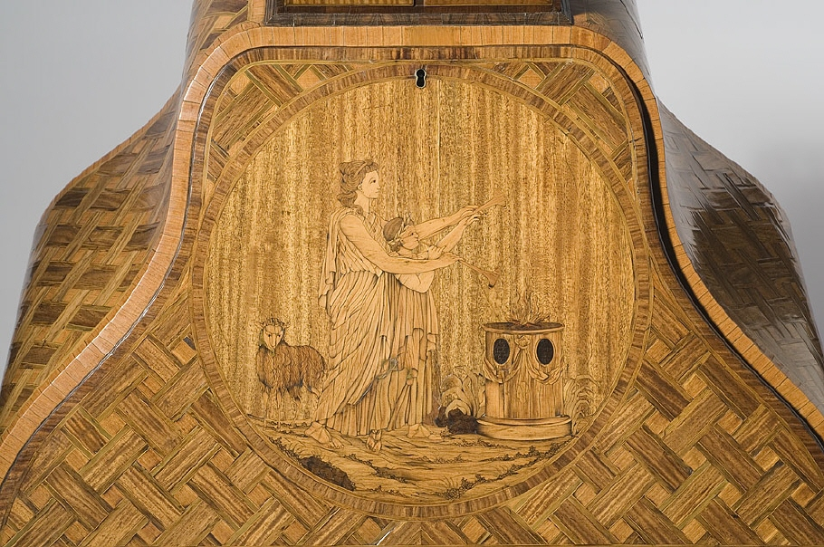
Figure 6.11. Marquetry panel depicting a sacrifice to the gods, unknown maker, circa 1772, NMS

The Historian Lucy Wood did not connect Samuel Martin with his three older brothers (2.3), even though the entries in the dictionary of English Furniture Makers for Samuel Martin support his workshop location close to Charles Martin. The fact that he was an upholder supports Wood’s argument that in subsequent generations the family veered towards upholstery. The lineage of Samuel Martin needs further investigation to confirm that he was not the father of Frederick Martin (1787-1860) and that Charles Martin was the father.

The question of whether Martin was a fully paid up member of a Masonic Society in London is still unresolved, though it is likely that he attended lodge meetings, and the fact that he joined the Swedish Masonic Lodge as soon as he returned to Sweden confirms that he felt that being a mason was beneficial. This is given extra credence when you look at the design for secretaire on page 138. We see that Martin has incorporated into the decoration emblems with strong connections to the Masonic Society.

6.2.4 Artist and Architects
In undertaking the research you come across people who you feel, possibly with a little more research you may be able to make a connection. One name that did appear in a number of documents was a David Martin; he does not seem to have had a relationship with the ‘Swedish Circle’, but his activities warrant further investigation, as they suggest a possible working relationship with Elias Martin.

The late eighteenth century was a boom time for building or refurbishing the great town and country houses. As discussed in this thesis, popular architects Robert Adam and Sir William Chambers were in great demand. Adam’s workload at that point in time was such that he was subcontracting some of the smaller design aspects to others, notably Wilton, Chambers and John Linnell. The relationship between these three possibly needs further exploration, as it seems unlikely that Adam would have liaised with a rival architect such as Chambers, although there are documents that indicate otherwise.

6.3 Contribution to Knowledge
Whilst the subject of this thesis is Elias Martin, in many respects the protagonist is Sir William Chambers, who throughout his career helped so many young foreign artists and craftsmen launch their professional careers in London. It could be said that the ‘Swedish Circle of Emigrés’ came about due to the generosity of Chambers, making London a more inviting location for artists and craftsmen (particularly from Sweden due to Chambers’ Swedish heritage) to gain experience or settle.

In order to support the idea of a circle of friends, I have in some cases taken what may seem to be a number of tenuous unrelated events and drawn them together to make a more plausible picture of relationships, of fellow craftsmen brought together for the mutual benefit of all parties. In other examples, I have re-evaluated current thinking, and through new research put forward a different scenario. I have explored in greater depth the relationships between Elias Martin and George Haupt, and the Martin brothers, and most importantly their relationship with Sir William Chambers.
In primary research, I have looked across different artistic disciplines to discover that there was significantly more co-operation between architects, artist, and craftsmen than many existing texts recognise.

One of the more interesting aspects of undertaking this research and writing this thesis has been looking at the results from a practitioner’s point of view. As an apprenticed trained cabinet-maker and furniture conservator/restorer I have interpreted some of my research in a different way from a traditional academic. Having spent thirty years in the museum sector, with twenty five years at the Wallace Collection, and being surrounded by some of the most knowledgeable curators of fine and decorative arts, I have obtained an understanding of not only the history of a wide range of objects but also of the process and procedure of how they are made.

As a conservator, one of the overarching principles is that you need to understand how an object is made before you can conserve it; as you deconstruct the object you soon realise that what you are dealing with is more than the work of one craftsman. Each craftsman in the eighteenth century was highly skilled and highly trained in his chosen profession; he was not a ‘jack of all trades’, he would have worked with other artists/craftsmen and subcontracted elements outside his skill set, in order to produce an object. While the design is a very important element of any object, be it a building, a ship, a painting or a piece of furniture, in the end it is how the design is interpreted by the people who are building or making it that is more important.

Their training was such that they knew what the architect/designer required, and could deliver it with the minimum of supervision; this is why Chambers and others would often use the same circle of craftsmen time after time. Martin, by bringing his brother, Johan Fredrick, to London, Martin had someone who, once trained, could engrave and help him produce his prints in the style and quality he required; furthermore, he also had a much closer element of control. Thus, by looking at this research from a different perspective, I have contributed to further knowledge in the area of fine and decorative arts.

To conclude, the relationships between members of the Swedish Circle have been investigated and through a number of projects or societies, evidence of a working rapport has been established. At Danson House, I have challenged some of the statements put forward by Lea, Miele and Higgott (2011) to confirm that Chambers was working there before 1768, and that it was the first project on which Chambers and Martin collaborated.

Martin kept in contact with his Swedish contemporaries, and when he felt the time and opportunity were right, he returned to Sweden with far greater status than when he left, and went on to implement a number of the initiatives that he had developed in London.

References

Account of Sources
Bibliography:

Primary Sources

Academy of Art, Stockholm, two diaries of Elias Martin
Bedford Record Office, (Bedford office, account books of the 4th & 5th Dukes)
Bedford Record Office, invoice dated 25th February 1764, The Marquess of
Tavistock for Sefferin Alken, ‘carved work done by order of Mr Chambers’
Bodleian Library
British Library, Chambers W. Letter books, (BL) ADD. MS 41133-7
British Library, S.C. 1484. (C.) Sir John Boyd Bart, sale, sold by Peter Cox, Burrell
and Foster, Tuesday 7th May 1805. A two-day sale of pictures by 21
renowned artists.
British Museum, William Chambers letters books, (BL) ADD.MS 41133 (vol I)
British Museum, William Chambers letters books, (BL) ADD.MS 41134 (vol II)
Chambers W. Plans, elevations, sections and perspectives, views of the gardens and
buildings at Kew, Surrey, 1763
Columbia University, New York, Avery Architectural Library, drawing IC/29
Drummonds Bank, (Royal Bank of Scotland Archives), the bank account of Sir
William Chambers
Groves A. Royal Academy, Exhibitors, 1769 – 1904, S. R. P. Kingsmead 1990
Holborn public library, London rate books
International Genealogical Index (IGI)
Metropolitan Museum of Art, New York, design for pier glass for Adderbury Oxfordshire, formally the home of the Duke of Baccleuch. Metropolitan museum of Art, Harris Brisbane Dick Fund, 1934, 34.78.2(36)
National Museum of Stockholm, NMH 55/1904, Wooburn abby (sic)
Oxford Dictionary of National Biography, John Russell, fourth Duke of Bedford
Oxford DNB Vol 12, edited by H G G Mathew & Brian Harrison, Cobb J
Oxford DNB, Boyd, Sir John (1718-1800)
Oxford DNB, Francis Egerton, Francis Egerton, 3rd Duke of Bridgewater (1736–1803)
Oxford DNB, Joseph Wilton
Oxford DNB, Sir William Chambers
Riksarkivet (The state archives), Anglicana Diplomatica. The dispatch from Nolcken
enclosing Martin's l Elias Martin, letter was sent on 14 January 1780. The
letter and Nolcken's dispatch are also published in Frolich 1939, appendices
III and VI, pp. 272-273, 274-275.
Royal Academy library, CHA/1/19
Royal Academy library, CHA/1/20
Royal Academy Library, The memorandum and subsequent Instrument of Foundation are recorded in: Minutes of the assembly of the Academicians, 14th
December 1768, RAA/GA/1/1
Royal Academy, Directory of Membership. 1996
Royal Academy, list of students, RRA/KEE/1/1/1, 1768
Royal Academy, the Royal Book, list of officers and council members,RAA/GA/7/1,
1768
Sir John Soane’s Museum, drawings for motifs, drawer 42/3/8
Sir John Soane’s Museum, profile & ornaments for the frames over Mr Boyd’s
doors, drawing, 42/38
Swedish Church in London. Book of Communion 1748 - 1816, no 20
Swedish Guild of Cabinet Makers, Stockholm. Copies of original drawing for
‘masterpiece’ item of furniture.
The National Library of Sweden. The Library has four documents of which we were able to look at three. 1. Elias writing to his brother Johan Fredrick; Brev från broden J F Martin in 1794 (1 Konept) 080626. 2. Application for passport, 3rd July1787. 3
Letter to the Royal Secretary and old friend Carl Jonas Linnerhielm. 23rd July 1796
The Royal Academy Stockholm: They have three diaries from the 1790’s
V&A Department of Prints & Drawings, drawing for a bookcase, W102, 207H 7757 Metropolitan Museum of Art, Harris Brisbane Dick Fund, a pedestal (term), 1934,
34.78.2(17)
V&A Drawing Department, Drawing collection, numbers; 7078.2, E4984-1910,
3861.19, 3861.20.
V&A Museum Prints & Drawings Department, Sir Williams Chambers drawing of
elevation of basin bridge at Woburn, accession number 2826

Manuscripts
Diderot D. Rond d'Alembert J. Ed Encyclopédie, ou dictionnaire raisonné des
sciences, des arts et des métiers (Encyclopedia, or a Systematic Dictionary of
the Sciences, Arts, and Crafts) 1757-80

Secondary Sources
Acerbi J. Travels through Sweden, Finland and Lapland to the North Cape in the
years 1798 & 1799. Joseph Mawmanin, 1802
Ahlund, M. PhD Thesis , Uppsala University, published as; Landskapets roster.
Studier i Elias Martins Bildvärld (Landscape Votes: Studies in Elias Martin’s
Imagery), 2011
Ahlund M. Landskapets Röster, studier i Elias Martin bildvärld (Landscape Votes:
Studies in Elias Martin’s Imagery), Atlantis, 2012, p. 187
Baarsen R. Paris 1650-1900, Decorative Arts in the Rijksmuseum, Rijksmuseum,
Amsterdam, 2013
Barker E. Kidson A. Joseph Wright of Derby in Liverpool, Yale University Press,
London, 2008
Beard J. & Gilbert C. David & Roberts, Furniture History Society 1986
Beard J. & Gilbert C. Dictionary of English Furniture Makers, Furniture History Society, W. S. Maney & sons Ltd 1986
Beard, J. Craftsman and Interior Decoration in England 1660 – 1820
Benezit, dictionary of artist, volume 12, Gründ 2006, Sergel, Johan Tobias
Benezit, dictionary of artist, volume 6, Gillray J, Gründ 2006
Bindman D. Hogarth, Thames & Hudson, 1980
Bryan’s Dictionary of Artists, Volume III, Martin, Elias
Burke J. A General and Heraldic Dictionary of the Peerage and Baronetage of the
British Empire, Volume II, Colburn & Bentley, 1832
Cipolla C. (ed), Industrial Revolution, 1700 – 1914, Havester Press, London, 1976
Ashton, The Industrial Revolution (1760 – 1830), Oxford University Press, 1948
Colvin Sir S. Cust L. The History of the Society of Dilettanti, London, 1962
Crow T. Painters and Public life in 18th Century Paris, Yale University Press, 1985
Corpus of Painting Sold in Netherlands during the 19th Century 1801-1810. Vol I
Duggan D. Woburn Abbey, The First Episode of a Great country House,
Architectural History, Vol 46, 2003
Encyclopaedia Britannica, Encyclopædia Britannica, Inc, 2010
Evander S. Sjöström L. Svenska Kyrkan I London, (Swedish Church in London)
1700 – 2000, Ulrika Elaonora Svenska Forsamling, London, 2001
Fredericksen B. Editor, Index of Paintings sold in the British Isles during the 19th C, vol 1, 1801 -1805, Vol II 1806-10, Vol IV 1816-1820. The provenance index, Getty
Information Institute, 1998
Frolich Hans, Elias och Johan Fredrik Martin Gravyrer, (Elias and Fredrick Martin Engravers) Trvcker Ljustrycks, Stockholm 1935
Geertz C. The Interpretation of Cultures, Basic Books N.Y. 1973
Goodison N. Matthew Bolton, Furniture History Society, Oblong 1990
Chambers W. Treatise on the Decorative part of Civil Architecture, 3rd edition,
published in 1791
Goodison N. William Chambers Furniture Designs, Journal of the Furniture History
Society XL, Oblong 1974
Greig H. & Riello G. Eighteenth Century Interiors - redesigning the Georgian, Journal
of Design History, Vol 20, number 4, 2007
Grove Art, Creutz [Crutz], Comte Gustav Filip [Philip]
Hall J. Hall’s, Dictionary of Subjects & Symbols in Art, John Murray publishers,
1989

Harris J. Sir William Chambers, Knight of the Polar Star, A. Zwemmer, London,
1970
Harris J. Snodin M. Sir William Chambers, Architect to George III. Yale University
Press.1996
Hatt M. Klonk C. Art History, a critical introduction to its methods, 2006
Havard H. Dictionnaire de l’Ameublement (1910) Vol 1
Hayward J. Christopher Fuhrlogh, An Anglo-Swedish Cabinet-Maker, The Burlington Magazine, November 1969
Hayward J. A Newly discovered Commode Signed Christopher Fuhrlogh, The Burlington Magazine, October 1972
Hayward J. A further note on Christopher Fuhrlogh, The Burlington Magazine,
July 1977
Hayward J. & Kirkham P. W & J Linnell, Furniture History Society, Oblong, 1980.
Hodges A. Painshill Park, Cobham, Surrey (1700-1800): notes for a history of the
Hodges, A. Painshill, Cobham, Surrey, the Grotto, Garden History, Vol. 3, No. 2
(Spring, 1975)
Hood, T. Hoods own.
Hoppe R. Elias Martins life. Sveriges Allmänna Konstförenings, 1933
Hutchison S. C. Royal Academy 1768-1968, Chapman & Hall – London, 1968
Hutchison S. C. The History of the Royal Academy, 1768-1968
Ingamells J. Hertford - Mawson Letters, Trustees of the Wallace Collection 1982
Jackson H. Shelled Houses and Grottoes, Shire Publications, 2001
Jones R. Manners & Morals, Hogarth and British Painting, 1700-1760, Tate Gallery
Publications, 1987, p.21
Kirkham P. The Careers of W & J Linnell, Furniture History Society, Many & Sons,
1967
Kirkham, P. Furniture-Makers and the Trade Unions, Furniture History Society,
Many & Sons, 1982
Kirkham P. ‘The London Furniture Trade 1700-1870’, Furniture History
Society, Oblong publications, 1988
Kent, N. The Soul of the North: A Social, Architectural and cultural history of the
Nordic Region

Lagrange I. Les Joseph Vernet et la peinture au XVIII siècle... avec le texte livres de
raison, Didier, Paris, 1864
Lea, R. Miele, C. Higgott, G. Danson House, The Anatomy of a Georgian Villa,
English Heritage, 2011
Leiderstam M. See & Seen, dissertation, 2005
Ljungström L. George Haupt, Gustav III:s hovschatullmakare, Kungl. Husgeradskammaren, 2006
Lindhagen, N. Elias Martin painter to Gustav III, Exhibition Catalogue 1950
Longstaffe-Gowan T. The London Square, Yale University Press, London, 2012
Luttervelt, van R. ‘Sweden’s Golden Age’ The Burlington Magazine 1935
McKendrick N. Brewer J. Plumb J. The Birth of Consumer Society, Europa
Publications Ltd, London, 1982
Montfaucon B. de, L’Antiquité expliquée et representée en figures, Paris 1719.
Murray, R. Kronprinsens Barnabok (Crown princess child’s book). Reprint 1983
National Library of Sweden, Print Department, tender mother educating her
daughter from birth to her marriage, six engravings, EM portfolio 1, No 59-65
Northcote J. The Life of Sir Joshua Reynolds, London 1819
Painshill Park Trust, A guide to the Park, Painshill Park Trust 2000
Preziosi, D. The art of art history, a critical Anthology
Rochefoucauld, F. La. A Frenchman’s Year in Suffolk, 1784
Smith C. S. The Company of Artists: The Origins of the Royal Academy of Arts in
London, Modern Art Press, 2012
Solkin D. Painting for Money; The Visual Arts and the Public Sphere in eightieth
century England, Yale University Press, 1993
Solkin D. Richard Wilson, The Landscape of Reaction, Tate Gallery, 1982
Szczelkun S. Introduction to History & Methodology
The McMillan Dictionary of Art volume 10, edited by Jane Turner, Macmillan 1980,
Ehrensvärd, Carl August
The McMillan Dictionary of Art volume 12, edited by Jane Turner, Macmillan 1980,
Gillray James
The McMillan Dictionary of Art volume 28, edited by Jane Turner, Macmillan 1980,
Sergel, Johan Tobias
Thornton P. Rieder W. Pierre Langlois, Ebéniste. (part 1) The Connoisseur,
December 1971
Turner J. edit, The Dictionary of Art, Vol 6, edited by Jane Turner, Macmillan 1980,
Sir William Chambers
Ungersma M. Sunbury Court, Its History, Salvation Army, Lucas design and print,
1978
Westminster Archives, St Anne’s Church Soho, Microfiche, Volume 3
White G. Elias Martin, Arts Council Exhibition, The Arts Council, 1963
Whitley W. T. Artists and their Friends in England, 1700 – 1799, Medici Society,
Vol 1
Wood L. Commodes in the Lady Lever Art Gallery, Liverpool Art Galleries. 1982
Wood L. George Haupt and his compatriots in London, Furniture History Society
Journal, Oblong, 2014
Wood L. A Bonheur-du-Jour at Stourhead: the work of John Linnell and Christopher
Fuhrlohg, The Furniture History Society Newsletter, Oblong, 2010
Wood, L. Pierre Langlois, The Furniture History Society Newsletter, Oblong, 2015

Catalogues
Uppsala University Library, Sweden. Illustrated catalogue – Swedish Painting, published in 2004
Vårutställning 2007 Exhibition catalogue published by the Art Dealer Åmells
Arts Council of Great Britian, Elias Martin, Exhibition catalogue 1963
Olaussen M. Chambers and Sweden, in Harris J. and Snodin M. (ed) Sir William
Chambers Architect to George III, exhibition cat, Courtauld Art Gallery,
London, 1996
Nationalmuseum, Stockholm, illustrated catalogue – Swedish Painting,
Nationmuseum of Stockholm 1995

Newspapers and Journals
Ahlund M. Art bulletin of Nationalmuseum, Stockholm, number 13
Ahlund M. Art bulletin of Nationalmuseum, Stockholm, number 11
Ahlund M. Art bulletin of Nationalmuseum, Stockholm, number 9
Ahlund, M. Art bulletin of Nationalmuseum, Stockholm, number 7
Beard J. Wood carvers of England 1660-1880, Antiques, 2004
British Library, Newspaper annex
Draper M. P. G. The Houses of the Russell family, Apollo, June 1998
Hayward J. A newly discovered commode by C Fuhrlohg, The Burlington Magazine
Vol CXI, Burlington Magazine Publications Ltd, 1969
Hayward J. A further note on Christopher Fuhrlohg, The Burlington Magazine Vol
CXIV, Burlington Magazine Publications Ltd, 1969
Hoppe R. Elias Martin in England, The Burlington Magazine, Vol LXXXIII,
Burlington Magazine Publications Ltd, 1943
Jungmarker (Karl Gunnar) Sergel, Martin, Ehrensvärd, Swedish National Museum
Bulletin, 1955
Landscaped garden, Charles Hamilton, garden history, Vol 2, No 1, (autumn 1973)
Sotheby’s, London, Fine furniture sale, September 22nd
The New York Times, Art Notes from London, 21st July 1912
The Walpole Society, The papers of the Society of Artists of Great Britain, volume 6,
1917-18
Walpole H. Journals of Visits to Country Seats, Walpole society, London Vol XVI
1928
Walpole H. The Journals of the Walpole Society
Watson F. Woburn Abbey and its Collection, Apollo, Kimberly Fortier, June 1998
Letters
Buck A. The Royal Collection
Wright A. The Holburne Museum of Art
Boström A. The Swedish Church in London
Bedford A. Mitchell A. Gravett C. Woburn Abbey.
Hone A. Compton Verney
Lindholm B. Lund University Library
Clements D. The Library and Museum of Freemasonry
Ahlund M. Nation Museum of Stockholm
Gunilla E. Uppsala University Library
Entwistie G. HRH The Prince of Wales Collection
Wettre H. Goteborg Museum of Art
Tovey J. Croome Court
Benington J. Victoria Art Gallery (Bath)
King J. curator at Foundling Museum, London
Akcil J. Sunbury Court
Pomeroy M. Royal Academy of Arts
Winterbottom P. Asset Management, Europe
Wong R. The Royal Library, Windsor
Dashwood E. Sir, West Wycombe Estates
Webber S. Elmbridge Museum
Earl T. Coutts & Co (Bank)
Carter W. Croome Park
Nittnaus W. Nation Museum of Stockholm

Record Offices
London Metropolitan Archive
National Museum, Stockholm
Public Records Office, Kew
Suffolk County record Office
The Bedford Archives, Bedfordshire Record Office
The Bedford Archives, the private property of the Russell family, Woburn Beds.
The British Library
The National Archive of Sweden
The National Library of Sweden
Uppsala University Library, Sweden
Westminster Archive

Appendix I: Elias Martin Letter to the King of Sweden
The All Powerful King!
On behalf of your Majesty’s subordinate, Elias Martin, who is staying here in London and who has asked for my recommendation, I hope that your Majesty would accept the copper engraving of the portrait of your Majesty as a gift. My humble hope is to dare to forward other works by the artist at your Majesty’s feet. Your Majesty who Himself is well known for His own merits can see Himself which of the works by Elias Martin and his brother He thinks are worthy of His acceptance. ~ Elias Martin and his brother are longing to return to their homeland.

They will leave it to our Majesty to decide if His Majesty Himself would like to show them his support. Then they will leave the place where they have found sufficient income.

It is my duty to report that Elias Martin has stayed here for about twelve years and since 1770 he has been a member of the Royal Academy of Arts and during that time he has been productive by making bigger and smaller paintings.
With inexorable loyalty and devotedness etc.
G. Nolcken.

To this, Nolcken’s recommendation letter, the Martin brothers attached the following memorandum:

‘The plan for my upcoming efforts in Sweden.’
- Through Swedish history to become knowledgeable of places in the kingdom that are notable for historical events for both in the past and in the more modern times.
- In the summer time to undertake trips around the country and make detailed drawings of places with notes of the size and dimensions of buildings and make notes on people’s customs, agriculture and fishing equipment ~ in one word to document the character of the areas where I travel for the subjects of my paintings ~ the above mentioned things become part of my own work.
- My brother Johan Fredrick Martin will undertake the teaching of engraving to apprentices (students) and he will teach engraving, especially of the sort which is made with line.
- During our schooling we were both taught mezzotint, with this technique we propose to engrave different kinds of work.
- In copper plate printing in itself it is of great importance for the engraver to know (beforehand) what the print should look like. Thus, my brother Joh. Fred. has dedicated all his diligence to preparing paper, colours and inks. We will train an apprentice to become a professional in these specific areas.
- We will train ourselves in order to start exporting our work abroad hoping that the sale will take care of itself when the price is low and work is of good quality.
Elias and J. F. Martin.

Appendix II: Early Artistic Training:
Most of the major capitals of Europe and Scandinavia had a national school or academy of art to teach promising young artists; many were also supported by Royal patronage. In London during the early period of the Eighteenth-Century, there was no one national school or academy for these promising young artists to attend, though a number of individual artists set up their own schools in an attempt to improve the situation.

The first academy of painting and drawing from life was set up by Sir Godfrey Kneller (1646–1723) in 1711. Kneller was a leading painter during the reign of Queen Anne and was governor of the academy, which was near his home in Great Queen Street, London. In 1716, Kneller’s great rival, Sir James Thornhill (1675-1734) succeeded Kneller as governor of the academy, there then followed a period of unrest within the academy as the two great rivals argued over precisely how the institution should be run. In 1720, these arguments led to Thornhill splitting off to start a new school in Covent Garden and upon his death in 1734, his son-in-law, William Hogarth (1697–1764) took the remaining students to a new site in St Martin’s Lane. The St Martin’s Lane Academy grew from strength to strength under Hogarth’s guidance and it seemed likely that it was destined to become the new British academy.

The Dilettanti Society was formed in 1734, by a group of wealthy, young art loving amateurs, who supported the idea of a British Academy. This led to discussions with Hogarth into transforming the St Martin’s Lane Academy into a British Academy. Unfortunately, the Dilletantis felt that the best way to achieve this was for them to appoint the president from their society and to have a majority number of members on the committee that would run the new academy. As one might imagine Hogarth found this proposal unacceptable, so the idea was dropped.

In 1760, the Society of Artists was formed; its main aim was to promote its members’ work by holding regular exhibitions where their work could be displayed and purchased. By the end of 1760, the most prominent artists of the day (including Hogarth (1697–1764), Reynolds (1723-1792) and Gainsborough (1727-1788)) were members. In 1765, The Society of Artists obtained their Royal Charter; the previous exhibitions had been well received, ticket sales had been high, so the society was financially sound, all that was needed was for them to find a suitable location for a school and the long-awaited British Academy could become a reality.

However, bitter internal rivalry over who was to receive the most advantageous placing of their paintings at exhibitions, and ticket allocation for private views, led to continuing disputes. The most vindictive unrest was caused by the election of a new president. The four most likely candidates were: Joshua Reynolds, Thomas Gainsborough, Sir William Chambers and James Paine (1717–1789). When Reynolds and Gainsborough began to distance themselves from the competition, because of conflicting artistic visions, it left a two-horse race between Sir William Chambers and James Paine who were both prominent architects. It was Paine who won, becoming president in 1770, and thus Chambers vowed revenge, insisting that he would: ‘form another school that it would be eminent over all others’.

Appendix III: The Formation of The Masons
The formation of the Freemasons at the beginning of the eighteenth-century needs to be clarified as it was formed in two parts, which were amalgamated in 1813. ‘The Grand Lodge of England’ was constituted on the festival of John the Baptist, 24th June 1717, at the Apple Tree Tavern, Covent Garden, London. ‘The Premier Grand Lodge of England, according to the old Institutions’ was constituted on the 17th July 1751, at the Turks Head Tavern, Greek Street, Soho, London.

From 1751 ‘The Premier Grand Lodge of England’ was referred to as the ‘Modern’ Masons, their membership being made up of mainly ‘Craft’ based professions. ‘The Grand Lodge, according to the old Institutions were referred to as ‘Ancients’ or ‘Athol’ Masons due to the 3rd and 4th Dukes of Athol having been the Grand Masters. All attempts at bringing the two factions together failed, until H.R.H. the Duke of Kent became Grand Master of the Moderns and H.R.H. the Duke of Sussex became Grand Master of the Ancients. The ‘Articles of Union’ were finally signed on 27th December 1813 and, thereafter, they became known as ‘The United Grand Lodges of England.

The word ‘lodge’ in this context means ‘meeting place’. These meetings often took place in taverns and coffee houses throughout London. The locations often changed over time, through the lodge either outgrowing the venue or amalgamating with other lodges. Each lodge was assigned a number when their warrant was granted; these numbers were sequential, therefore the lower your lodge number, the greater your status. When a lodge closed, or amalgamated, their number would be reallocated to the next subsequent lodge, this meant that the lodge numbers were constantly changing. It was not until 1894, that common sense prevailed and each lodge keep its current number for perpetuity. In quoting lodge numbers, the first number will be the lodge number at the time that the person was a member, and then its current number today.

Appendix IV: Royal Academy Exhibition
The list of paintings, drawing & watercolours exhibited by the Martin Brothers
Royal Academy Exhibition, 1769-1904, ed. Algernon Graves, S.R.P Kingsmead 1970
Martin, Elias, A R A Painter.
At Miss Laverocke’s Milliner, in Mill St, Hanover Square
1769 65 A view of Westminster Bridge, with the King of Denmark’s procession by water, taken from Mr Searle’s Timber yard
66 A landscape with figures and cattle
67 A view in Sweden; drawing
68 A Watchman Sleeping; drawing
1770 124 A picture of the Royal Plaister Acadamy
125 A view of Hanover Square
126 A seaport
127 A ruin
(Elected A.R.A.) Dean Street, Soho
1771 127 A View of the King’s Palace in Stockholm
128 A landscape
129 do
130 do The nurse
1772 148 A View of Wooburn Abbey, and a part of the new bridge
149 Portraits of three ladies. Drawing in chalk (Three daughters of Richard Veron, Esq, prettily done - Walpole)
150 Portrait of a child; drawing in chalk
151 Portraits in fancied dresses; drawing in chalk
152 Two landscapes and four drawings of figures; washed
(In 1772 Walpole writes of Elias Martin: “A Swede, excellent for character and caricatures in washed drawings. He teaches to draw but does not draw well”)
1773 187 View of Pope’s house at Twickenham.
188 View in the Park, Woburn Abbey
189 A landscape
190 A family; in chalks
191 Portrait of a child in crayons
192 The tender mother educating her daughter, from her birth to her marriage; six prints in imitation of red chalk Leicester Street, Leicester fields
1774 171 A large landscape
172 Two views of Ampthill Park, belonging to the Earl of Upper Ossory, with portraits of horses and colts.
173 Two views of Navestock, belonging to the Earl of Waldegrave, with portraits of the young ladies.
174 A landscape and cattle
175 A night-piece; the old woman and her grandchildren
176 Two sketches, in the manner of Salvator Rosa
(The last four were water colours)
1777 227 A View of Pain’s Hill, near Cobham, taken from the Tent
228 A view of Pain’s Hill, taken from the Vineyard
229 A large landscape and figures
230 An offering of milk to Pan, for the restoration of a brother’s health
231 A cabinet-maker enjoying his tipping time
1779 190 St. John in the wilderness
191 A View of Castle Triedrick, on Windsor river, Nova Scotia
192 A Chelsea pensioner
1780 78 View from the Duke of Montagu’s at Richmond
80 Do. Do. Do
(Painter to the King of Sweden.) 15, Trim Street, Bath
1790 95 The Kidnapping of the negroes, as described by Mr. Wadstrom
1790 126 Our first parents in their state of innocence
213 A Swedish soldier relating the events of the war to his family
280 A Swedish soldier’s arrival to his family after the wars
428 An artist and a horse
441 A sailor on his travels, bestowing his small pittance on a child
450 A sailor mending his net, with his family
452 Landscape, with a mother caressing her child

Appendix V: The Society of Artists of Great Britain

The list of paintings, drawing & watercolours exhibited by the Martin Brothers
The Society of Artists of Great Britain 1760-1791
The Free Society of Artists 1761-1783 ed. Algernon Graves, F.S.A. Kingsmead Reprints
Martin, Carolus, Furniture Designer,
Free Society, Dean Street, Soho
1771 159 The top of a box; a new invention of Cabinet work
At Mr. E. Martin’s, Dean Street, Soho
1772 116 A drawing of an escritoire for a lady; in the modern taste
Martin, Elias, A.R.A. Painter
The Society of Artists. At Mrs Pinkley’s, Duke Street, Piccadilly
1768 98 A view of Paris, from Pont Neuf
99 A view of Black-fryar’s (sic) bridge
100 Two landskips, (sic) with figures and cattle
101 A View of Danson, in Kent, in water colours
Free Society
1776 163 A view of Paris, taken from Port Neuf

Martin, John Frederick, Engraver
(Fellow of the Royal Academy at Paris)
The Society of Artists Mr Martin, at Mr Martin’s, Dean Street, Soho
1772 203 A descent from the cross. Mr Frederick Martin, at Mr Martin’s, Dean Street, Soho
1773 165 The milliner; a proof print, in the manner of red chalk. Mr J F Martin, Leicester Street, Leicester Fields
1774 141 The pigeons; a proof print in the manner of red chalk. Mr J.F.Martin, 8 Leicester Street
1778 124 A Landscape; an Engraving (unfinish’d)
1780 173 The Cabinet-maker enjoying his tippling Time
174 Acontius and Cidippe
175 A sacrifice to Pan
176 A Domestic Scene
177 177 A Venus

The Free Society of Artists
Mr John Martin, Dean Street, Soho
1771 157 A drawing, after an original picture
At Mr.E.Martin’s, Dean Street, Soho
1772 117 A drawing of a yard near the Thames side
118 A ditto; its companion
Carl Gustaf Martin
1771 Mr Carolus Martin, Dean Street, Soho
159 The top of a box; a new invention of Cabinet work
1772 Mr Carolus Martin at Mr E Martin’s, Dean Street, Soho
116 A drawing of an escritoire for a Lady; in modern taste

Appendix VI: Elias Martin Studio Addresses

Duke Street, near Piccadilly 1768-9

Mill Street, Hanover Square London, 1769- 70

Dean Street, Soho, 1770-74

Leicester Street, Leicester Fields, 1774-80 (Numbers 8 then 1)

Christopher Fuhrlohg Workshops

24 Tottenham Court Road, London. 1769-1773

George Haupt Workshop Address

24 Tottenham Court Road, London. 1767-8

Between Percy Street and Hanaway Yard

Appendix VII: Examples of Elias Martin’s Drawings Showing the Breadth of his Skill in Other Areas

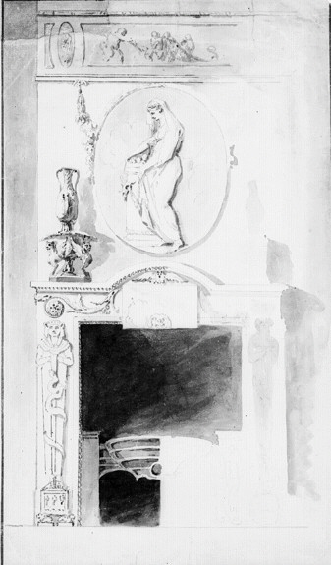
Figure AVII.1 Design for fire place, with over mantle, Elias Martin, NMS 187/188
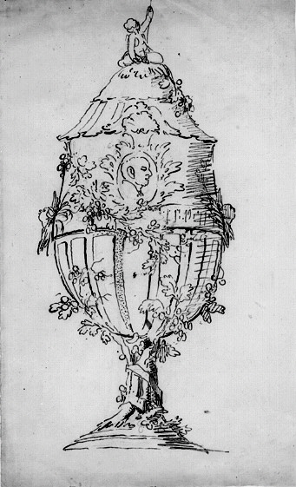
Figure AVII.2 Design for a decorative urn, Elias Martin, NMS 12/1922
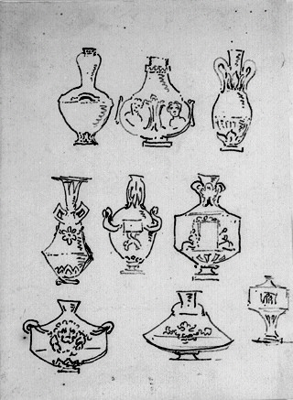
Figure AVII.3 Designs for vases, Elias Martin, NMS 311/1884
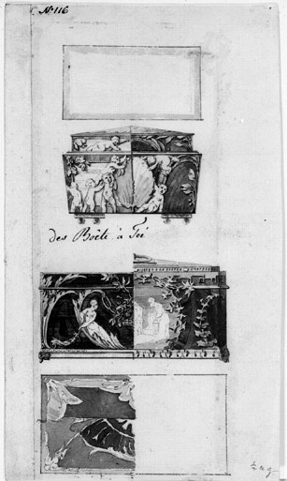
Figure AVII.4 Design for tea caddies Elias Martin, NMS 298/1884
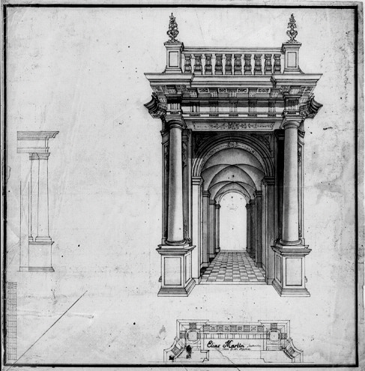
Figure AVII.5 Architectural study, Elias Martin, NMS 569/1890

Figure AVII.6 London Bridge and St Paul’s viewed from Thames side Elias Martin, 1769, NMS 488/1884
The title is incorrect; it is Blackfriars Bridge under construction 1769
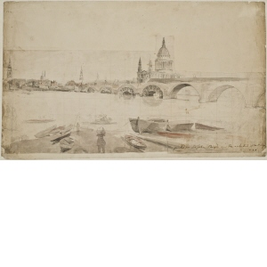

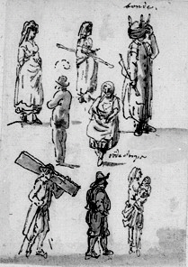
Figure AVII.7 Figure studies, Elias Martin, NMS 244/1884
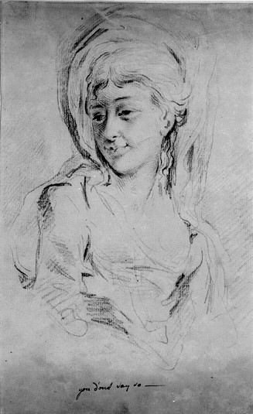
Figure AVII.8 Figure study; ‘you don’t say so’, Elias Martin, (1768-80) NMS 23/1884

R. Hoppe, Elias Martin in England, The Burlington Magazine, Burlington Magazine publications Ltd, Vol. 83, December 1943, pp. 301-304
R. Hoppe, Elias Martin’s life, Sveriges Allmänna Konstförenings, 1933
R. van Luttervelt, ‘Sweden’s Golden Age,’ The Burlington Magazine, Burlington Magazine publications Ltd, 1935, p. 466
Elias Martin; an exhibition organised by Arts Council of Great Britain, 1963
R. Wong, Print Room Assistant The Royal Collection Library, letter dated 14th August 2007. In the Arts Council exhibition and in W. Minchinton, The Northern Seas: politics, economies & culture: eight essays, Pontefract 1968
Y. Chastang, Painting in wood, French Marquetry Furniture, Trustees of the Wallace Collection, Westerham Press, 2001, p. 8
Ada Polak was a Norwegian glass expert, but spent the latter part of her career as a freelance writer, in books, journals, yearbooks, magazines and newspapers
Between 1951 to 1970, Scandinavia began to promote its architecture, design and art with a series of major exhibitions and shows. From 1970 the enthusiasm for Scandinavian art diminished, but of late there has seen a revival in Scandinavian art and design. Swedish Information Service
Jo Headley. Curator of pictures, pre 1800, The Wallace Collection, London, 2008
In particular Danson House with John Boyd (1718-1800), Woburn Abbey and the Duchess of Bedford (Lady Gertrude Leveson-Gower, 1715-1794). This connection with the Bedfords may well also account for work that he carried out for John FitzPatrick, 2nd Earl of upper Ossory (1745-1818) at Ampthill which is situated close to the Bedford Estates in Bedfordshire.
While published texts have looked into how this aspect of artists and craftsmen moving from country to country has influenced their work. A. Kidson The Liverpool Art Scene, Joseph Wright of Derby, exhibition catalogue Liverpool, Yale University Press, 2007, p.31
C. Cipolla, ed, Industrial Revolution,1700–1914, Havester Press, London, 1976. Ashton, The Industrial Revolution (1760–1830), Oxford University Press, 1948
N. McKendrick, J Brewer, J. Plumb, The Birth of Consumer Society, Europa Publications Ltd, London, 1982
H. Greig, G. Riello, Eighteenth Century Interiors - redesigning the Georgian, Journal of Design History, Vol 20, number 4, 2007, p. 289
E. Barker, A. Kidson, Joseph Wright of Derby in Liverpool, Yale University Press, London, 2008. Wright’s work was to stimulate a new appetite for depicting science and industry, notably through his use of light to bring the innovations of industry to life.
L. Wood, Commodes in the Lady Lever Art Gallery, Liverpool Art Galleries, 1982
L.Wood, George Haupt and his compatriots in London, Furniture History Society Journal, Oblong, 2014
L. Ljungström, George Haupt, Gustav III:s hovschatullmakare, Kungl Husgeradskammaren, 2006
L. Wood, George Haupt and his compatriots in London, Furniture History Society Journal, Oblong, 2014
L. Wood, Pierre Langlois, The Furniture History Society Newsletter, Oblong, 2015
R. Hoppe, Elias Martins life, Sveriges Allmänna Konstförenings, 1933
R. Hoppe, Elias Martin, The Burlington Magazine, Burlington Publications Ltd, 1943, pp. 302-305
J. Hayward, Christopher Fuhrlogh, An Anglo-Swedish Cabinet-Maker, The Burlington Magazine, Burlington publications Ltd, November 1969, pp. 648-655
J. Hayward, A Newly discovered Commode Signed Christopher Fuhrlogh, The Burlington Magazine, Burlington publications, 1972, pp. 704-714 and J. Hayward, A further note on Christopher Fuhrlogh, The Burlington Magazine, Burlington publications Ltd, 1977 pp. 486-493
P. Kirkham, The Careers of W & J Linnell, Furniture History Society, Oblong, 1967, pp. 29-44
S. Evans, Osterley Park and House Guidebook, The National Trust, 2009, pp. 6-9
P. Kirkham, ‘The London Furniture Trade 1700-1870’, The Furniture History Society, Oblong publications, (1988)
H. Frolich, Elias och Johan Fredrick Martin’s gravyrer, Ljustrvck Stockholm, 1939
Illustrated catalogue – Swedish Painting Nationalmuseum, Stockholm, Nationalmuseum, 1995
Art bulletin of Nationalmuseum, Stockholm, Nationalmuseum, annually, numbers 7,9,11,13
Academy of Art, Stockholm, Swedish National Library
W. Chambers, Letter books, British Library (BL) ADD. MS 41133-7
J. Acerbi, Travels through Sweden, Finland and Lapland to the North Cape in the years 1798 & 1799, Joseph Mawmanin, 1802, pp. 157-168
D. Solkin, Painting for Money; The Visual Arts and the Public Sphere in Eightieth Century England, Yale University Press, 1993
C. S. Smith, The Company of Artists: The Origins of the Royal Academy of Arts in London, Modern Art Press, 2012
T. Crow, Painters and Public life in 18th Century Paris, Yale University Press, 1985
K. Barker, Joseph Wright of Derby in Liverpool, Yale University Press, London, 2008
T. Longstaffe-Gowan, The London Square, Yale University Press, 2012, p.42
M. Ahlund, Landskapets roster, Studier Elias Martins bildvärld, (Landscape Votes: Studies in Elias Martin’s Imagery), Atlantis, Sweden, 2012.
M. Ahlund, Landskapets Röster, studier i Elias Martin bildvärld, Atlantis, 2012, p. 382
C. Gilbert, G Beard, The Dictionary of English Cabinet-Makers 1660-1840, The Furniture History Society, Maney, 1986
L. Woods, Commodes, Lady Lever Art Gallery Merseyside, HMSO, 1995, pp. 6-7
J. Hayward, Christopher Fuhrlogh, An Anglo-Swedish Cabinet-Maker, The Burlington Magazine, Burlington Magazine publications Ltd, November 1969, p. 493
L. Ljungström, George Haupt, Gustav III’s hovschayllmakare, Atlantis, Stockholm 2006, p. 43.
Fuhrlohg arrived in London in 1767, and as his career flourished he remained in London, unlike his fellow artists who returned to their native Sweden.
J. Hayward, Christopher Fuhrlohg, The Burlington Magazine, Burlington Magazine publications Ltd, Vol. CXI, 1969, pp. 648-55 and Vol. CXIV, pp. 704-11
L. Wood, George Haupt and his compatriots in London, Furniture History Society 2014, Oblong, p. 244
R. Hoppe, Elias Martins life. Sveriges Allmänna Konstförenings, 1933.
C. S. Smith, The Company of Artists: The Origins of the Royal Academy of Arts in London, Modern Art Press, 2012
D. Solkin, Painting for Money; The Visual Arts and the Public Sphere in Eighteenth-Century England, Yale University Press, 1993. Richard Wilson, The Landscape of Reaction, Tate Gallery, 1982
The memorandum and subsequent Instrument of Foundation of the Academy are recorded in; Minutes of the assembly of the academicians 14th December 1768. Royal Academy Library, RAA/GA/1/1
M. Ahlund, Landskapets roster, Studier Elias Martins bildvärld, (Landscape Votes: Studies in Elias Martin’s Imagery), Atlantis, Sweden, 2012.
H.C.G. Matthew, B. Harrison, editors, Oxford DNB, Oxford University Press, 2004, Vol 36, Elias Martin, p. 930
National Museum Stockholm, drawing department, inv num, 285/84
M. Ahlund, Landskapets Röster, studier i Elias Martin bildvärld (Landscape Votes: Studies in Elias Martin’s Imagery), Atlantis, 2012, pp. 57-58
National Museum Stockholm, drawing department, inv num 258/951
H. Ragnar, Elias Martin’s life, Sveriges Allmänna Konstförenings 1933, p. 7
In eighteenth-century use, a genius locus, usually refers to a location's distinctive atmosphere, or a ‘spirit of place’
M. Ahlund, Landskapets Röster, studier i Elias Martin bildvärld (Landscape Votes: Studies in Elias Martin’s Imagery), Atlantis, 2012, p. 384
H. Ragnar, Elias Martin’s life. Sveriges Allmänna Konstförenings, 1933, p. 10
Réau, Histoire de l’Expansion de l’art Français, Payes Scandinaves, Paris, 1931. July 1766. Elias Martin. P De Stockholm
Claude Joseph Vernet, (1714-1789), A full member of the French Royal Academy: 1753
Elias Martin och Hans Krets, National Museum Stockholm, Liljevalchs Konsthall, 1950, p. 11
T. Crow, Painters and Public life in 18th Century Paris, Yale University Press, 1985, p. 20
M. Ahlund, Landskapets Röster, studier i Elias Martin bildvärld (Landscape Votes: Studies in Elias Martin’s Imagery), Atlantis, 2012, p. 55
Evander S. Sjöström L. Svenska Kyrkan I London, (Swedish Church in London) 1700–2000, Ulrika Elaonora Svenska Forsamling, London, 2001
A. Graves, RA exhibitions, 1769–1904, S R P Kingsland 1970, pp. 201-2
L. Wood, George Haupt and his compatriots in London, Furniture History Society 2014, Oblong, p. 244
M. Olaussen, Chambers and Sweden, in John Harris and Michael Snodin (ed) Sir William Chambers Architect to George III, exhibition cat, Courtauld Art Gallery, London, 1996, p. 13
J. Turner, The Dictionary of Art, McMillan 1996, vol VI, p. 410. This somewhat over used quote comes from a series of letters to John Adam. All the English who have travelled for these five years (in Italy) imagine him a prodigy for Genius for sense and good taste. He in great measure deserves their encomium. Though his taste is more architertonick than picturesque, as for grounds and gardens can’t be more Gothic. But his taste for the Bas reliefs, ornaments and the decoration of building, he both knows well and draws exquisitely. J. Fleming, Robert Adam and his circle, 1964, p.192
J. Harris, Sir William Chambers, Knight of the Polar Star, A. Zwemmer, London, 1970, p.10
Royal Academy Library, the memorandum and subsequent Instrument of Foundation are recorded in; Minutes of the assembly of the academicians 14th December 1768, RAA/GA/1/1
R. Jones, Manners & Morals, Hogarth and British Painting, 1700-1760, Tate Gallery Publications, 1987, p.21
J. King, curator at the Foundling Museum, E-mail to Paul Tear dated 10th February 2011
J. King, curator at the Foundling Museum, E-mail to Paul Tear dated 10th February 2011
Royal Academy Library, General Assembly Minutes. 1768, Vol 1, pp, 1-4
Royal Academy Library, The memorandum and subsequent Instrument of Foundation are recorded in; The Minutes of General Assembly of the Royal Academy, 14th December 1768, RAA/GA/1/1
J. Northcote, The Life of Sir Joshua Reynolds, London, 1819, p. 166
A. Graves, Dictionary of membership RA, S.K.P Kingsland, 1996, p. 82
Royal Academy Library, The Minutes of General Assembly of the Royal Academy, RAA/GA/1/1, p. 40
A. Graves, Dictionary of membership RA, S.K.P Kingsland, 1996, p. 82
Royal Academy Library, The Minutes of general assembly of the Royal Academy, RAA/GA/1/1
A. Graves, A Dictionary of Artists who exhibited works in the principal London exhibitions, S.K.P Kingsland, 1901, p. 202
The Athenaeum, January – date? 1832, p. 38. – Journalist, title of article?
Evander S. Sjöström L. Svenska Kyrkan I London, (Swedish Church in London) 1700–2000, Ulrika Elaonora Svenska Forsamling, London, 2001, p. 216
Evander S. Sjöström L. Svenska Kyrkan I London, (Swedish Church in London) 1700–2000, Ulrika Elaonora Svenska Forsamling, London, 2001, p. 217
www.swedish-church.org.uk, accessed on 29th June 2008 & September 2012
Evander S. Sjöström L. Svenska Kyrkan I London, (Swedish Church in London) 1700–2000, Ulrika Elaonora Svenska Forsamling, London, 2001 p. 231
www.swedish-church.org.uk, accessed on 29th June 2008
Evander S. Sjöström L. Svenska Kyrkan I London, (Swedish Church in London) 1700–2000, Ulrika Elaonora Svenska Forsamling, London, 2001, p. 225
The Swedish Church in London. The book of Communion 1748–1816, No 20
The Swedish Church in London. The book of Communion 1748–1816, No 20
Visited the Church on 31st January 2008
Westminster Archives, microfiche, St Anne’s Church Soho, Volume 3
Westminster Archives, Microfiche, St Anne’s Church Soho, Volume 3, XO256/010
C. Gilbert, Pictorial Dictionary of Marked London Furniture 1700–1840. p. 5
The London book trades 1775-1800, Exeter Working Papers in book History, bookhistory.blogspot.com Accessed 10th January 2010
Principal Register of the Probate, Divorce and Admiralty, Division of the High Court of Justice: The last will and testament of Robert Lee, proved in London on the 3rd November 1785.
A. Graves, RA Exhibitions, 1769–1904. S. R. P. Kingsland, 1970, pp. 201-2.
Exeter Working Papers in British Book Trade History, 1, the London Book Trades, 1775-1800: Elias (1771-1773) and David Martin (1769–1779) were recorded working at 62 Dean Street.
John Strype notes that 'Abundance of French people, many whereof are voluntary exiles for their religion, live in these streets and lanes, following honest trades; and some gentry of the same nation'. J. Strype, Critical Observations on the Building and Improvements of London, 1771, p. 72
P. Earle, The Making of the Middle Class, Berkeley and Los Angeles, 1989, pp. 90-3
H.C.G. Matthew, B. Harrison, eds, Oxford DNB.Vol. 36, Oxford University Press, 2004, p. 930. N. Lindhagen, Elias Martin and Hans Kret, Natur och Människor in the reign of Gustav III, Gernandts Boktryckeri, (Nature and People in the reign of King Gustav III, Gernandt Typographical) Stockholm, 1950, p.11. L. Ljungström, George Haupt Gustav III’s hovschatullmakare, (Cabinet-maker) Atlantis, Stockholm, 2006, p. 9
Search.org/England/search/IGI/family_group_record.asp?familyid=314009740, accessed 12/03/2012
Search.org/England/search/IGI/family_group_record.asp?familyid=314009740.WWW.family accessed 12/03/20010. Ulrica Haupt (1716–1769) was the daughter of Elias Haupt from his first marriage to Christina Felix, when Christina died in 1717, Elias re-married to Magdelena Hochfeldt and she gave birth to George Haupt in 1741, so there was a twenty-five-year age gap between step brother and step sister
G. Beard, C. Gilbert, (ed), Dictionary of English Makers, 1660 –1840, Furniture History Society, W.S. Maney and Sons, 1986 p. 324
L. Wood, George Haupt and his Compatriots in London, Furniture History Society, Oblong, 2014, p. 252
J.D. Augarde, Marks on French Furniture and the decree of Parliament of 1749, The Decorative Arts Society Newsletter, Vol VIII, number 4, December 1982, p. 1
A. Pradere, French Furniture Makers; from Louis XIV until the Revolution. Paris, Sotheby’s, 1978, p. 281
P. Kirkham, Furniture-Makers and the Trade Unions, Furniture History Society, Many & Sons, 1982, p. 2
Royal Academy Library, The Memorandum and subsequent Instrument of Foundation are recorded in: Minutes of the Assembly of the Academicians, 14th December 1768, RAA/GA/1/1
The breakfront form and the trellis parquetry reflect Fuhrlohg’s recent training in Paris. The medallion of Diana, however, is in the distinctive style of the painter Angelica Kauffman, who worked in London in the 1760s–1770s. In fact, the medallion on a companion commode is signed in Latin, ‘C. Fuhrlohg, 1772, after Angelica Kauffman’. Fuhrlohg could have been following original drawings by Kauffman, for no engraved source for either composition is known
H.C.G. Matthew, B. Harrison, editors, Oxford DNB, Oxford University Press, p. 928
British Library, newspaper annex, ‘Lloyds Evening Post’, April 22nd 1761
British Library, newspaper annex, ‘Bingley’s Journal’, Saturday 20th July 1771
A. Graves, RA exhibitions, 1769–1904. S. R. P. Kingsland, 1970, pp. 201-2
Exeter Working Papers in; British Book Trade History; 1, the London book trades 1775-1800: Elias (1771-1773) and David Martin (1769–1779) were recorded working at 62 Dean Street
A. Graves, RA exhibitions, 1769–1904. S. R. P. Kingsland, 1970, p. 201-2
British Library, newspaper annex, St James Chronicle, Saturday 6th August, 1774
British Library, Newspaper annex, Public Advertiser. Friday 14th January, 1785
Sir Ambrose Heal, London Furniture makers, Portman Books, London, 1998 p. 112
Victoria & Albert Museum, Apprentice indenture, 1810, misc 21B – 1923
M. H. Port, The Commissions for Building Fifty New Churches, The minute books, 1711-1727. A calendar, London Record Society, vol. 23, 1986, p. 40
W, Atkins, History of St Georges, St George’s Church, London, 1976, p. 1
British Library, newspaper annex, The Weekly Medley, 1717
J. Strype, Critical Observations on the Building and Improvements of London, 1771, p. 63
A. Graves, RA exhibitions, 1769 –1904. S. R. P. Kingsland, 1970, pp. 201-2
W. Atkins, History of St George’s, St George’s Church, London, 1976, p. 80
British Library, Newspaper annex, General Evening Post, St Georges, Hanover square, subscription for the relief of the poor, 1st February, 1776
A direct quote written in old English, where the letter ‘f’ is often used in place of the letter ‘s’
British Library, letters of Sir William Chambers, BL 41134, vol II, letter dated 30th June 1770
E. Harris, Osterley, The National Trust, 1994, p. 24
E. Harris, p. 22
I am grateful to Stephen Asterly, curator of drawings at the Sir John Soane Museum, for this information.
J. Harwood, The Secret History of Freemasonry, Anness Publishing Ltd, 2009, p. 8
The United Grand Lodges of England, Library, London, Records of Premier Grand Lodge, London lodges, Folio 3, p. 12
J. Lane, p. 38
The United Grand Lodges of England, Library, London, Records of Premier Grand Lodge, London lodges. Folio 11, pp. 11-14
The United Grand Lodges of England, Library, London. Records of Premier Grand Lodge, London lodges. Folio 11, p. 12
J. Lane, p. 35
The Library and Museum of Freemasonry, Great Queen Street, London WC2B 5AZ.
J. Lane, p. 35
The Library and Museum of Freemasonry, Registers of the Grand Lodge of the Ancients 1751-1813, lodge roll No 6, F17 – 20, for 1775
Robert Lee wrote his last will and testament on October 5th October 1785, he died on the 2nd November 1785. The sum of his whole effects did not amount to more than three hundred pounds. Robert Lee Testament, Somerset House, 1785
A. Foxley, An Account of the Lodge of The Nine Muses (No 235). London 1940, p. 38
A. Foxley, p. 49
www.oxford dnb.com/view/article/1592.Oxford University Press, 2007, accessed 3rd September 2010
Jane Turner, (ed), Grove Dictionary of Art, New York, 1996. Entry for F. Bartolozzi, Vol. 3, p. 308
A.M Hind, Bartolozzi and other engravers working in England at the end of the 18th Century, Leopold Classic Library, 2015, p. 207
J. Harris, Sir William Chambers, Knight of the Polar Star, Zwemmer Ltd, 1970, pp. 175-6
J. Harris, Sir William Chambers, Knight of the Polar Star, Zwemmer Ltd, 1970, p. 185
Dr Andreas Onnerfors, E-mail to Paul Tear dated 29th September 2010
Membership records of the St Andrews (Scottish) Lodge “Glindrande Stierman” (Shining Star) for December 1779, Stockholm
Dr Andreas Onnerfors, E-mail to Paul Tear dated 29th September 2010
H. Bogdan, An Introduction to the Higher Degrees of Freemasonry. ‘Heredom’, The transaction of the Scottish Rite Research Society, 2006, Volume 14, p. 107
Membership records of the St Andrews (Scottish) Lodge “Glindrande Stierman” (Shining Star) for December 1779, Stockholm
N. Goodison, William Chambers Furniture Designs, Journal of the Furniture History Society Oblong, 1974, p. 78
R. Lea, C. Miele, G. Higgott, Danson House, The Anatomy of a Georgian Villa, English Heritage, 2011
R. Lea, C. Miele, G. Higgott, Danson House, The Anatomy of a Georgian Villa, English Heritage, 2011, p. 52
R. Lea, C. Miele, G. Higgott, Danson House, The Anatomy of a Georgian Villa, English Heritage, 2011, p. viii
R. Lea, C. Miele, G. Higgott, p. 3
Bexley Heritage Trust, Danson (guide book) Jarrold publishing, 2006. p. 18
M. Binney, The villas of Sir Robert Taylor, Country Life, parts 1 & 2, July 1967, p 28
M. Binney, page 28
A. Palladio, The four books of Architecture, 1570
E. Lucie-Smith, Dictionary of Art terms, Thames & Hudson, 1991, p. 145
See G. Barrett’s painting of the front of the house, Figure 4.8
R. Lea, C. Miele, G. Higgott, p. 30
R. Lea, C. Miele, G. Higgott, p. 52
Oxford DNB, Sir William Chambers, p. 2, accessed September 2014
British Library, William Chambers letters books, (BL) ADD.MS 41134 (vol II)
R. Lea, C. Miele, G. Higgott, p. 52
R. Lea, Danson House guide book, Bexley Heritage Trust, 2006, p. 8
I. Lagrange, Les Joseph Vernet et la pienture au XVIII siècle... avec le texte livres de raison, Didier, Paris, 1864, p. 247
R. Lea, C. Miele, G. Higgott, p. 52
T. Crow, Painters and Public Life in Eighteenth Century Paris, Yale University Press, 1985, p. 11. Vernet earned close to one million livres over his career and most of his pictures were spoken for before they left his studio
S. C. Hutchison, The History of the Royal Academy, 1768-1968. Chapman & Hall – London, 1968
Oxford DNB, George Barrett (1732?-1784). Accessed September 2010
Oxford DNB, George Barrett (1732?-1784). Accessed September 2010
S. C. Hutchison, The History of the Royal Academy, 1768-1968, Chapman & Hall – London, 1968
British Library, S.C. 1484. (C.) Sir John Boyd Bart, sale, sold by Peter Cox, Burrell and Foster, Tuesday 7th May 1805. A two-day sale of pictures by 21 renowned artists
British Library, S.C. 1484. (C.) Sir John Boyd Bart, sale, lot 45
The Royal Academy library, CHA/1/19
British library, William Chambers’s letters books, MSS Add 41134, (vol 1) letters 24 & 25
The Royal Academy library, CHA/1/20
Oxford DNB, Boyd, Sir John (1718-1800), p. 2, accessed 21/02/2009
British library, Chambers letters, MSS Add, 41134, (vol 1) letter 30
Sir John Soane’s Museum, profile & ornaments for the frames over Mr Boyd’s doors, drawing number 42/38
R. Lea, C. Miele, G. Higgott, p. 54, reference 38, Nail holes on the timber battens surrounding the opening to the fireplace show that the saloon was lined with wallpaper or damask scrim before Chambers’s fireplace was fitted
R. Lea, C. Miele, G. Higgott, p. 55.
B. De Montfaucon, L’Antiquité expliquée et representée en figures, Paris 1719 Translated into English by D Humphreys, Tomson & Humphreys, London, 1721-5
New York, Columbia University, Avery Architectural Library, IC/29
R. Lea, C. Miele, G. Higgott, p. 54, reference 38. The overall width of the edges of the wallpaper on each side was 5 ft 1 inch, thus allowing 4 inches of frame on each side of the painting together with ½ inch for the rebate for the picture to sit in
¹⁸⁷ William Chambers, design for fireplace, General Ralph Burton's house at Haworth Hall in Hull. Avery Architectural and Fine Art Library, Columbia University
Metropolitan Museum of Art, New York, The Elisha Whittlesey collection 1949
J. Stuart and N. Revett, Bacchus stroking the head of a leopard, Bacchus relief from the Choragic Monument of Lysicrates, Athens, Antiquities of Athens, 1762
R. Lea, C. Miele, & G. Higgott, p. 46. J. Harris, Sir William Chambers, Knight of the polar Star, London, 1970
Oxford DNB, Sir William Chambers, p. 2, accessed September 2009
Milordi, Generic term to describe English gentry on their Grand Tour
Oxford DNB, Sir William Chambers, p. 2, accessed September 2009
Oxford DNB, Joseph Wilton, accessed January 2010
Christies, London, Exceptional Sale, 4th July 2013, lot 18
Christies, London, Exceptional Sale, 4th July 2013, lot 18
Metropolitan Museum of Art, New York, design for pier glass for Adderbury Oxfordshire, formally the home of the Duke of Baccleuch. Metropolitan Museum of Art, Harris Brisbane Dick Fund, 1934, 34.78.2(36)
N. Goodison, William Chambers Furniture designs, Journal of the Furniture History Society XL, Oblong, 1974, p.74
N. Goodison, The design of the Griffin at Blenheim are a more advanced neo-classical design and figure in Chambers, Treatise on the Decorative part of Civil Architecture, 3rd edition, published in 1791, p. 75
N. Goodison, William Chambers Furniture designs, Journal of the Furniture History Society XL, Oblong, 1974, p.74.
V&A department of Prints & Drawings, a bookcase, W102, 207H 7757. Metropolitan Museum of Art, Harris Brisbane Dick Fund, a pedestal (term), 1934, 34.78.2(17). Metropolitan Museum of Art, The Elisha Whittlesey collection, 1949
D. Duggan, Woburn Abbey, The First Episode of a Great country House, Architectural History, Vol 46, 2003, p. 57
D. Duggan, Woburn Abbey, pp. 57-80. For a full account of the transition of Woburn from Abbey to a Palladian house
Oxford DNB, John Russell (1710-1771), accessed 21/02/2009
M. P. G. Draper, The Houses of the Russell family, Apollo, June, 1998, p. 390
M. P. G. Draper, p. 391
M. P. G. Draper, p. 391
M. P. G. Draper, p. 390
M. P. G Draper, p. 392
M. P. G. Draper, p. 391, ‘the Duke would not admit the least variation to be made and would insist on employing his own workmen and making contracts with them’
British Museum, BL.ADD.MS 41133 (vol 1) Chambers letters, p. 18
J. Harris, Sir William Chambers, Knight of the Polar Star, A. Zwemmer, London, 1970, p. 75
Possibly Giovanni Battista Borra, an Italian artist who work for Chambers.
British Museum, Chambers letters, BL.ADD.MS 41133 (vol 1), page 45
M. P. G. Draper, p. 392. (Bedford office, account books of the 4th & 5th Dukes)
British Museum, BL.ADD.MS 41133 (vol 1) Chambers letters, p. 9
British Museum, BL.ADD.MS 41133 (vol 1) Chambers letters, p. 28
British Museum, BL.ADD.MS 41133 (vol 1) Chambers letters, p. 10
British Museum, BL.ADD.MS 41133 (vol 1) Chambers letters, p. 12
Oxford DNB, Francis Egerton, Francis Egerton, 3rd Duke of Bridgewater (1736–1803), the ‘Canal Duke’. He accumulated great wealth through his canal and coal interests, and his annual income was said to have exceeded £80,000. The family owned three estates at the time: Belton House, a small Sussex estate, and the old house and 6,000 acres at his house of Ashridge. accessed 03/09/2009
British Museum, BL.ADD.MS 41133 (vol 1) Chambers letters, p. 28
V&A Museum Prints & Drawings Department, Sir Williams Chambers drawing of elevation of basin bridge at Woburn, accession number 2826
A. Graves, Royal Academy Exhibitions, 1769-1904, S R P Kingsmead 1970, p. 201
National museum of Stockholm, NMH 55/1904, Wooburn Abby [sic]
The Inventory of 1771 was commissioned upon the death of the fourth Duke in 1771. Letter, Woburn Abbey, Mrs Anne Mitchell, Archivist
Access to the Bedford Archives has been limited to date
National Library of Sweden, The tender mother educating her daughter from birth to her marriage,
six engraving, EM portfolio 1, No 59-65
G. Beard & H. Hayward, The Houses of the Russell family, Apollo, June 1998, p. 398
G. Beard & H. Hayward, p. 397
H. Havard, Dictionnaire de l’Ameublement (1910) Vol 1, pp. 810-11.
G. Beard & H. Hayward, page 398.
G Beard & H Hayward, page 400
Old St Pancras church registers, the London record office, recorded as John Peter Langlois
Bedford office, London
Holborn public library, the rate books only commence in 1773
G. Beard & H. Hayward, p. 397
Drummonds Bank, (Royal Bank of Scotland Archives), the bank account of Sir William Chambers
L. Wood, New light on Pierre Langlois (1718-1767). The Furniture History Society Newsletter, No 196, November 2014, for the latest research on Pierre Langlois furniture
F. Watson, Woburn Abbey and its collection, Apollo, June 1998, pp. 382-426
J. Burke, A General and Heraldic Dictionary of the Peerage and Baronetage of the British Empire, Volume II, Colburn & Bentley, 1832, p. 307
M. Ungersma, Sunbury Court, its History, Salvation Army, Lucas design and print 1978, p. 1
M. Ungersma, Sunbury Court, its History, Salvation Army, Lucas design and print 1978, p. 2
M. Ungersma, Sunbury Court, its History, Salvation Army, Lucas Design and print 1978, p. 2
Staffage: Human and animal figures depicted in a scene, especially a landscape, that are not the primary subject matter of the work
G. White, Elias Martin, Arts Council Exhibition, The Arts Council 1963, p. 10. Capricci: means, especially an architectural fantasy, placing together buildings, archaeological remains and other architectural elements in fictional and often fantastical combinations
M. Ungersma, Sunbury Court, its History, Salvation Army, Lucas design and print 1978, p. 1
R. Lea, C. Miele, G. Higgott, Danson House, The anatomy of a Georgian Villa, English Heritage, 2011, p. 45
Satyr: In ancient Greece, a satyr is considered one of the spirits of the woods and mountains, it is identified with the God Faunus in Roman mythology.
The Peerage, thepeerage.com, Accessed September 2010
The Peerage, thepeerage.com, Accessed September 2010
Painshill Park Trust, A guide to the Park, Painshill Park Trust 2000, p. 1
Painshill Park Trust, A Guide to the Park, Painshill Park Trust 2000, p. 2
Painshill Park Trust, A guide to the Park, Painshill Park trust 2000, p. 2
H. Walpole, Journals of Visits to Country Seats, Walpole society, London, Vol XVI, 1928
For a full account of the formation Painshill see; A. Hodges, Painshill Park, Cobham, Surrey(1700-1800): notes for a history of the landscaped garden Charles Hamilton, garden history, Vol 2, No 1, (Autumn 1973), pp. 39-68
R. Lea, C. Miele, G. Higgott, Danson House, The anatomy of a Georgian villa, English Heritage, 2011
N. Goodison, p. 68. ‘As in other houses he made suggestions for objects to be commissioned and controlled and paid the workmen’
In 1764 Sefferin Alken, a caver who Chambers employed on a number of commissions, rendered an account to the Marquess of Tavistock for ‘carved work done by order of Mr Chambers’. Bedford Record Office, invoice dated 25th February 1764
G. Beard, Wood carvers of England 1660-1880, Antiques, 2004, pp. 74-83
J. Harris, Sir William Chambers, Knight of the Polar Star, A. Zwemmer, London, 1970, p.75
British Library, Chambers letters, BL.ADD.MS 41133 (vol 1)
Metropolitan Museum of Art, New York, design for pier glass for Adderbury Oxfordshire, formally the home of the Duke of Baccleuch. Metropolitan museum of Art, Harris Brisbane Dick Fund, 1934, 34.78.2(36)
Sir John Soane’s Museum, drawings for motifs, drawer 42/3/8
V&A Drawing collection, numbers; 7078.2, E4984-1910, 3861.19, 3861.20
J. Harris, Sir William Chambers, Architect to George III, Yale University Press,1997, pp. 57-8
W. Chambers, Plans, elevations, sections and perspectives, views of the gardens and buildings at Kew, Surrey, 1763
J. Harris, Sir William Chambers, Knight of the Polar Star, A. Zwemmer, London, 1970, p. 40
J. Turner, editor, The Dictionary of Art, Vol 6, Macmillan 1980, Sir William Chambers, p. 410
Oxford DNB, John Russell, fourth Duke of Bedford. Accessed on 21/02/2009
T. Knox, West Wycombe Park, The National Trust, 2001, p.48
J. King, curator at the Foundling Museum, E-mail to Paul Tear dated 10th February 2011
Study for the large panel for the east wall of the painted room at Sunbury Court, Elias Martin, Uppsala University library, No 735
H. Jackson, Shelled Houses and Grottoes, Shire Publications, 2001, p. 4.
Woburn Abbey, grotto design by Isaac Caus in 1626 and redeveloped throughout the 19th Century.
Popes villa, home of the poet Alexander Pope, laid out his gardens, which included a grotto, between 1720-1725.
A. Graves, Royal Academy Exhibitions 1769–1904, SRP Kingsland, 1970 p. 201.
Stockholmsposten 3/10 1780. “The news: Stockholm. During the past months some of well-known Swedish artists have returned to their home country. Their exceptional skills cannot but be beneficial to the general public. These include the following: Painter Elias Martin who has specialized in landscape painting. He lived in London for 14 years (sic) where he won all acknowledgements. Sweden would have lost this skillful artist had it not been for His Majesty’s mercy towards arts and science that he called Martin home and engaged him here in Sweden. Martin came at the end of July and his brother Joh. Fr. Martin, who is a skillful copper engraver and who has lived in London for ten years, is expected to come home soon.”
M. Ahlund, Landskapets Röster, studier i Elias Martin bildvärld (Landscape Votes: Studies in Elias Martin’s Imagery), Atlantis, 2012, p. 390
V. Gatrell, City of Laughter, Atlantic Books, London 2006, p.1
S. Södderlind, Lust & Last, Exhibition catalogue National Museum Stockholm, Tryckeri, Falth & Hassler, 2011
J. Turner, Grove Art online, Sergel Johan Tobias, 2 drawings, www.groveart.com. Accessed 30/04/2008
Benezit, Dictionary of Artists, Gründ 2006, vol 12, Sergel, p. 1009
National Museum Stockholm, drawing department, NMS
Oxford, Dictionary of National databases, Elias Martin, www.oxforddnb.com. Accessed 09/08/2014
For fuller overview of Martin’s career in Sweden when he returned in 1780 see; M. Ahlund, PhD thesis, Uppsala University, published as; Landskapets roster. Studier i Elias Martins Bildvärld, (Landscape votes: Studies in Elias Martin imaginary) 2011
Ahlund, M. PhD, Uppsala University, published as; Landskapets roster. Studier i Elias Martins Bildvärld, 2011, p. 387
AhlundM. PhD, Uppsala University, published as; Landskapets roster. Studier i Elias Martins Bildvärld, 2011, p. 388
Louis Jean Desprez 1743–1804 was a French painter and architect who worked in Sweden during the last twenty years of his life, was in the circle of friends of Sergel and Martin, NMS 552/1875
NLS, Brev från broden J F Martin (letter to Brother J. F Martin) in 1794, 1 Konept 080626, p.1
NLS, Brev från broden J F Martin (letter to Brother J. F Martin) in 1794, 1 Konept 080626, p.2. He has annotated the bottom of the letter with a scene of three men around a table two sitting and one standing and on top of this we can see some fine pencil drawings of female heads. There are still more little annotations around the drawing; describing a lady called Anna how beautiful she is and an apprentice who will later become a landscape painter
In the late eighteenth-century 1 Riksdealer equalled approximately 5 guineas
Jonas Carl Linnerhielm, was a Swedish nobleman, State Herald of Sweden, artist and writer. He was taught drawing by Elias and Fredrick Martin
Letter to the Royal Secretary and old friend Carl Jonas Linnerhielm. 23rd July 1796, NLS, 1 Konept 080626, p. 4
L Wood, The Journal of the Furniture History Society, Oblong, Vol L, 2014, p. 252
T. Crow, Painters and Public life in Paris in 18th Century Paris, Yale University Press,1985, p.21
British Museum, Chambers W. Letter books, (BL) ADD. MS 41133-7
Royal Academy Library, The Minutes of general assembly of the Royal Academy, RAA/GA/1/1
A. Graves, The Society of Artists of Great Britain 1760-1791, The Free Society of Artists 1761-1783, Kingsmead Reprints, p. 157
British Museum, Banks collection of trade cards, ref 229/h28
G. Beard, C. Gilbert, Dictionary of English Furniture Makers, Furniture History Society, 1990 p. 951. In the dictionary they have spelt Martin with an i, whereas on the trade card, it is spelt with an e
A. Heal, Sir, London Furniture makers, Portman Books, London, 1998, p. 197
L Wood, The Journal of the Furniture History Society, Oblong Vol L, 2014, p. 258
P. Nicholas "The Ambitious Man". Reynolds (Exhibition catalogue), Royal Academy of Arts 1986, p. 24.In 1760 Joshua Reynolds moved into a large house, with space to show his works and accommodate his assistants, on the west side of Leicester Fields (now Leicester Square)
The Times, Sale Of The Vaile and Other Pictures, 25th May, 1903
British listed buildings, Mistley Hall, www.britishlistedbuildings.co.uk/en-438420-old-mistley-hall-essex. Accessed 5th June 2013
M. Ahlund, Two New Landscapes by Elias Martin in the National Museum, Art Bulletin, National Museum, 1998, p. 14-15
Manningtree Museum.org.uk, Accessed 12th February 2013
L. Wood, George Haupt and his compatriots in London, Furniture History Society Journal, Oblong, 2014, p. 271, endnote 69
L. Wood, George Haupt and his compatriots in London, Furniture History Society Journal, Oblong, 2014, p. 257
Appendix II, Carolus Martin The Free Society of Artists
J. Murrey, (ed) Hall’s Dictionary of Subjects & Symbols in Art, Richard Clay Ltd, 1989, p. 254
J. Murrey, (ed) Hall’s Dictionary of Subjects & Symbols in Art, Richard Clay Ltd, 1989, p. 254. The two priestess’s are entertaining the gods with music before sacrificing the sheep
J. Beard & Gilbert C. Dictionary of English Furniture Makers, Furniture History Society, W. S. Maney & sons Ltd 1986, p. 951
L. Wood, George Haupt and his compatriots in London, Furniture History Society Journal, Oblong, 2014, p.272, note 77
Riksarkivet (The state archives), Anglicana Diplomatica. The dispatch from Nolcken enclosing Martin's l Elias Martin, letter was sent on 14 January 1780. The letter and Nolcken's dispatch are also published in Frolich 1939, Appendices III and VI, pp. 272- 275
S. Hutchison, Royal Academy 1768-1968, Chapman & Hall – London, 1968, p. 26
D. Bindman, Hogarth, Thames & Hudson, 1980, p. 149
Sir Sidney Colvin, L Cust, The History of the Society of Dilettanti, London, 1962, pp. 52-5
W. T. Whitley, Artists and their Friends in England, 1700 –1799, Medici Society Vol 1, p. 165
C. Saumarez Smith, The Company of Artists: The Origins of the Royal Academy of Arts in London, Modern Art Press, 2012, p. 49
J. Lane, Masonic Records 171–1894, The United Grand Lodge of England (second edition), London, 2000, p. 29
J. Lane, p. 21
J. Lane, p. 22
J. Lane, p. 19

