Gibbon, K. C., Debuse, D., Hibbs, A. and Caplan, N. (2017), Reliability and Precision of Sonography of the Lumbar Multifidus and Transversus Abdominis During Dynamic Activities. J Ultrasound Med, 36: 571–581. doi:10.7863/ultra.16.03059
http://dx.doi.org/10.7863/ultra.16.03059

Downloaded from: http://collections.crest.ac.uk/

This document is protected by copyright and was first published Journal of Ultrasound in Medicine. It is published with permission and all rights are reserved.

Usage of any items from Buckinghamshire New University’s institutional repository ‘CREST Collections’ must follow the usage guidelines.

Any item and its associated metadata held in the institutional repository is subject to

(CC) Creative Commons Attribution International (CC BY 4.0)

You are free to:
Share – copy and redistribute the material in any medium or format.
Adapt – remix, transform, and build upon the material.
Under the following terms

- Attribution — You must give appropriate credit, provide a link to the license, and indicate if changes were made. You may do so in any reasonable manner, but not in any way that suggests the licensor endorses you or your use.
- No additional restrictions — You may not apply legal terms or technological measures that legally restrict others from doing anything the license permits.

Please note that you must also do the following;

• the authors, title and full bibliographic details of the item are cited clearly when any part of the work is referred to verbally or in the written form
• a hyperlink/URL to the original Insight record of that item is included in any citations of the work
• the content is not changed in any way
• all files required for usage of the item are kept together with the main item file.

You may not

• sell any part of an item
• refer to any part of an item without citation
• amend any item or contextualise it in a way that will impugn the creator’s reputation
• remove or alter the copyright statement on an item.

Read Bucks New University’s Open Access policy here http://bucks.ac.uk/content/documents/Formal_Documents/Research/Open_Access_Policy.pdf

If you need further guidance contact the Research Enterprise and Development Unit redunit@bucks.ac.uk.

Reliability and precision of ultrasound imaging of lumbar multifidus and transversus abdominis during dynamic activities

Gibbon, K.C.¹, BSc, Debuse, D.¹, PhD, Hibbs, A.¹, PhD, & Caplan, N.¹, PhD

- Faculty of Health and Life Sciences, Northumbria University, Newcastle upon Tyne, United Kingdom

Financial disclosure
The authors have nothing to disclose.

Conflicts of interest
There are no conflicts of interest relating to this work

Corresponding author:

Dr Nick Caplan
Faculty of Health and Life Sciences
Northumbria University
Northumberland Building
Newcastle upon Tyne
NE1 8ST
United Kingdom

Tel: +44(0)191 243 7382
Email: nick.caplan@northumbria.ac.uk

Running title: Reliability of ultrasound imaging in dynamic activities
Abstract
Objective: To determine the intra-rater reliability and precision of measurement of lumbar multifidus (LM) and transversus abdominis (TrA) thickness using freehand ultrasound imaging (USI) in a range of static and dynamic conditions.
Methods: Fifteen asymptomatic participants performed a range of exercises whilst USI was used to measure absolute muscle thickness and change in muscle thickness from rest. Exercise conditions included the abdominal drawing in manoeuvre (ADIM), active straight leg raise (ASLR), contralateral arm lift, both unloaded (CAL) and loaded (LCAL), treadmill walking (WALK) and using the Functional Re-adaptive Exercise Device (FRED). Intra- and inter-day reliability was assessed using intraclass correlation coefficients (ICC), and standard error of measurement was used to assess measurement precision.
Results: Good to excellent reliability was achieved for TrA and LM absolute thickness in all conditions. Measurement precision for absolute LM thickness was ≤2.8mm for CAL, ≤1.8mm for LCAL, ≤3.1mm for WALK and ≤3.8mm for FRED, and for absolute TrA thickness was ≤0.6mm for ADIM, ≤0.5mm for ASLR, ≤0.7mm for WALK and ≤0.5mm for FRED. Good to excellent reliability was achieved for TrA and LM relative muscle thickness in all conditions. Measurement precision for relative LM thickness was ≤3.7% for CAL, ≤3.8% for LCAL, ≤6.3% for WALK and ≤7.6% for FRED, and for relative TrA thickness was ≤13.6% for ADIM, ≤6.9% for ASLR, ≤11.1% for WALK and ≤7.2% for FRED.
Conclusions: Acceptable reliability and precision of measurement is achieved for absolute and relative measures of deep spinal muscle thickness using freehand USI in relatively static and dynamic exercises.

Keywords: Reliability, precision, ultrasound, spinal muscles
Introduction

The recognition of the deep lumbo-pelvic muscles’ contribution to inter-segmental spinal stability has led to the wide-spread use of ultrasound imaging (USI) in rehabilitation and research to assess their activity.¹ Lumbar Multifidus (LM) and Transversus Abdominis (TrA) are deep spinal muscles that are the most widely studied in this context. They make an important contribution to lumbo-pelvic stability due to their anatomical positioning, morphology and function,^{2, 3} including activation during movements in upright postures, often in a manner that is tonic and not specific to the direction or force of the movement ^{4, 5}. Studies of individuals with LBP report atrophy, asymmetry and altered recruitment of deep spinal muscles,^{6, 7} underlining the relevance of well-functioning TrA and LM to lumbo-pelvic health and prevention and rehabilitation of LBP.

Recently, the Functional Re-adaptive Exercise Device (FRED) has been developed to recruit the deep lumbo-pelvic muscles, including the LM and TrA (Figure 1).⁸⁻¹² Unlike conventional exercise devices, the FRED offers no external resistance to motion. This requires the user to maintain a smooth controlled movement whilst maintaining a stable upright posture above an unstable base of support. Previously the device has been shown to recruit both the LM and TrA automatically in an asymptomatic population to a greater extent than simply standing on an unstable base of support.⁸ It has also been shown to promote a more kinematically stable spine and pelvis,¹⁰ as well as a more tonic activation of the deep spinal muscles than walking.⁹ Caplan et al used surface electromyography to study superficial lumbo-pelvic muscle activity, including LM, in response to FRED exercise.⁹ However, surface EMG does not permit assessment of deep spinal muscle activity that are impaired in LBP.

Typical USI assessment of LM and TrA include linear muscle thickness measurements during rest and contraction.¹³ Electromyographic studies have shown that linear muscle thickness change (between rest and contraction) as measured using USI closely reflects muscle activity at low levels (<40 % maximal voluntary contraction).^{14, 15} This makes this non-invasive method a useful alternative to fine-wire EMG for assessing deep spinal muscle activity.¹⁶

To date, numerous studies have examined various aspects of reliability concerning USI and the assessment of LM and TrA during relatively static clinical tests.¹ These studies have used exercises such as the abdominal drawing in manoeuvre (ADIM),¹⁷ active straight leg raises (ASLR)¹⁸⁻²⁰ and contralateral arm lifting (CAL)²¹ to preferentially activate the deep paraspinal and abdominal musculature. To our knowledge, however, only two studies have examined the reliability and precision of USI during dynamic activity, where TrA and LM were evaluated whilst the transducer was held in place with a custom made belt during treadmill walking.^{22, 23} No studies have reported the reliability of USI measurements of TrA and LM using a freehand technique during dynamic activities such as treadmill walking or when using the Functional Re-adaptive Exercise Device. The purpose of this study was to determine the intra- and inter-day reliability and measurement precision of LM and TrA USI using a freehand technique during walking and while using the FRED, in comparison to a range of relatively static clinical tests.

Materials and Methods

Design
Participants visited an exercise physiology laboratory on three separate occasions with each visit separated by three days for all participants. All experimental conditions were assessed on each day. Conditions were counterbalanced to avoid systematic order effects.

Participants
Fifteen asymptomatic adults volunteered for this study (nine male). Participants had a mean±SD age, height, mass and body mass index of 28.1±6.9 years, 1.74±0.07 m, 74.2±11.5 kg and 24.5±3.8 kg.m⁻², respectively. Participants were excluded if they had a history of LBP within the preceding six months, existing or previous musculoskeletal pathology/injury, any known neuromuscular or joint disease, previous abdominal or lumbar spinal surgery, or were currently pregnant. They were also excluded if they showed any symptoms that suggested weakened paraspinal or abdominal musculature. Approval for this study was gained from the Ethics Committee at Northumbria University. All participants gave written informed consent to participate.

Ultrasonographic Assessment of Lumbar Multifidus and Transversus Abdominis
A digital ultrasound imager (Technos MP, Esaote, Genoa, Italy) in B-mode was used by a single operator (KG) to collect images of LM and TrA during each condition. The operator had been trained in the use of USI for assessment of LM and TrA thickness, and had 12 months experience prior to the start of this study. A 60 mm curvilinear transducer (CA621, Esaote, Genoa, Italy) with a variable centre frequency of 2-7 MHz was used throughout. A fixed centre frequency of 5 MHz was chosen for both muscles.

For the measurement of TrA, the transducer was placed transversely on the antero-lateral abdominal wall superior to the iliac crest along the longitudinal midaxilary line with the muscle belly in the centre of the screen and the aponeurosis clearly visible. To control for the influence of food consumption on TrA measurements²⁴ all participants were instructed to record the time of their last meal before the first visit and replicate this for subsequent visits. All TrA images were captured at the end of relaxed exhalation where TrA thickness is at its greatest.²⁵

For the measurement of LM, the transducer was placed longitudinally along the spine, lateral to the L4 spinous process and orientated medially to identify the L4/5 facet joint. All images were captured unilaterally on the right side of the body. Three images were captured during each condition, with less than 10 seconds between successive images. Images were saved locally before being exported for offline analysis following completion of data collection.

Experimental Protocol
During each visit participants completed a battery of conditions for assessment of both LM and TrA. Lumbar Multifidus conditions were rest, unloaded contralateral arm lift (CAL), loaded contralateral arm lift (LCAL), treadmill walking (WALK), and FRED exercise in standing. Transversus Abdominis conditions were rest, abdominal drawing-in manoeuvre (ADIM), active straight leg raise (ASLR), treadmill walking (WALK), and FRED exercise in standing.

For LM at rest, participants lay prone with pillows placed under the abdomen to reduce the lumbar/sacral junction to less than 10° so that the muscles lie as horizontally as possible along the spine.^{15, 26} For CAL and LCAL participants lay prone with their shoulder abducted 120° and their elbow flexed 90° and instructed to raise their arm approximately 5 cm off the examination couch. For LCAL, participants additionally held a weight of either 0.68 or 0.9 kg in their hand, dependent on their body mass.

For TrA at rest, participants lay supine with their hips and knees flexed to 50 and 90°, respectively. The ADIM was also performed with the participants lying supine. They were instructed to “take a relaxed breath in and out, hold the breath out, and then draw-in your lower abdomen without moving your spine”. Alternative cues such as “cut off the flow of urine” were provided to optimise preferential activation of TrA. Participants were supine for ASLR with legs extended and feet approximately 20 cm apart. Participants were instructed to slowly raise the leg ipsilateral to the image site approximately 5 cm off the examination couch and hold this position for 10 seconds.

For WALK, participants walked on a treadmill at a self-selected comfortable speed with images captured when their right foot was in its most anterior position (i.e. heel strike). Participants were blinded to the actual walking speed selected although this was noted and replicated at subsequent visits. A digital metronome was set to match stride frequency of each participant and provided an audible indicator to the imager for image capture.

For FRED exercise, participants were instructed to self-select a movement frequency that allowed them to achieve a smooth, controlled movement with minimal cephalad/caudad excursion of the torso. As with WALK, images were captured when the right foot was in its most anterior position in the cycle and a digital metronome matched to the movement frequency was used to provide an audible indicator to the imager.

Image Analysis & Blinding
All ultrasound images were processed offline using publicly available software (ImageJ, US National Institutes of Health, available at http://rsb.info.nih.gov/ij/). Images were analysed by a single rater (KG), in random order to ensure blinding of the imager as to the test condition, participant and previous values.

Linear measurements between the most posterior portion of L4/5 facet joint and the thoracolumbar fascia (Figure 2) were taken as LM muscle thickness. Thickness of the TrA was taken as the linear distance between the superficial and deep hyperechoic fasciae (Figure 3), perpendicular to the muscle fibres, at a standardised distance of 15mm lateral from the aponeurosis.

Data Processing and Statistical Analysis
Two-way random effects intra-class correlation coefficients (ICC) of the three individual thickness measurements taken each day (ICC2,1) were calculated for estimation of intra-day reliability of LM and TrA. Intraclass correlation coefficients were calculated separately for each day that participants attended. Inter-day reliability was assessed using two-way random effects ICC of thickness and thickness change using the mean of three consecutive measurements (ICC2,3), where thickness change was given as:

$$\%Change=\left(\frac{(Contracted-Rest)}{Rest}\right)∙100$$

Intra-class correlation coefficients were interpreted in accordance with published recommendations²⁷ where an ICC ≥ 0.9 was excellent, ≥ 0.75 was good, ≥ 0.5 was moderate and < 0.5 was poor.

Standard error of measurement (SEM) and minimum detectable change (MDC) were calculated for estimates of intra- and inter-day precision of measurement for LM and TrA. Standard error of measurement was calculated as SD∙√(1-ICC) and MDC was calculated as 1.96∙(SEM∙√2). Biases and 95% limits of agreement (LOA) were also calculated for inter-day precision of measurement estimates as the mean of inter-day difference measurements on consecutive days ±2SD. All statistical analysis was performed within SPSS (v21, IBM Corporation, Armonk, New York).

Results
Absolute linear LM thickness and relative thickness change from rest is illustrated in Figure 4 for days 1, 2 and 3. Figure 5 shows absolute linear TrA thickness and relative thickness change from rest for days 1, 2 and 3.

Intra-day Reliability and Precision
Intra-day reliability and precision of measurement estimates for all conditions for absolute linear muscle thickness on each of the three days are presented in Table 1. Intra-day reliability estimates for LM and TrA absolute linear muscle thickness demonstrated good to excellent reliability with ICC values ranging from 0.83 to 0.97 and 0.89 to 0.97, respectively.

Intra-day reliability and precision of measurement estimates for all conditions for relative linear muscle thickness change on each of the three days are presented in Table 2. Intra-day reliability estimates for LM and TrA relative linear muscle thickness demonstrated moderate to excellent reliability with ICC values ranging from 0.59 to 0.95 and 0.52 to 0.97, respectively.

Inter-day Reliability and Precision
Inter-day reliability and precision estimates for absolute linear muscle thickness of LM and TrA are presented in Table 3. Inter-day reliability estimates for LM and TrA absolute linear muscle thickness demonstrated excellent reliability, with ICC values ranging between 0.93 to 0.99 and 0.94 to 0.99, respectively.

Inter-day reliability and precision of measurement estimates for all conditions for relative linear muscle thickness change on each of the three days are presented in Table 4. Inter-day reliability estimates for LM and TrA for relative linear muscle thickness change demonstrated good to excellent reliability with ICC values ranging from 0.79 to 0.90 and 0.79 to 0.90, respectively.

Discussion

This study investigated intra- and inter-day reliability and precision of absolute linear thickness and relative thickness change measurements of LM and TrA during treadmill walking and while using the Functional Re-adaptive Exercise Device, in comparison to relatively static clinical tests. Good to excellent reliability was achieved for both intra- and inter-day measurements of absolute linear LM and TrA muscle thickness across all conditions. Relative thickness change demonstrated good reliability between days.

Intra-day reliability estimates for absolute thickness measurements were consistent with previous studies. Larivière et al²⁸ reported ICC and SEM of 0.94 and 1.5 mm, respectively, corresponding closely with the values obtained across all three days in this study. In terms of thickness change, however, Larivière et al²⁸ reported notably lower reliability (ICC = 0.61), although precision estimates were similar.

There is no published literature reporting inter-day reliability of absolute and relative thickness change of the LM muscle in asymptomatic individuals. In comparison to the findings of Koppenhaver et al,¹⁸ however, general consistency was found in terms of ICC, SEM and MDC for both absolute and relative thickness changes of LM during LCAL.

Intra-day reliability estimates for absolute TrA thickness during the ADIM were consistent with previous literature. Koppenhaver et al¹⁹ reported ICCs greater than 0.9, as in the current study. Their ICC was slightly higher than that that reported here (ICC = 0.97) which was reflected in the reduced SEM and MDC reported. Hides et al²⁹ reported a lower ICC of 0.8, which could be explained by their use of a novice rater. For relative TrA muscle thickness, Koppenhaver et al¹⁸ reported excellent reliability compared to the moderate to good reliability reported in the current data.

Reliability estimates for absolute TrA thickness during the ASLR (ICC = 0.96-0.97) were in line with both Teyhen et al²⁰ and Koppenhaver et al¹⁹, who reported ICCs of 0.96. For relative TrA thickness during the ASLR, excellent reliability was observed which was in line with previous reports¹⁸, although Koppenhaver et al¹⁸ reported a higher SEM.

Koppenhaver et al¹⁹ and Hides et al²⁹ reported inter-day reliability estimates for absolute TrA muscle thickness. During the ADIM, the present data showed better reliability than both these studies. Similarly during the ASLR, improved reliability was found in the current study compared to Koppenhaver et al¹⁹.

Whilst the ADIM, ASLR and CAL tasks have been used to facilitate or evaluate the recruitment of deep paraspinal and abdominal muscles in populations such as those with LBP,¹⁷⁻²⁰ they lack functional relevance to dynamic activity. They are typically used early in rehabilitation programmes such as specific motor control training to help the patient re-learn how to correctly activate these muscles, before progressing on to more functional movements.³⁰

As walking is arguably one of the most common functional activities associated with daily living, it is surprising that, to date, only two studies have explored the use of ultrasound imaging in this context^{22, 23}. Bunce et al²² examined TrA muscle function using M-mode USI during treadmill walking in asymptomatic participants whilst using a custom-built belt to secure the transducer in place, thus allowing hands-free gathering of ultrasound images. Mangum et al²³ also used a belt to hold the transducer in place, measuring both TrA and LM. The lumbar spine and abdominal wall, however, do not typically experience large ranges of motion. Therefore, a freehand imaging technique could be simpler if an appropriate level of reliability and measurement precision can be achieved.

Bunce and colleagues²² reported marginally lower reliability estimates for absolute TrA thickness during treadmill walking (ICC = 0.88), alongside precision estimates (SEM = 0.56 mm) consistent with those observed in the current investigation. Mangum et al,²³ however, reported reduced reliability for TrA activation ratio (equivalent to relative thickness) during walking (ICC = 0.74). Reliability of LM activation ratio was reported as only being reliable when lying prone. These comparisons suggest that for TrA during walking, a freehand technique is at least as successful in obtaining reliable ultrasound measures of absolute and relative muscle thickness. However, the freehand technique appears to achieve much more reliable measurements of relative LM thickness compared to using a transducer belt in walking. This could be a result of the ability of the imager to make small and continuous adjustments to the transducer orientation to ensure optimal image quality, which is not possible when using a transducer belt. Notably, both the reliability and precision estimates for TrA were improved during FRED exercise than those during treadmill walking. This may be a consequence of the reduced axial rotation of the trunk over the pelvis that has been observed in FRED exercise compared to walking.¹⁰

To date, this is the only study to include ultrasound thickness measurements of the LM during dynamic activities. Intra-day reliability of absolute muscle thickness was good during WALK and FRED conditions. As expected, precision estimates were larger during both WALK and FRED in comparison to the relatively static clinical tests (CAL and LCAL) where physical movement is much more restricted.

Relative thickness changes are arguably the most relevant for assessment of change in functioning across time. These measures, however, incorporate errors associated with measurements of rest and contraction.¹⁸ It is not surprising, therefore, that when expressed in such a manner, relative inter-day LM thickness changes typically demonstrated reduced reliability estimates during both WALK and FRED.

Study Limitations

This study took measurements of TrA and LM muscle thickness from a relatively small, homogenous sample of healthy individuals. In symptomatic individuals, it can be more difficult to obtain reliable measurements of muscle thickness during contraction due to the altered motor control seen, the difficulty that symptomatic participants can have in recruiting TrA and LM, and the heterogeneity of their presentation.³⁰⁻³² The reliability estimates presented here are for a single imager and rater, limiting the generalisability of the findings to the wider group of USI users. However, this is the first study to have reported on the intra- and inter-day reliability of USI using a freehand technique in dynamic conditions. It also took measurements on three separate days to determine inter-day reliability. Other studies have typically taken measurements over only two days.²⁹ The reduction in MDC reported here on days two and three suggest that where images of TrA and LM are to be used in either clinical or research settings during novel exercises or positions, an opportunity for familiarisation should be provided to increase measurement reliability.

Conclusion

Intra-day reliability was found to be good to excellent for a range of dynamic and control conditions for both absolute and relative thickness measurement of LM and TrA. Minimum detectable change in LM and TrA absolute muscle thickness measurements within day was lower than for relative muscle thickness measurements. Inter-day reliability was found to be good to excellent across all conditions for both absolute and relative thickness measurements. Minimum detectable change between days was also found to be lower for absolute than for relative muscle thickness measurements. These findings support the use of freehand USI for the assessment of lumbopelvic muscle thickness during dynamic activities such as treadmill walking and FRED exercise. The minimum detectable change values reported also provide a useful reference for use in future studies investigating lumbopelvic muscle activity using USI.

References
1. Hebert JJ, Koppenhaver SL, Parent EC, Fritz JM. A Systematic Review of the Reliability of Rehabilitative Ultrasound Imaging for the Quantitative Assessment of the Abdominal and Lumbar Trunk Muscles. Spine 2009; 34:E848-E856.
2. Hodges P, Kaigle Holm A, Holm S, et al. Intervertebral stiffness of the spine is increased by evoked contraction of transversus abdominis and the diaphragm: in vivo porcine studies. Spine 2003; 28:2594-2601.
3. Wilke HJ, Wolf S, Claes LE, Arand M, Wiesend A. Stability increase of the lumbar spine with different muscle groups. A biomechanical in vitro study. Spine 1995; 20:192-198.
4. Hodges PW, Richardson CA. Feedforward contraction of transversus abdominis is not influenced by the direction of arm movement. Exp Brain Res 1997; 114:362-370.
5. Moseley GL, Hodges PW, Gandevia SC. Deep and superficial fibers of the lumbar multifidus muscle are differentially active during voluntary arm movements. Spine 2002; 27:E29-36.
6. Hodges PW, Richardson CA. Inefficient muscular stabilization of the lumbar spine associated with low back pain. A motor control evaluation of transversus abdominis. Spine 1996; 21:2640-2650.
7. Hides J, Gilmore C, Stanton W, Bohlscheid E. Multifidus size and symmetry among chronic LBP and healthy asymptomatic subjects. Man Ther 2008; 13:43-49.
8. Debuse D, Birch O, St Clair Gibson A, Caplan N. Low impact weight-bearing exercise in an upright posture increases the activation of two key local muscles of the pumbo-pelvic region. Physiother Theory Pract 2013; 29:51-60.
9. Caplan N, Gibbon KC, Hibbs A, Debuse D. Phasic-to-tonic shift in tunk muscle activity during low-impact weight bearing exercise. Acta Astronautica 2014; 104:388-395.
10. Gibbon KC, Debuse D, Caplan N. Low impact weight-bearing exercise in an upright posture achieves greater lumbopelvic stability than overground walking. J Bodywork Mov Ther 2013; 17:462-468.
11. Evetts S, Caplan N, Debuse D, et al. Post Space Mission Lumbo-Pelvic Neuromuscular Reconditioning: A European Perspective. Aviat Space Environ Med 2014; 85:764-765.
12. Lindenroth L, Caplan N, Debuse D, Salomoni SE, Evetts S, Weber T. A novel approach to activate deep spinal muscles in space – results of a biomechanical model. Acta Astronautica 2015; 116:202-210.
13. Whittaker JL, Stokes M. Ultrasound imaging and muscle function. J Orthop Sports Phys Ther 2011; 41:572-580.
14. McMeeken JM, Beith ID, Newham DJ, Milligan P, Critchley DJ. The relationship between EMG and change in thickness of transversus abdominis. Clin Biomech 2004; 19:337-342.
15. Kiesel KB, Uhl TL, Underwood FB, Rodd DW, Nitz AJ. Measurement of lumbar multifidus muscle contraction with rehabilitative ultrasound imaging. Man Ther 2007; 12:161-166.
16. Stokes IA, Henry SM, Single RM. Surface EMG electrodes do not accurately record from lumbar multifidus muscles. Clin Biomech 2003; 18:9-13.
17. Teyhen DS, Miltenberger CE, Deiters HM, et al. The use of ultrasound imaging of the abdominal drawing-in maneuver in subjects with low back pain. The Journal of orthopaedic and sports physical therapy 2005; 35:346-355.
18. Koppenhaver SL, Hebert JJ, Fritz JM, Parent EC, Teyhen DS, Magel JS. Reliability of rehabilitative ultrasound imaging of the transversus abdominis and lumbar multifidus muscles. Arch Phys Med Rehab 2009; 90:87-94.
19. Koppenhaver SL, Parent EC, Teyhen DS, Hebert JJ, Fritz JM. The effect of averaging multiple trials on measurement error during ultrasound imaging of transversus abdominis and lumbar multifidus muscles in individuals with low back pain. J Orthop Sports Phys Ther 2009; 39:604-611.
20. Teyhen DS, Williamson JN, Carlson NH, et al. Ultrasound characteristics of the deep abdominal muscles during the active straight leg raise test. Arch Phys Med Rehab 2009; 90:761-767.
21. Kiesel KB, Uhl T, Underwood FB, Rodd DW, Nitz AJ. Measurement of lumbar multifidus muscle contraction with rehabilitative ultrasound imaging. Man Ther 2007; 12:161-166.
22. Bunce SM, Moore AP, Hough AD. M-mode ultrasound: a reliable measure of transversus abdominis thickness? Clin Biomech 2002; 17:315-317.
23. Mangum LC, Sutherlin MA, Saliba SA, Hart JM. Reliability of Ultrasound Imaging Measures of Transverse Abdominis and Lumbar Multifidus in Various Positions. PM R 2016; 8:340-347.
24. Kordi R, Rostami M, Noormohammadpour P, Mansournia MA. The effect of food consumption on the thickness of abdominal muscles, employing ultrasound measurements. Eur Spine J 2011; 20:1312-1317.
25. Ainscough-Potts AM, Morrissey MC, Critchley D. The response of the transverse abdominis and internal oblique muscles to different postures. Man Ther 2006; 11:54-60.
26. Stokes M, Hides J, Elliott J, Kiesel K, Hodges P. Rehabilitative ultrasound imaging of the posterior paraspinal muscles. J Orthop Sports Phys Ther 2007; 37:581-595.
27. Shrout PE, Fleiss JL. Intraclass correlations: Uses in assessing rater reliability. Psychol Bull 1979; 86:420-428.
28. Larivière C, Gagnon D, De Oliveira Jr E, Henry SM, Mecheri H, Dumas J-P. Ultrasound Measures of the Lumbar Multifidus: Effect of Task and Transducer Position on Reliability. PM&R 2013; 5:678-687.
29. Hides JA, Miokovic T, Belavy DL, Stanton WR, Richardson CA. Ultrasound imaging assessment of abdominal muscle function during drawing-in of the abdominal wall: an intrarater reliability study. J Orthop Sports Phys Ther 2007; 37:480-486.
30. Richardson CA, Jull GA. Muscle control-pain control. What exercises would you prescribe? Man Ther 1995; 1:2-10.
31. Van K, Hides JA, Richardson CA. The use of real-time ultrasound imaging for biofeedback of lumbar multifidus muscle contraction in healthy subjects. J Orthop Sports Phys Ther 2006; 36:920-925.
32. Richardson CA, Hides JA. Closed chain segmental control. In: Richardson CA, Hodges P, Hides JA, (eds). Therapeutic Exercise for Lumbopelvic Stabilization. Edinburgh: Churchill Livingstone; 2004:221-232.

Figure 1
Figure 1. The Functional Re-adaptive Exercise Device

Figure 2
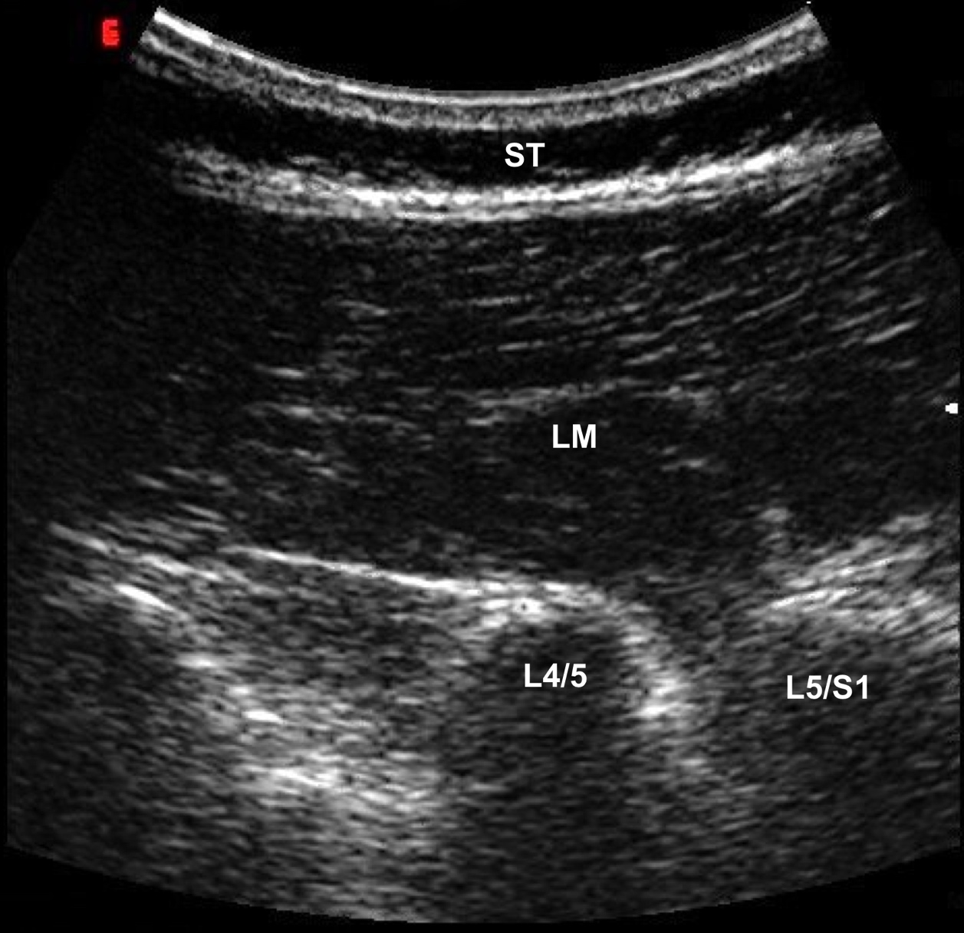
Figure 2. Exemplar captured ultrasound image of the longitudinal view of the lumbar vertebrae including the subcutaneous tissue (ST), lumbar multifidus muscle (LM), and the L4/5 and L5/S1 facet joints

Figure 3
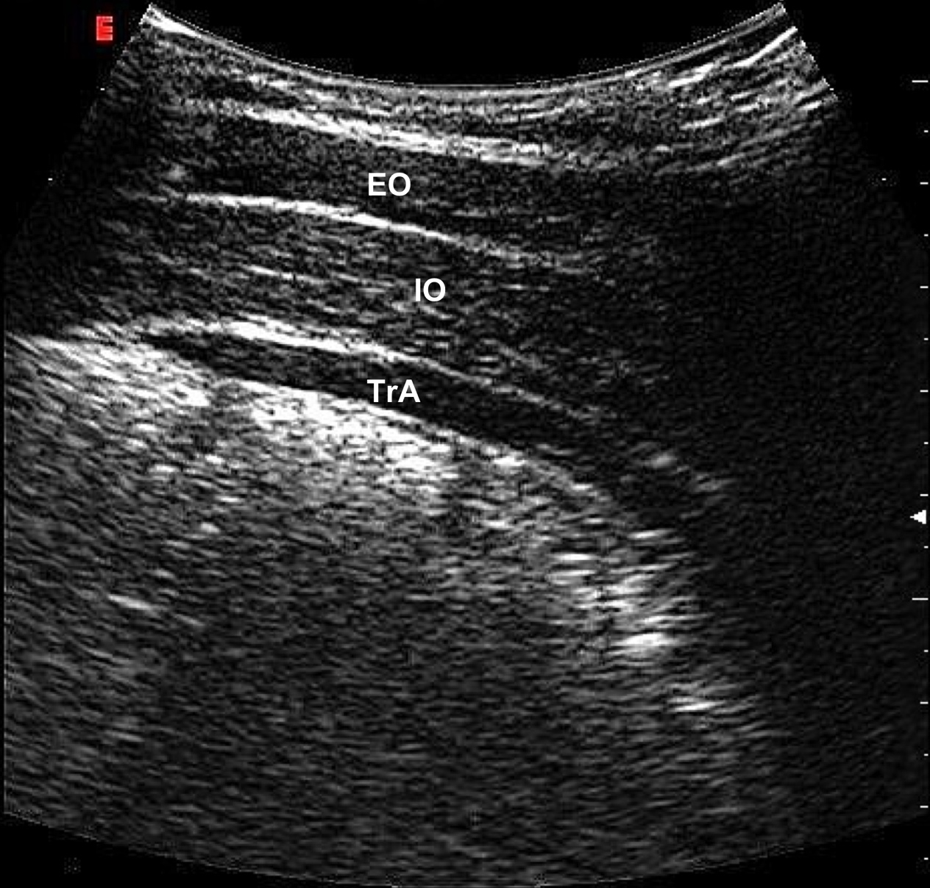
Figure 3. Exemplar captured ultrasound image of the anterolateral abdominal wall including the external oblique (EO), internal oblique (IO) and the transversus abdominis (TrA) muscles
Figure 4
Figure 4. Absolute thickness (A) and percentage thickness change relative to resting thickness (B) of the lumbar multifidus (LM) during each condition (CAL, contralateral arm lift; LCAL, contralateral arm lift with external load; WALK, treadmill walking; FRED, Functional Re-adaptive Exercise Device) across days one (black bars), two (white bars) and three (grey bars). Error bars indicate intra-day standard error of measurement
Figure 5
Figure 5. Absolute thickness (A) and percentage thickness change relative to resting thickness (B) of the transversus abdominis (TrA) during each condition (ADIM, abdominal drawing-in manoeuvre; ASLR, active straight leg raise; WALK, treadmill walking; FRED, Functional Re-adaptive Exercise Device) across days one (black bars), two (white bars) and three (grey bars). Error bars indicate intra-day standard error of measurement
Table 1
Table 1. Intra-day reliability and precision of absolute linear muscle thickness using three consecutive individual measures for each assessed conditions, presented separately for each of the three days.
 | ICC_{2,1} |  |  |  | SEM (mm) |  |  |  | MDC (mm)
Condition | Day |  |  |  | Day |  |  |  | Day
 | 1 | 2 | 3 |  | 1 | 2 | 3 |  | 1 | 2 | 3
LM
Rest | 0.97 | 0.95 | 0.96 |  | 1.2 | 1.3 | 1.3 |  | 3.2 | 3.6 | 3.7
CAL | 0.88 | 0.92 | 0.93 |  | 2.8 | 2.2 | 2.2 |  | 7.8 | 6.0 | 6.0
LCAL | 0.96 | 0.97 | 0.96 |  | 1.8 | 1.5 | 1.8 |  | 4.9 | 4.2 | 5.0
WALK | 0.89 | 0.84 | 0.91 |  | 3.1 | 3.1 | 2.4 |  | 8.7 | 8.5 | 6.8
FRED | 0.83 | 0.84 | 0.89 |  | 3.8 | 3.4 | 3.3 |  | 10.5 | 9.4 | 9.1
TrA
Rest | 0.96 | 0.97 | 0.96 |  | 0.4 | 0.3 | 0.3 |  | 1.0 | 0.9 | 0.9
ADIM | 0.91 | 0.92 | 0.93 |  | 0.6 | 0.5 | 0.5 |  | 1.6 | 1.5 | 1.4
ASLR | 0.96 | 0.97 | 0.97 |  | 0.5 | 0.3 | 0.4 |  | 1.3 | 1.0 | 1.0
WALK | 0.89 | 0.93 | 0.93 |  | 0.7 | 0.5 | 0.6 |  | 1.8 | 1.5 | 1.5
FRED | 0.97 | 0.97 | 0.95 |  | 0.4 | 0.4 | 0.5 |  | 1.2 | 1.2 | 1.4
Abbreviations: ICC, intraclass correlation coefficient; SEM, standard error of measurement; MDC, minimum detectable change; CAL, contralateral arm lift; LCAL, loaded contralateral arm lift; WALK, treadmill walking; FRED, Functional Re-adaptive Exercise Device; ADIM, abdominal drawing-in manoeuvre; ASLR, active straight leg raise.

Table 2
Table 2. Intra-day reliability and precision of relative linear muscle thickness change using individual measures for each assessed conditions, presented separately for each of the three days.
 | ICC_{2,1} |  |  |  | SEM (%) |  |  |  | MDC (%)
Condition | Day |  |  |  | Day |  |  |  | Day
 | 1 | 2 | 3 |  | 1 | 2 | 3 |  | 1 | 2 | 3
LM
CAL | 0.91 | 0.79 | 0.83 |  | 3.3 | 3.5 | 3.7 |  | 9.0 | 9.8 | 10.1
LCAL | 0.91 | 0.95 | 0.90 |  | 3.8 | 2.8 | 3.5 |  | 10.6 | 7.9 | 9.6
WALK | 0.80 | 0.89 | 0.88 |  | 6.3 | 6.1 | 5.1 |  | 17.6 | 16.9 | 14.2
FRED | 0.59 | 0.83 | 0.73 |  | 7.6 | 6.3 | 6.5 |  | 21.0 | 17.4 | 18.1
TrA
ADIM | 0.67 | 0.80 | 0.62 |  | 13.6 | 8.3 | 8.3 |  | 37.8 | 23.1 | 23.0
ASLR | 0.88 | 0.97 | 0.96 |  | 6.9 | 4.8 | 5.2 |  | 19.1 | 13.4 | 14.4
WALK | 0.70 | 0.83 | 0.52 |  | 11.1 | 8.0 | 7.9 |  | 30.8 | 22.1 | 21.9
FRED | 0.81 | 0.89 | 0.81 |  | 6.4 | 6.2 | 7.2 |  | 17.8 | 17.2 | 20.0
Abbreviations: ICC, intraclass correlation coefficient; CI, confidence interval; SEM, standard error of measurement; MDC, minimum detectable change; ADIM, abdominal drawing-in manoeuvre; ASLR, active straight leg raise; CAL, contralateral arm lift; LCAL, loaded contralateral arm lift; FRED, Functional Re-adaptive Exercise Device.

Table 3
Table 3. Inter-day reliability and precision of absolute linear muscle thickness using a mean of three measures for each assessed conditions for each of the three days.
 | ICC_{2,3} |  |  |  | Bias (95 CI) ± 95% LOA |  |  | SEM (mm) |  |  | MDC (mm)
Condition | All | D1-D2 | D2-D3 |  | D1-D2 | D2-D3 |  | D1-D2 | D2-D3 |  | D1-D2 | D2-D3
LM
Rest | 0.99 | 0.96 | 0.96 |  | -0.4 (-1.4-0.6) ± 3.5 | 0.4 (-0.5-1.4) ± 3.4 |  | 1.2 | 1.2 |  | 3.4 | 3.4
CAL | 0.93 | 0.95 | 0.93 |  | 0.4 (-0.3-1.0) ± 2.3 | -0.8 (-1.7-0.1) ± 3.3 |  | 1.8 | 2.1 |  | 4.9 | 5.9
LCAL | 0.98 | 0.96 | 0.96 |  | -0.1 (-0.6-0.4) ± 1.8 | 0.8 (0.4-1.3) ± 1.6 |  | 1.8 | 1.8 |  | 5.0 | 4.9
WALK | 0.94 | 0.93 | 0.93 |  | -1.7 (-3.4-0.1) ± 6.0 | -1.9 (-3.7-0.0) ± 6.4 |  | 2.3 | 2.1 |  | 6.2 | 5.8
FRED | 0.95 | 0.93 | 0.94 |  | 2.4 (0.9-3.9) ± 1.4 | 0.8 (-0.7-2.2) ± 5.1 |  | 2.3 | 2.3 |  | 6.5 | 6.2
TrA
Rest | 0.99 | 0.99 | 0.99 |  | 0.1 (0.0-0.3) ± 0.5 | -0.2 (-0.3-0.0) ± 0.6 |  | 0.2 | 0.2 |  | 0.5 | 0.5
ADIM | 0.98 | 0.97 | 0.98 |  | 0.1 (-0.2-0.5) ± 1.4 | 0.0 (-0.3-0.4) ± 1.1 |  | 0.3 | 0.3 |  | 0.9 | 0.8
ASLR | 0.98 | 0.97 | 0.99 |  | -0.1 (-0.4-0.2) ± 1.0 | 0.2 (0.1-0.3) ± 0.4 |  | 0.4 | 0.2 |  | 1.0 | 0.6
WALK | 0.94 | 0.97 | 0.94 |  | -0.1 (-0.6-0.3) ± 1.5 | 0.0 (-0.3-0.3) ± 1.0 |  | 0.3 | 0.5 |  | 0.9 | 1.4
FRED | 0.98 | 0.98 | 0.98 |  | 0.1 (-0.2-0.3) ± 0.2 | 0.1 (-0.1-0.3) ± 0.7 |  | 0.4 | 0.3 |  | 1.0 | 0.9
Abbreviations: ICC, intraclass correlation coefficient; CI, confidence interval; LOA, limits of agreement; SEM, standard error of measurement; MDC, minimum detectable change; D1-3, Day 1-3, ADIM, abdominal drawing-in manoeuvre; ASLR, active straight leg raise; CAL, contralateral arm lift; FRED, Functional Re-adaptive Exercise Device.

Table 4
Table 4. Inter-day reliability and precision of linear muscle thickness change (normalised to resting thickness) using a mean of three measures for each assessed conditions for each of the three days.
 | ICC_{2,3} |  |  |  | Bias (95 CI) ± 95% LOA |  |  | SEM (%) |  |  | MDC (%)
Condition | All | D1-D2 | D2-D3 |  | D1-D2 | D2-D3 |  | D1-D2 | D2-D3 |  | D1-D2 | D2-D3
LM
CAL | 0.79 | 0.77 | 0.76 |  | 2.4 (-1.9-6.8) ± 15.5 | -4.6 (-8.7--0.6) ± 14.4 |  | 4.3 | 3.9 |  | 12.0 | 10.8
LCAL | 0.90 | 0.89 | 0.82 |  | 1.0 (-3.4-5.5) ± 15.8 | 1.0 (-4.2-6.3) ± 18.6 |  | 4.3 | 3.4 |  | 11.8 | 9.5
WALK | 0.84 | 0.85 | 0.82 |  | -3.2 (-9.8-3.4) ± 23.3 | -9.0 (-17.0--0.7) ± 29.5 |  | 6.4 | 5.1 |  | 17.7 | 14.0
FRED | 0.84 | 0.78 | 0.79 |  | 10.6 (4.2--7.2) ± 22.8 | -0.2 (-7.7-7.2) ± 26.2 |  | 6.4 | 5.3 |  | 17.7 | 14.8
TrA
ADIM | 0.87 | 0.82 | 0.89 |  | -1.1 (-8.7-6.55) ± 27.0 | 4.7 (-0.8-10) ± 19.8 |  | 7.5 | 4.6 |  | 20.7 | 12.7
ASLR | 0.9 | 0.84 | 0.91 |  | -4.7 (-12.0-2.8) ± 26.5 | 7.5 (3.0-11.9) ± 15.8 |  | 9.3 | 4.1 |  | 25.8 | 11.3
WALK | 0.79 | 0.74 | 0.77 |  | -8.4 (-19-1.6) ± 35.7 | 3.2 (-4.5-10.8) ± 27.1 |  | 10.1 | 8.7 |  | 28.1 | 24.2
FRED | 0.88 | 0.81 | 0.93 |  | -3.1 (-11.0-4.4) ± 26.5 | 7.5 (2.4-13) ± 18.2 |  | 7.4 | 3.6 |  | 20.4 | 9.9
Abbreviations: ICC, intraclass correlation coefficient; CI, confidence interval; LOA, limits of agreement; SEM, standard error of measurement; MDC, minimum detectable change; D1-3, Day 1-3, ADIM, abdominal drawing-in manoeuvre; ASLR, active straight leg raise; CAL, contralateral arm lift; FRED, Functional Re-adaptive Exercise Device.

